**Alphanumeric Series**

footer line

**Introduction to Alphanumeric series**

Alphanumeric series is a sequence of characters containing either alphabets or numbers or both. In some cases, it may also include special characters like ‘@’,’&’,’*’ etc. This type of reasoning is a mixed bag of coding-decoding, series-based reasoning and finding positions-based reasoning questions. Alphanumeric series problems are asked in many competitive exams across the world.

|  |
| --- |
| Example:  1. 1A2B3C…         2. 1 3 5 7 9…         3. ABABCABCD…  are all alphanumeric series |

**Types of alphanumeric series problems**

* **Finding the next term in the series**: To solve these types of problems you have to observe the pattern of occurrence of numbers and alphabets. Start looking for patterns either from the left or right of the sequence.
* **Finding the missing term**: This type of problem is similar to the previous one. Here you have to observe the pattern till the missing term and continue following the pattern up till the end of the sequence.
* **Positional questions**: In this type of question, you’ll be given a sequence and asked to find certain alphabets or numbers based on a particular condition.

Note: Alphanumeric series problems usually require the knowledge of Arithmetic Progression and Geometric Progression. So, here are some formulas related to AP and GP.

**Arithmetic Progression**

1. The general form of an Arithmetic Progression is a, a + d, a + 2d, a + 3d and so on. Thus the nth term of an AP series is Tn = a + (n - 1) d, where Tn = nth term and a = first term. Here d = common difference = Tn - Tn-1.

2. Sum of first n terms of an AP: S = (n/2)[2a + (n- 1)d]

3. Tn = Sn - Sn-1 , where Tn = nth term

footer line

**Geometric Progression**

1. The general form of a GP is a, a*r, a*r^2, a*r^3 and so on.

2. The nth term of a GP series is Tn = a*r^(n-1), where a = first term and r = common ratio = Tn/T(n-1) .

3. The formula applied to calculate the sum of first n terms of a GP: Sn=(a(r^n-1))/(r-1) .

Example: B 8 C % S & E K 4 $ 9 2 ! V A 6 @ T I 8 Z # U 5

Which of the following is fifth to the right of eleventh from the right end of the given series?

a)$

b)A

c)8

d)I

Answer: d) I

Solution:11th from the right=V

5th to the right of V=I

Thus the answer is I

**Problem statement**

Send feedback

**2,A,9,B,6,C,13,D,?**

**Options:**Pick one correct answer from below

**9**

**10**

**E**

**15**

**Solution description**

A number is followed by an alphabet and vise versa. We observe that the number pattern goes this way 2(+7)-->9(-3)-->6(+7)-->13(-3)-->10(the missing value) Thus the answer is 10.

**Problem statement**

Send feedback

2A11, 2D13, 4G17,?

**Options:**Pick one correct answer from below

**12J23 ==**

**48M29**

**36I19**

**8E15**

**Problem statement**

Send feedback

ACE *?* MOQ SUW(last term)

**Options:**Pick one correct answer from below

**GIL**

**EFH**

**GIK**

**FHJ**

**Solution description**

(ABCDE)F(GHIJK)L(MNOPQ)...(STUVW) Thus the answer is GIK

**Problem statement**

Send feedback

867 209 242 283 543 Given this series: When the digits within the number are multiplied with each other, the product of which number is the lowest?

**Options:**Pick one correct answer from below

**867**

**209 ==**

**242**

**283**

**Problem statement**

Send feedback

Study the following arrangement carefully and answer the question that follows:

S K 6 £ Q 2 R * C F 8 E $ G 2 # 4 9 L N 3 U V 5 Y α B 7 W 9

Which of the following letters, numbers, or symbols will be third to the left or a fifth of the left?

**Options:**Pick one correct answer from below

**Q**

**S**

**6 ==**

**2**

## ****Artificial language****

## ****Introduction to Artificial Language****

Artificial language is an alternate language similar to human-readable languages. These languages are created out of the existing letters in human language in such a way that the two languages are related through some pattern or relation. Questions related to Artificial languages can be formed in a variety of ways. This makes these questions tricky. One needs to be careful while solving artificial language problems.

### **How to solve:**

1. Observe the given paragraph carefully.

2. Look for the given word in the paragraph.

3. Choose the corresponding word as the answer.

|  |
| --- |
| Example: ‘Share market doing well’ is written as ‘va jo ba ma’, ‘learn to share stuff’ is written as ‘si pa la va’, ‘well known to market’ is written as ‘si nu ma jo’ and ‘stuff the whole market’ is written as ‘fi ma pa do’. (Naggaro 2018 hiring)  What does the code ‘ba’ stand for?  a) Well  b) Share  c) Doing  d) Whole  Answer: c) Doing **Here are some words translated from an artificial language.** morpirquat means birdhouse  beelmorpir means bluebird  beelclak means bluebell  Which word could mean "houseguest"?  **Options:**Pick one correct answer from below  **Morpirhunde**  **Beelmoki**  **Quathunde**  **Clakquat**  **Solution description**  Morpir means bird; quat means house; beel means blue; clak means bell. Choice c, which begins with quat, is the only possible option.  **Problem statement**  Send feedback  fenplac means filmy holiday Placston means holiday beach Stonrum means beach perform Rumfen means perform filmy  Which word means “holiday”?  **Options:**Pick one correct answer from below  **plac**  **rum**  **ston**  **fen**  **Solution description**  fen=filmy; plac=holiday; Thus, answer is a) Plac |

**Problem statement**

Send feedback

Mallonpiml means blue ligh  
Mallontifl means blueberry  
Arpantifl means rasberry

Which word means “lighthouse”?

**Options:**Pick one correct answer from below

**Tiflmallon**

**Pimlarpan**

**Mallonarpan**

**Pimldoken**

**Solution description**

Mallon=blue, piml= ligh;  
Tifl=berry; arpan=ras  
Thus lighthouse can only be Pimldoken.

**Problem statement**

Send feedback

Creektulo means tree plantation  
creekfuos means tree mutation  
fuosseed means mutation sapling

Which word means “plantation”?

**Options:**Pick one correct answer from below

**Creek**

**Tulo ==**

**Fuos**

**Seed**

**Problem statement**

Send feedback

jalkamofti means happy birthday  
moftihoze means birthday party  
mentogunn means goodness

Which word could mean "happiness"?

**Options:**Pick one correct answer from below

**Jalkagunn ==**

**Mentohoze**

**Moftihoze**

**hozemento**

Blood relationsfooter line

**Introduction to Blood relations**

Blood relation is one of the most important topics of logical reasoning and found its importance in almost every entrance exam. This topic tests the analytical skills of the students and their solution approach. The questions asked in this chapter depend upon ‘Relations’. You should have a sound knowledge of the blood relation in order to solve the questions.

**To remember easily, the relation may be divided into two forms:**

**Relation of the paternal side**

|  |  |
| --- | --- |
| Father’s father | Grandfather |
| Father’s mother | Grandmother |
| Father’s brother | Uncle |
| Father’s sister | Aunt |
| Children of uncle | Cousin |
| Wife of uncle | Aunt |
| Children of aunt | Cousin |
| Husband of aunt | Uncle |

**Relation of the maternal side**

|  |  |
| --- | --- |
| Mother’s father | Maternal Grandfather |
| Mother’s mother | Maternal Grandmother |
| Mother’s brother | Maternal Uncle |
| Mother’s sister | Aunt |
| Children of maternal uncle | Cousin |
| Wife of maternal uncle | Maternal Aunt |
| Children of the maternal aunt | Cousin |
| Husband of the maternal aunt | Maternal Uncle |

**Others**

Son’s wife                                              Daughter-in-law

Daughter’s husband                               Son-in-law

Husband’s (or) wife’s father                  Father-in-law

Husband’s (or) wife’s mother                Mother-in-law

Husband’s (or) wife’s brother                Brother-in-law

Husband’s (or) wife’s sister                   Sister-in-law

Sister’s husband                                     Brother-in-law

Brother’s (or) sister’s son                      Nephew

Brother’s (or) sister’s daughter              Niece

|  |  |
| --- | --- |
| Son’s wife | Daughter-in-law |
| Daughter’s husband | Son-in-law |
| Husband’s (or) wife’s father | Father-in-law |
| Husband’s (or) wife’s mother | Mother-in-law |
| Husband’s (or) wife’s brother | Brother-in-law |
| Husband’s (or) wife’s sister | Sister-in-law |
| Sister’s husband | Brother-in-law |
| Brother’s (or) sister’s son | Nephew |
| Brother’s (or) sister’s daughter | Niece |

**Relations from one generation to other**

**Generation1:**Grandfather, Grandmother, Maternal grandfather, Maternal grandmother

**Generation 2:**Mother, Father, Uncle, Aunt, Maternal uncle, Maternal aunt

**Generation 3:**Self, Sister, Sister-in-law, Brother, Brother-in-law

**Generation 4:**Son, Daughter, Nephew, Niece

**Symbols**

1. ‘+’ for male          2.  ‘-’ for female    3.  ‘’ for couples

**Types of problem statements**

**Type 1: Statement based relationship questions**

Problem 1:

Pointing to a lady on the stage, Sonali said, “She is the sister of the son of the wife of my husband.” How is the lady related to Sonali?

Solution:

My husband = Sonali’s husband

Wife of my husband = is me = Sonali

Son of the wife of my husband = My Son

Sister of the Son of the wife of my Husband = My Son’s Sister = My daughter

So, the lady on the stage is Sonali’s daughter.

Problem 2:

Eeshas father was 34 years of age when she was born. Her younger brother, Shashank, now that he is 13, is very proud of the fact that he is as tall as her, even though he is three years younger than her. Eeshas mother, who is shorter than Eesha, was only 29 when Shashank was born. What is the sum of the ages of Eeshas parents now? (asked in TCS)

92

76

66

89

Answer: a) 92

Solution:Let Eesha's present age be x.

Eesha's father's present age = x + 34

Shashank's age = 13

Eesha's present age = 13 + 3 = 16

Eesha's mother's present age = 29 + 13 = 42

Sum of the ages of Eeshas parents now = 42 + 16 + 34 = 92

Problem 3:

Pointing to a lady a man said, “Her husband is the only son of my mother”. How is the lady related to the man?

Solution:

My mother’s only son = is me ( man)

Her husband = is me

So, the lady is Man’s wife.

Problem 4:

Pointing to Alex, Lita says, “I am the daughter of the only son of his grandfather.” How Lita is related to Alex? (Asked in Sapient)

Niece

Daughter

Sister

Cannot be determined

Answer: C) Sister

Solution:

Lita is the daughter of the only son of Alex’s grandfather. Hence, it’s clear that Lita is the sister of Alex.

Problem 5:

Pointing to a man Manisha said, “He is the youngest son of my father-in-law’s only son”. How is Manisha related to this youngest son’s father?

Sister

Sister-in-law

Wife

Mother

Solution:

Manisha’s father in law’s only son = Manisha’s husband

The youngest son of my father-in-law’s only son is my husband’s son = My son = Manisha’s son

So, Manisha is the wife of the youngest son’s father

**Type 2: Puzzle type questions with a family relationship component**

Problem 1:

A family consists of a husband and wife, their three sons and two daughters, three wives of three sons. How many females are in this family? (Wipro hiring 2018)

Solution:

Husband wife (female)

Three sons = S1 S2 S3 and two daughter = D1 D2

Son’s wives = W1 W2 W3

So, the total number of females = wife + D1 + D2 + W1 + W2 + W3 = 6 females.

Directions for problem 2 to 6:

If a + b means, a is the daughter of b,

a - b means, a is the husband of b,

ab means, a is the brother of b.

Problem 2:

What does the relation pq - r show?

p is the son-in-law of r

p is the brother of r

r is the wife of p

None of these

Solution:

pq means p is the brother of q

q - r means, q is the husband of r i.e.

p is the brother-in-law of r or r is the sister-in-law of p.

So the answer to this question is an option (d).

Problem 3:

If h+ij+kl+mn, then what is the present generation of h. Assume that the oldest generation of this group is 1st generation.

2nd (b) 3rd

(c) 1st (d) 4th

Solution:

Here symbol ‘+’ is for a generation change.

mn = m is the brother of n (1st generation)

l+m = l is the daughter of m (2nd generation)

kl = k is the brother of l

j+k = j is the daughter of k (3rd generation)

ij = i is the brother of j

h+i = h is the daughter of i (4th generation)

Hence, present generation of ‘h’ = 4th generation i.e. option (d)

Problem 4:

Which of the following options does not hold?

a+bc

a-bc

a+b+c

a+b-c

Solution:

a+bc, here ‘b’ is the brother of ‘c’ i.e ‘b’ is a male and ‘a’ is the daughter of ‘b’.

This option is correct.

a-bc, here ‘b’ is the brother of ‘c’ i.e ‘b’ is a male and ‘a’ is the husband of ‘b’

This option can not hold. ‘a’ can’t be the husband of ‘b’, because ‘b’ comes out a male.

Problem 5:

From the statement abcd, which of the following statements is not necessarily true?

‘b’ is the brother of ‘a’

‘c’ is the brother of ‘a’

‘d’ is the brother of ‘c’

a,b,c are male

Solution:

abcd, here ‘c’ is the brother of ‘d’, ‘b’ is the brother of ‘c’ and ‘a’ is the brother of ‘b’

So, here a,b,c are males.

Option (c) ‘d’ is the brother of ‘c’ is not necessarily true because we don’t know whether ‘d’ is male or not.

Problem 6:

From the statement p-q+rs, how is ‘q’ related to ‘s’?

Niece

Sister

Daughter

Brother

Solution:

rs = ‘r’ is the brother of ‘s’ ( ‘r’ is male)

q+r = ‘q’ is the daughter of ‘r’(‘q’ is a female)

p-q = ‘p’ is the husband of ‘q’

So from the above conclusion, ‘q’ is the niece of ‘s’ i.e. option (a) is the correct answer.

Directions for questions 7 to 8.

a*b means ‘a’ is the brother of ‘b’

a@b means ‘a’ is the daughter of ‘b’

a$b means ‘a’ is the sister of ‘b’

Problem 7:

Which of the following show the relationship ‘p’ is the paternal uncle of ‘c’?

n $ o @ p

n @ o $ p

All of the above

None of these

Solution:

n $ o @ p

o @ p = ‘o’ is the daughter of ‘p’ and n $ o = ‘n’ is the sister of ‘o’

So, here ‘p’ is either the father or the mother of ‘n’.

n @ o $ p

o $ p = ‘o’ is the sister of ‘p’ and n @ o = ‘n’ is the daughter of ‘o’

So, ‘p’ is either uncle or aunt of ‘n’ because the gender of p can not be determined.

Hence, the answer will be an option (d).

Problem 8:

a$b$c@d@e*f*g, then how many males and females are there respectively?

4,3

3,4

5,2

Can’t be determined

Solution:

f*g = ‘f’ is the brother of ‘g’ ( i.e. ‘f’ is a male)

e*f = ‘e’ is the brother of ‘f’ ( i.e. ‘e’ is a male)

d@e = ‘d’ is the daughter of ‘e’ (i.e. ‘d’ is a female)

c@d = ‘c’ is the daughter of ‘d’ (i.e. ‘c’ is a female)

b$c = ‘b’ is the sister of ‘c’ (i.e. ‘b’ is a female)

a$b = ‘a’ is the sister of ‘b’ (i.e. ‘a’ is a female)

Here we can not find the gender of ‘g’.

Here 4 women and 2 men but we can't find the gender of one person.

So, the answer is can’t be determined, option(d)

**Problem statement**

Introducing a boy, Naveen said, “His mother is the only daughter of my mother-in-law.” How is Naveen related to the boy?

**Options:**Pick one correct answer from below

**Uncle**

**Father**

**Brother**

**Husband**

**Solution description**

Mother-in-law’s only daughter= Naveen’s wife Naveen’s wife son= Naveen’s son Therefore Naveen is the father is the boy.

**Problem statement**

Pointing to a man in a photograph, a woman said, “His brother’s father is the only son (and child) of my grandfather.” How is the woman related to the man in the photograph?

**Options:**Pick one correct answer from below

**Mother**

**Sister ==**

**Aunt**

**Daughter**

**Problem statement**

Send feedback

Directions: If a + b means a is the sister of b,  
a – b means a is the brother of b,  
a ¥ b means a is the daughter of b,  
a Π b means a is the mother of b.  
Which of the following relationships shows that l and n are wife and husband?

**Options:**Pick one correct answer from below

**l Π m ¥ n**

**l – m ¥ n**

**l + m ¥ n**

**None of these**

**Solution description**

l is the mother of m and m is the daughter of n;  
Therefore l and n are wife and husband

**Problem statement**

Send feedback

If a + b means, a is the sister of b.

a-b means a is the brother of b,

a*b means a is the daughter of b,

a/b means a is the mother of b.

Q. How many females are there in the following relationship? l+m-n+o-p*q

**Options:**Pick one correct answer from below

**2**

**3**

**4**

**Can’t be determined**

**Solution description**

l+m-n+o-p*q can be read as l is the sister of m, m is the brother of n, n is the sister of o, os is the brother of p and p is the daughter of q. Thus, l, n and p are females, m and o are males and we do not know the gender of q. Hence, we cannot be sure about the number of females in the string.

**Problem statement**

Directions:  
If a + b means a is the sister of b,  
a – b means a is the brother of b,  
a ¥ b means a is the daughter of b,  
a Π b means a is the mother of b.  
  
The relationship p + q – r ¥ s Π t shows that(choose from the following options):

**Options:**Pick one correct answer from below

**p, q, r, s are children of t**

**p, q, r, t are children of s**

**p, q, r are children of t and s**

**p, q, r, s, t are all siblings.**

**Solution description**

P is the sister of q  
Q is the brother of r  
R is the daughter of s  
And s is the mother of t  
Therefore p,q,r,t are siblings and s is their mother

Calendar Problems

**Introduction to Calendar problems**footer line

The calendar is a small chapter but an important chapter of the reasoning part. Questions in calendars come from time to time for you in your exams.

**A calendar**is a series of pages that contains days, weeks, and months of a particular year and gives information.

**Normal year:**Any year which contains 365 days is called a normal year.

**Leap year:**Any year which contains 366 days is called a leap year.

**Odd days:**Number of days from which we can’t complete a week are called odd days i.e. if a month has 31 days, then we have 3 days of 29, 30 and 31 which are left alone and don’t make up a week. Odd days is basically ( number of days )%7 i.e. number of days that remain as remainder if we divide the total number of days by 7.

A normal year has 365 days. In which there are 52 complete weeks and the last day would be an odd day. It would shift the calendar ahead or behind by a certain day.

Suppose in a normal year you start 1st January of the year on Monday, then 30th Dec of that year would be a Sunday and 31st Dec being a Monday and hence, the 1st Jan of the next year will skip the calendar forward by one day.

A leap year has 366 days. If 1st Jan starts with Monday of leap year then 29th Dec would be the last Sunday of that year. 30th Dec will again Monday and 31th Dec will be Tuesday. Hence, 1st Jan of the next year will skip by 2 days.

**The number of odd days in different months of a calendar**

|  |  |
| --- | --- |
| **MONTHS** | **NUMBER OF ODD DAYS** |
| JANUARY | 3 |
| FEBRUARY(normal/leap) | 0/1 |
| MARCH | 3 |
| APRIL | 2 |
| MAY | 3 |
| JUNE | 2 |
| JULY | 3 |
| AUGUST | 3 |
| SEPTEMBER | 2 |
| OCTOBER | 3 |
| NOVEMBER | 2 |
| DECEMBER | 3 |

**NOTE:**

1. The number of odd days in the first 100 consecutive years is 5.
2. The number of odd days in the first 200 consecutive years is 3.
3. The number of odd days in the first 300 consecutive years is 1.
4. The number of odd days in the first 400 consecutive years is 0.

Example 1:

11 August 2019 is a Sunday, what day was on 11 August 1983?

Solution:

To find the day on 11 August 1983, you have to count the number of odd days.

From 1983 to 2019 there are 36 years. This means 36 odd days and now count how many leap years or 29th Feb will appear.

So, 29th Feb would appear in 1984,1988,1992,1996,2000,2004,2008,2012,2016. So, 9 leap years means 9 further odd days.

Hence, the total number of odd days = 36+9=45 days

45 days have 6 complete weeks and 3 odd days left out.

Going behind 3 odd days from Sunday. Hence, 11 August 1983 would be a Thursday.

Example 2: What was the day of the week on 13th April 1723?

Monday

Tuesday

Wednesday

Thursday

Answer:b)

Solution: No. of odd days in 1700=5(1600=0+ 100=5)

No of odd days in 22 years=5(leap years)*2+17(normal years)=27mod7=6

No. of odd days in Jan, Feb, and march=3+0(1723 is not a leap year)+3=6

No. of odd days in 13 days=6

Total odd days =23mod7=2

Thus 13th April 1723 is Tuesday

OR

No. of odd days in 1700 = 5 (1600 = 0 + 100 =5)

No of odd days in 22 year = 5(leap years) * 2 + 17 (normal years) = 27mod7 = 6

No. of odd days in Jan, Feb, March and 13 days of April = 31 + 28(not leap year) + 31 + 13 = 103mod7 = 5

Total odd days = 5+6+5 = 16mod7 = 2

Thus 13th April 1723 is Tuesday.

**Problem statement**

Send feedback

If the third day of a month is Monday, then which day of the week will be the fifth day from the 21st of that month ?

**Options:**Pick one correct answer from below

**Friday**

**Sunday**

**Wednesday**

**Tuesday**

**Solution description**

The fifth day from 21st of that month will be 26th day of the month. Now, 3rd day of the month is Monday. So, 24th day will also be the Monday. Therefore, 26th of the month will be Wednesday. Hence, option (C) is the correct answer.

**Problem statement**

Send feedback

9th June of leap year was on Thursday. Then what was the day of the week on 17 February?

**Options:**Pick one correct answer from below

**Wednesday**

**Monday**

**Thursday**

**Tuesday**

**Solution description**

number of days between 17th Feb and 9th June=113 Number of odd days =113 mod 7 =1 Therefore it is one day before Thursday = Wednesday

**Problem statement**

Send feedback

What will be the day of the week 15th August 2010?

**Options:**Pick one correct answer from below

**Sunday===**

**Saturday**

**Monday**

**Wednesday**

**Soluton**

Year(2000)=0 ,year 10=2*2 +8=12mod7=5

Date=31+28+31+30+31+30+31+15=227mod7=3

Total 0+5+3=8mod=1 sunday

**Problem statement**

Send feedback

If 10th May, 1997 was a Monday, what was the day on Oct 10, 2001?

**Options:**Pick one correct answer from below

**Sunday**

**Saturday**

**Thursday**

**Friday ===**

**Solution**

Total years =4 +leap(1)=5mod7 =5

5days from Monday is friday

**Problem statement**

Send feedback

Pinky was born on 29th, Feb 2016 which happened to be a Monday. If she lives to be till 2099, how many birthdays would she celebrate on a Monday?

**Options:**Pick one correct answer from below

**1**

**2**

**3**

**5**

**Solution description**

29th Feb, 2016 = Monday => 28th Feb, 2012 = Sunday 28th Feb, 2017 = Tuesday (because 2016 is a leap year, there will be 2 odd days) Therefore, Feb 28th 2018 (Wednesday), Feb 28th 2019 (Thursday), Feb 28th 2020 (Friday), Feb 29th 2020 (Saturday) Or, Feb 29th to Feb 29th after 4 years, we have 5 odd days. So, every subsequent birthday, would come after 5 odd days. 2020 birthday – 5 odd days 2024 birthday – 10 odd days = 3 odd days 2028 birthday – 8 odd days = 1 odd day 2032 birthday – 6 odd days 2036 birthday – 11 odd days = 4 odd days 2040 birthday – 9 odd days = 2 odd days 2044 birthday – 7 odd days = 0 odd days. So, after 28 years, his birthday would fall on Monday. The next birthday on Monday would be in year 2072 (further 28 years later), the one after that would be in year 2100. But we are told that she lives upto year 2099. So, there are 2 occurrences of his birthday falling on Monday – 2044 & 2072.

Deductive Reasoning/ statement analysis

**Introduction to deductive reasoning/ statement analysis**footer line

Deductive reasoning is the process of reasoning from one or more statements to reach a logically certain conclusion.

Deductive reasoning questions will require you to use your problem-solving and reasoning skills, by evaluating arguments, analyzing scenarios, and drawing logical conclusions.

In deductive reasoning questions, you must draw conclusions based on only the information given in the question and not your own knowledge. If the conclusion cannot be drawn from the information given, then the conclusion does not follow.

**Types of problems**

**Syllogisms**:

The most common types of deductive reasoning questions are syllogisms. A syllogism is a type of logical argument in which a pair of sentences serve as the rules/premises and a third sentence serves as the conclusion.

Example: All crows are black. All black birds are loud. All crows are birds.

Statement: All crows are loud.

A: True

B: False

C: Insufficient information

Answer: A.

Solution: Deductive reasoning questions are rarely that simple and the premises given can also be given less directly, as through a text paragraph.

**Arrangements:**

Another very common form of deductive reasoning question is arrangements. In arrangements, you are given information about the order of items or people in comparison to one another. You are required to mentally arrange the items/people according to the information given and answer a question based on the arrangement.

Example: Mike finished ahead of Paul. Paul and Brian both finished before Liam. Owen did not finish last.

Who was the last to finish?

A: Owen

B: Brian

C: Paul

D: Liam

Answer: D.

Solution: Mike finished before Paul, so Mike was not last. Paul and Brian finished before Liam, so Paul and Brian were not last. It is stated that Owen did not finish last. Only Liam remains, so Liam must have been last to finish.

**Problem statement**

Send feedback

Statements: 1. The prices of petrol and diesel in the domestic market have remained unchanged for the past few months.  
2. The crude oil prices in the international market have gone up substantially in the last few months.

**Options:**Pick one correct answer from below

**Statement I is the cause and statement II is its effect**

**Statement II is the cause and statement I is its effect**

**Both statements I and II are independent causes**

**Both statements I and II are effects of independent causes ===**

**Both the statements I and II are effects of some common cause**

**Solution description**

We notice that both statements are the effect of a cause. The cause of those statements is not related. Therefore the causes are independent

**Problem statement**

Send feedback

Statements:  
1. The police authority has recently caught a group of house breakers.  
2. The citizens' group in the locality has started night vigil in the area.

**Options:**Pick one correct answer from below

**Statement I is the cause and statement II is its effect**

**Statement II is the cause and statement I is its effect**

**Both statements I and II are independent causes**

**Both statements I and II are effects of independent causes**

**Both the statements I and II are effects of some common cause ==**

**Solution description**

Both the statements are clearly backed by a common cause, which is clearly an increase in the number of thefts in the locality.

**Problem statement**

Send feedback

Statements:  
I. There is a sharp decline in the production of oil seeds this year.  
II. The Government has decided to increase the import quantum of edible oil.

**Options:**Pick one correct answer from below

**Statement I is the cause and statement II is its effect ===**

**Statement II is the cause and statement I is its effect**

**Both statements I and II are independent causes**

**Both statements I and II are effects of independent causes**

**Both the statements I and II are effects of some common cause**

**Solution description**

A sharp decline in oilseed production is bound to reduce oil supply and import of oil is the only means to restore the essential supply.

**Problem statement**

Statements:  
I. There is an unprecedented increase in the number of young unemployed in comparison to the previous year.  
II. A large number of candidates submitted applications against an advertisement for the post of manager issued by a bank

**Options:**Pick one correct answer from below

**Statement I is the cause and statement II is its effect**

**Statement II is the cause and statement I is its effect==**

**Both statements I and II are independent causes**

**Both statements I and II are effects of independent causes**

**Both the statements I and II are effects of some common cause**

**Solution description**

An increase in the number of unemployed youth is bound to draw in huge crowds for a single vacancy.

Clock problems

footer line

**Introduction to clock problems**

A clock is a complete circle having 360 degrees. It is divided into 12 equal parts i.e. each part is 360/12 = 30°.

As the minute hand takes a complete round in one hour, it covers 360° in 60 minutes.

In 1 minute it covers 360/60 = 6°/ minute.

Also, as the hour hand covers just one part out of the given 12 parts in one hour. This implies it covers 30° in 60 minutes i.e. ½° per minute.

This implies that the relative speed of the minute hand is 6 - ½ = 5 ½ degrees.

We will use the concept of relative speed and relative distance while solving problems on clocks.

**Some facts about clock problems**

* Every hour, both hands coincide once. In 12 hours, they will coincide 11 times. It happens due to only one such incident between 12 and 1'o clock.
* The hands are in the same straight line when they are coincident or opposite to each other.
* When the two hands are at a right angle, they are 15-minute spaces apart. In one hour, they will form two right angles and in 12 hours there are only 22 right angles. It happens due to right angles formed by the minute and hour hand at 3’o clock and 9'o clock.
* When the hands are in opposite directions, they are 30-minute spaces apart.
* If both the hour hand and minute hand move at their normal speeds, then both the hands meet after 65 minutes.

**Types of clock problems**

**Type 1: Finding the time when the angle between the two hands is given.**

When the angle between the hands is not perfect angles like 180°, 90°, or 270°, the solving of the questions becomes difficult and time-consuming at the same time. The logic below provides a trick to address problems involving angles of hands for other than standard aspects.

*T = 2/11 [H*30±A]*

Where:

1. T stands for the time at which the angle formed.
2. H stands for an hour, which is running.

(If the question is for the duration between 4 o’clock and 5 o’clock, it’s the 4th hour which is running hence the value of H will be ‘4’.)

3. A stands for the angle at which the hands are at present.

(The value of A is provided in the question generally)

The clock is divided into two parts: 1st and 2nd half as shown above

If the time given in the question lies in the first half, then the positive sign is considered while evaluating the time else, then the negative sign is used.

Example: At what time between 3 and 4 o’clock, the hands make an angle of 10 degrees?

Solution: Given: H = 3 , A = 10

Since both three and four lies in the first half considered a positive sign.

T = 2/11 [H*30±A]

T = 2/11 [3*30+10]

T = 2/11 [90+10]

T = 2/11 [100]

T = 200/11

T =18 2/11

The answer indicates that the hands of a clock will make an angle of 10 between 3 and 4 o’clock at exactly 3:18:2/11 ( 3’ o clock 18 minutes and 2/11 of minutes = 2/11*60 = 10.9 seconds)

**Type 2: Finding the angle between the two hands at a given time.**

|  |
| --- |
| **Example:**  The angle between the minute hand and the hour hand of a clock when the time is 4:20 is:  Answer: 10 degrees.  Solution: At 4:00, the hour hand was at 120 degrees.  Using the concept of relative distance, the minute hand will cover =  =110 degrees  The angle between the hour hand and the minute hand is = 120-110 = 10 degrees. |

**Type 3: Questions on clocks gaining/losing time.**

If a watch indicates 9.20, when the correct time is 9.10, it is said to be 10 minutes too fast. And if it indicates 9.00, when the correct time is 9.10, it is said to be 10 minutes too slow**.**

Such kinds of problems appear in exams very often, when a clock runs faster or slower than the expected pace.

**The clock is running fast:** It is also referred to as gaining time i.e. when a normal clock covers 60 minutes, a faster clock will cover more than 60 minutes.

**The clock is running slow:** It is also referred to as losing time i.e. when a normal clock covers 60 minutes, a slower clock will cover less than 60 minutes.

Example: A watch gains 5 minutes in one hour and was set right at 8 AM. What time will it show at 8 PM on the same day?

Answer: 9 pm

Solution: A correct clock would have completed 12 hours by 8 pm. But the faster clock actually covers 5 min. extra in one hour. So, it will cover 12 x 5 = 60 minutes extra.

Therefore, when the correct clock would show 8 pm, the faster clock will show 60 minutes extra i.e. 9 pm.

**Problem statement**

At what time between 10 and 11 will the minute and hour hand be at right angles? (Answer in minutes up to 2 decimal places)

38.18

**Problem statement**

At what time between 4 and 5, will the hands of a clock coincide? (Answer in minutes up to 2 decimal places)

21.81

**Problem statement**

The angle between the minute hand and the hour hand of a clock when the time is 3:30 is:

**Options:**Pick one correct answer from below

**75**

**85**

**165**

**90**

**Solution description**

At 4:00, the hour hand was at 90 degrees. Using the concept of relative distance, the minute hand will cover = (30x11)/2 =165 degrees The angle between the hour hand and minute hand is = 165-90= 75 degrees.

**Problem statement**

Send feedback

If it is 2:00 PM, what is the measure of the angle between the minute and hour hands of the clock?

**ptions:**Pick one correct answer from below

**30**

**45**

**60**

**90**

**Solution description**

First note that a clock is a circle made of 360 degrees, and that each number represents an angle and the separation between them is 360/12 = 30. And at 2:00, the minute hand is on the 12 and the hour hand is on the 2. The correct answer is 2 * 30 = 60 degrees.

**Problem statement**

Send feedback

A watch loses 5 seconds in one hour and is set right at 7 am. What time will it show at 2 pm on the same day? (Answer in hh:mm:ss format)

Coding decoding problems

**Introduction to coding-decoding problems**footer line

A code is ‘a system of signals. Coding is, therefore, a method of transmitting a message between sender and receiver which cannot be understood or comprehended by a third person. The Coding and Decoding test is mainly to judge the test-taker's ability to decipher a particular word/message by breaking the code or decoding the same.

**Codes based on English alphabets**

|  |  |
| --- | --- |
| **Alphabets** | **Codes** |
| A | 1 |
| B | 2 |
| C | 3 |
| D | 4 |
| . | . |
| . | . |
| . | . |
| Z | 26 |

**Series of opposite alphabets**

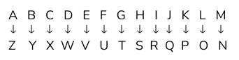

**Types of coding decoding problems**

1. **Letter coding**

**Case - I:** To form the code for another word (Coding)

Example: In a certain code, TEACHER is written as VGCEJGT. How is CHILDREN written in that code?

(a) EJKNEGTP

(b) EGKNFITP

(c) EJKNFGTO

(d) EJKNFTGP

Answer: d) EJKNFTGP

Solution: Each alphabet in the word "TEACHER " is moved two steps forward to obtain the corresponding alphabet of the code.

T E A C H E R=V G C E J G T (Each alphabet is increasing by 2)

Similarly, we have

C H I L D R E N=E J K N F T G D

**Case - II:** To find the word by analyzing the given code (Decoding)

Example: In a certain code language, the word ROAD is written as WTFI. Following the same rule of coding, what should be the word for the code GJFY?

(a) REAP

(b) TAKE

(c) BEAT

(d) LATE

Answer: c) BEAT

Solution: Each alphabet of the word is five steps behind the corresponding alphabet of the given code word.

Hence, BEAT is coded as GJFY.

1. **Substitution**

Example: If 'sky' is called as 'star', 'star' is called as 'cloud', 'cloud' is called as 'earth', 'earth' is called as 'tree', and 'tree' is called as 'book', then where do the birds fly?

(a) Cloud

(b) Sky

(c) Star

(d) Data Inadequate

Answer: c) star

Solution: Birds fly in the sky. The code for sky is star. Therefore, birds fly in the 'star'.

1. **Deciphering message word code**

Example: In a certain language, 'sun shines brightly' is written as ‘ba lo sul’, 'houses are brightly lit' as ‘kado ula ari ba’ and 'light comes from sun' as ‘dopi kup lo nro’. What is the code for sun and brightly?

(a) ba sul

(b) sul lo

(c) lo ba

(d) ba nro

Answer: c)lo ba

Solution: In the first and third statements, the common word is 'sun' and the common codeword is ‘lo’. So, ‘lo’ is the code for 'sun'. In the first and second statements, the common word is 'brightly' and the common code word is ‘ba’. So, ‘ba’ is the code for 'brightly'. Hence, the answer is (c).

1. **Numerical code values assigned to words**

Example: If ROSE is coded as 6821, CHAIR is coded as 73456 and PREACH is coded as 961473, then what will be the code for SEARCH?

(a) 246173

(b) 214673

(c) 214763

(d) 216473

Answer: b) 214673

Solution: The alphabets are coded as shown:

ROSECHAIR=682173456

Therefore, in SEARCH, S is coded as 2, E is coded as 1, A is coded as 4, R is coded as 6, C is coded as 7, H is coded as 3. Thus, the code for SEARCH is 214673.

## Problem statement

Send feedback

In a certain code language, “YEARLY” is written as “BVZIOB”. What will be the code for “ANNUAL” in the same language?

**Options:**Pick one correct answer from below

**ZFMOMM**

**ZNNFZA**

**ZMMFZO**

**XCADGF**

**Solution description**

YEARLY= BVZIOB =>A=Z and L=O So , ANNUAL= Z___ZO and the only matching option is c)

**Problem statement**

Send feedback

In some languages, “EXAM” is coded as “FYBN”. Then what does SFTVMU mean?

**Options:**Pick one correct answer from below

**RESULT**

**ERASER**

**PENCIL**

**YEARLY**

**Solution description**

The first step is to detect the code. For that, we need to focus on the word EXAM. The first letter E in code is F, similarly the code for X is Y, for A it is B and for M it is N. Thus we see that in this language the alphabet is shifted to one step to the front. Thus the code for R will be S and hence the correct option here is RESULT

**Problem statement**

Send feedback

In a certain code language “EASY” is written as “5117”. In the same code language, how will “BEAM” be written as?

**Options:**Pick one correct answer from below

**4512**

**4567**

**2513**

**2514**

**Solution description**

E=5th letter, A=1th letter, s=19th(1+9=10(1+0))=1 B=2, E=5, A=1, M=13(1+3)=4 BEAM=2514

**Problem statement**

Send feedback

If ‘cook’ is called ‘butler’, ‘butler’ is called ‘manager’, ‘manager’ is called ‘teacher’, ‘teacher’ is called ‘clerk’ and ‘clerk’ is called ‘principal’, who will teach in a class?

**Options:**Pick one correct answer from below

**Cook**

**Butler**

**Manager**

**Teacher**

**Clerk**

**Solution description**

Clearly, a ‘teacher’ teaches in a class and as given, ‘teacher’ is called is ‘clerk’. So, a ‘clerk’ will teach in the class. Hence, the answer is (e).

**Problem statement**

Send feedback

“black orange yellow purple blue” is written as “set jet let get bet”  
“grey green red purple” is written as “get pet wet vet”  
“purple blue red silver” is written as “vet set get tet”  
“grey orange pink” is written as ” bet ret pet”  
Based on the cryptic code given above, what is the code for red? (Wipro)

**Options:**Pick one correct answer from below

**Vet**

**Pet**

**Ret**

**Wet**

**Solution description**

We can clearly see from the paragraph that red corresponds to vet. Map colour to corresponding words based on frequency. The code for colour is jumbled and not in order.

Data sufficiency problemsfooter line

**Introduction to data sufficiency problems**

Data sufficiency questions test your knowledge of basic math facts and skills along with reasoning, analytical, and problem-solving abilities. Each data sufficiency item presents you with a question. You do not actually have to find the answer to the problem; instead, your challenge is to decide whether or not the information presented along with the question would be sufficient to allow you to answer the question.

Data sufficiency means you need to check whether the data given in the statements are sufficient to answer the question asked or not. You need to find a unique answer to the question asked. More than one answer is not allowed.

**How to answer data sufficiency questions**

First of all, you need to read the directions of a particular Data Sufficiency question very carefully as the examiner can change the directions, and even after solving all the questions correctly, you mark the wrong answers.

You need to remember the steps involved in solving a particular Data Sufficiency     question and follow them in this particular order:

Check A( first statement)

Then check B(the second statement)

And lastly, if required combine the two statements to get the answer.

Do not make any assumptions while solving  Data Sufficiency problems

Example 1: Three packages have a combined weight of 48 pounds. What is the weight of the heaviest package?

A. One package weighs 12 pounds.

B. One package weighs 24 pounds.

1. Statement A alone is sufficient to answer this question, but statement B alone is not sufficient.

2. Statement B alone is sufficient to answer this question, but statement A alone is not sufficient.

3. Both statements together are needed to answer this question, but neither statement alone is sufficient.

4. Either statement by itself is sufficient to answer this question.

5. Not enough facts are given to answer the question.

Answer: 2) Statement B alone is sufficient to answer this question, but statement A alone is not sufficient.

Solution: Statement A is not sufficient to determine the weight of the heaviest package. It implies only that the combined weight of the other two packages is 36 pounds. (Eliminate options 1 and 4). Statement B alone is sufficient for it implies that the combined weight of two of the packages is only 24 pounds. Since the weight of the 24 -pound packages is equal to the combined weight of the other two packages, the heaviest package must weigh 24 pounds. (Eliminate options 3 and 5). Since statement B alone is sufficient to answer the question but statement A alone is not, answer this question as option 2.

Example 2: How many books are there on a certain shelf?

A. If four books are removed, the number of books remaining on the shelf will be less than 12.

B. If three more books are placed on the shelf, the total number of books on the shelf will be more than 17.

1. Statement A alone is sufficient to answer the question, but statement B alone is not sufficient.

2. Statement B alone is sufficient to answer the question, but statement A alone is not sufficient.

3. Both statements together are needed to answer the question, but neither statement alone is sufficient.

4. Either statement by itself is sufficient to answer the question.

5. Not enough facts are given to answer the question.

Answer: 3. Both statements together are needed to answer the question, but neither statement alone is sufficient.

Solution: Neither statement alone is sufficient to answer the question asked. Statement A alone implies only that the number of books on the shelf is 15 or fewer, and statement B alone implies only that the number of books on the shelf is 15 or more. (Eliminate options 1, 2, and 4). But the two statements taken together are sufficient to answer the question, for they imply that the number of books on the shelf is 15. (15 is the only integer that satisfies both statements A and B). Since neither statement alone is sufficient, but the two statements together are, answer this question as option 3.

Example 3: Directions for data sufficiency questions (3 and 4):

If data in statement I alone is sufficient to answer the question.

If data in statement II alone is sufficient to answer the question.

If data either in statement I alone or statement II alone are sufficient to answer the question.

If data given in both I & II together are not sufficient to answer the question.

If data in both statements I & II together are necessary to answer the question.

Question 3. Who is taller among P, Q, R, S & T?

S is shorter than Q. P is shorter than only T.

Q is taller than only S. T is taller than P and R.

Answer: C.

Solution:From I : P is shorter than only T, this means that P is taller than all Q, R & S, so T is tallest.

From II : Q only taller than S, so S is shortest, and Q is second shortest, Now T taller than P and R both, So tallest of all.

Question 4. What is the distance between point P and point Q?

Point R is 10 m west of point P and point S is 10 m north of point P.

Point Q is 10 m south-east of point R. Point S is 20 m north-west of point Q.

Answer: D)

Solution:From I : No relation between points P and Q

From II : In this since we don’t know the angles between sides of triangle forming with points PQS and PQR, PQ cannot be determined.

**Problem statement**

Send feedback

DIRECTIONS :  
Mark (1) if the question can be answered by A alone but cannot be answered by B alone  
Mark (2) if the question can be answered by B alone but cannot be answered by A alone  
Mark (3) if the question cannot be answered by A or B alone but can be answered by combining the two statements.  
Mark (4) if the question can be answered by A alone and B alone  
Mark (5) if the question cannot be answered by A or B alone and cannot be answered even by combining the two statements.  
  
1.What is the value of x?  
A : x2 = 64  
B. x3 = 512

**Options:**Pick one correct answer from below

**1**

**2**

**3**

**4**

**Solution description**

Following the steps mentioned earlier, we see that statement A is not sufficient to answer the question as from statement A; we get 2 values of x as - 8 and + 8. Statement B is sufficient as we get x = 8.

**Problem statement**

Send feedback

DIRECTIONS :  
Mark (1) if the question can be answered by A alone but cannot be answered by B alone  
Mark (2) if the question can be answered by B alone but cannot be answered by A alone  
Mark (3) if the question cannot be answered by A or B alone but can be answered by combining the two statements.  
Mark (4) if the question can be answered by A alone and B alone  
Mark (5) if the question cannot be answered by A or B alone and cannot be answered even by combining the two statements.  
  
Is x odd?  
A : 3x - 12 = 12  
B. 2x + 16 = 24

**Options:**Pick one correct answer from below

**1**

**2**

**3**

**4 ==**

**Problem statement**

Send feedback

DIRECTIONS :  
Mark (1) if the question can be answered by A alone but cannot be answered by B alone  
Mark (2) if the question can be answered by B alone but cannot be answered by A alone  
Mark (3) if the question cannot be answered by A or B alone but can be answered by combining the two statements.  
Mark (4) if the question can be answered by A alone and B alone  
Mark (5) if the question cannot be answered by A or B alone and cannot be answered even by combining the two statements.  
  
What is the distance between Chandigarh and Delhi?  
Karnal is 130 km from Chandigarh  
Delhi is 120 km from Karnal

**Options:**Pick one correct answer from below

**1**

**2**

**3**

**4**

**5**

**Solution description**

Just by looking at the statements, we can infer that a unique answer can be obtained by combining the two statements. But, this answer is based on two assumptions: Chandigarh, Karnal, and Delhi are in a straight line and Karnal lies between Chandigarh and Delhi. Even if it is given that these 3 cities are in a straight line, still we have 2 possible answers to this question, even after combining the two statements i.e 250 km and 10 km. Since we are not getting any unique answer even after combining the two statements, so the answer is the 5th option.

**Problem statement**

Send feedback

How many books are there on a certain shelf? A. If four books are removed, the number of books remaining on the shelf will be less than 12. B. If three more books are placed on the shelf, the total number of books on the shelf will be more than 17.

**Options:**Pick one correct answer from below

**Statement A alone is sufficient to answer the question, but statement B alone is not sufficient.**

**Statement B alone is sufficient to answer the question, but statement A alone is not sufficient.**

**Both statements together are needed to answer the question, but neither statement alone is sufficient.**

**Either statement by itself is sufficient to answer the question.**

**Not enough facts are given to answer the question.**

**Solution description**

Neither statement alone is sufficient to answer the question asked. Statement A alone implies only that the number of books on the shelf is 15 or fewer, and statement B alone implies only that the number of books on the shelf is 15 or more. (Eliminate options 1, 2, and 4). But the two statements taken together are sufficient to answer the question, for they imply that the number of books on the shelf is 15. (15 is the only integer that satisfies both statements A and B). Since neither statement alone is sufficient, but the two statements together are, answer this question as option 3.

**Problem statement**

Send feedback

How is Shubham related to Shivani? Shubham is brother of Meenal. Shivani is the niece of Pooja Neeraj is Meenal’s uncle and Preeti’s brother

**Options:**Pick one correct answer from below

**Statement A alone is sufficient to answer the question, but statement B alone is not sufficient.**

**Statement B alone is sufficient to answer the question, but statement A alone is not sufficient.**

**Both statements together are needed to answer the question, but neither statement alone is sufficient.**

**The data given in both I and II together are not sufficient to answer the question. ==**

**Not enough facts are given to answer the question.**

**Solution description**

From both statements, we can get the relationship as Pooja is Neeraj’s sister but it cannot be clearly said that Shubham & Meenal are Pooja’s children or not & Shivani is Neeraj’s daughter because there can be other siblings of Neeraj and Pooja also.

**Deductive Reasoning/ Statement Analysis**

**Introduction to Deductive Reasoning/ Statement Analysis**

Deductive reasoning is the process of reasoning from one or more statements to reach a logically certain conclusion.

Deductive reasoning questions will require you to use your problem-solving and reasoning skills, by evaluating arguments, analyzing scenarios, and drawing logical conclusions.

In deductive reasoning questions, you must draw conclusions based on only the information given in the question and not your own knowledge. If the conclusion cannot be drawn from the information given, then the conclusion does not follow.

**Types of problems**

**Syllogisms**:

The most common types of deductive reasoning questions are syllogisms. A syllogism is a type of logical argument in which a pair of sentences serve as the rules/premises and a third sentence serves as the conclusion.

|  |
| --- |
| Example:  All crows are black. All black birds are loud. All crows are birds.  Statement: All crows are loud.  A: True  B: False  C: Insufficient information  Answer: A.  Solution: Deductive reasoning questions are rarely that simple and the premises given can also be given less directly, as through a text paragraph. |

**Arrangements:**

Another very common form of deductive reasoning question is arrangements. In arrangements, you are given information about the order of items or people in comparison to one another. You are required to mentally arrange the items/people according to the information given and answer a question based on the arrangement.

|  |
| --- |
| Example: Mike finished ahead of Paul. Paul and Brian both finished before Liam. Owen did not finish last.  Who was the last to finish?  A: Owen  B: Brian  C: Paul  D: Liam  Answer: D.  Solution: Mike finished before Paul, so Mike was not last. Paul and Brian finished before Liam, so Paul and Brian were not last. It is stated that Owen did not finish last. Only Liam remains, so Liam must have been last to finish. |

**Problem statement**

Send feedback

John is stronger than Mike, but Luke is stronger than John.            (SAP 2019)  
Statement: Mike is stronger than Luke.

**Options:**Pick one correct answer from below

**True**

**False--**

**Insufficient information**

**Solution description**

Since we are only measuring one variable – strength – we know that if John is stronger than Mike, and Luke is stronger than John, then Mike cannot be stronger than Luke. There is enough information to say this for sure. This is quite a straightforward example, containing only three pieces of information to work with.

**Problem statement**

Send feedback

The small red plastic cup is three-quarters full. The large blue plastic cup is also three-quarters full. The small green plastic cup is only a quarter full. The purple cup has even less liquid than the small green plastic cup, but the pink plastic cup is fuller than the small red plastic cup.                         
Statement: The green plastic cup is the same size as the purple cup.

**Options:**Pick one correct answer from below

**True**

**False**

**Cannot say --**

**Solution description**

This question is much more complex and has many pieces of information that are irrelevant to the question. In this case, it doesn’t matter how full each cup is, as we’re only concerned with the size of the cup. We aren’t told anything about the size of the purple cup in question, so we are unable to say for sure whether the statement is true or false. Everything about how full the cups are is meant to distract you.

**Problem statement**

Send feedback

Eight people are sitting around a round table facing inwards. Alex is two seats to Sophie’s left. Adam is three seats to Alex’s right. Michelle is two seats to Alex’s left. John is six seats to Lucy’s right. Edward is six seats to John’s right. Michael is not sitting next to Alex.

Who sits one seat to Edward’s left?

**Options:**Pick one correct answer from below

**Michael --**

**John**

**Alex**

**Lucy**

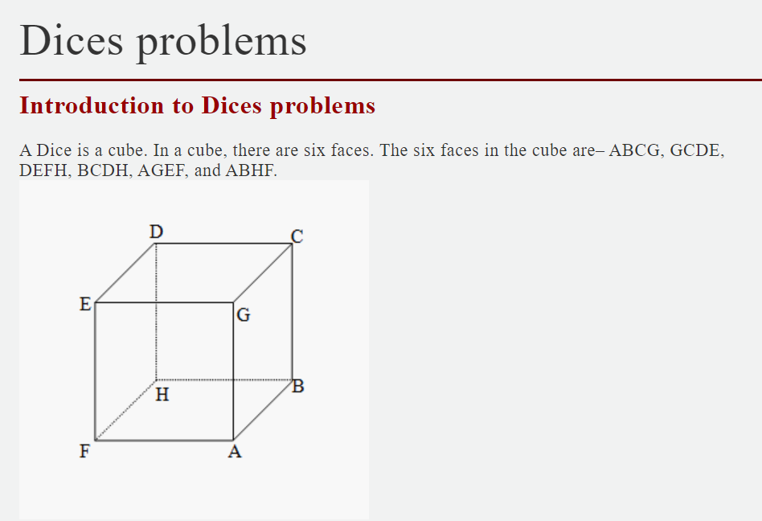

1. Four faces are adjacent to one face
2. There are pairs of opposing faces e.g. Opposite of DEFH is ABCG and so on.
3. CDEG is the upper face of the cube
4. ABHF is the bottom face of the cube.

**Important facts**

1. A cube has 6 square faces or sides
2. A cube has 8 points(vertices)
3. A cube has 12 edges
4. Only 3 sides of a cube are visible at a time and these sides can never be on the opposite side of each other
5. Things that are shaped like a cube are often referred to as cubic
6. Most dice are cube-shaped, with the numbers 1 to 6 on the different faces.

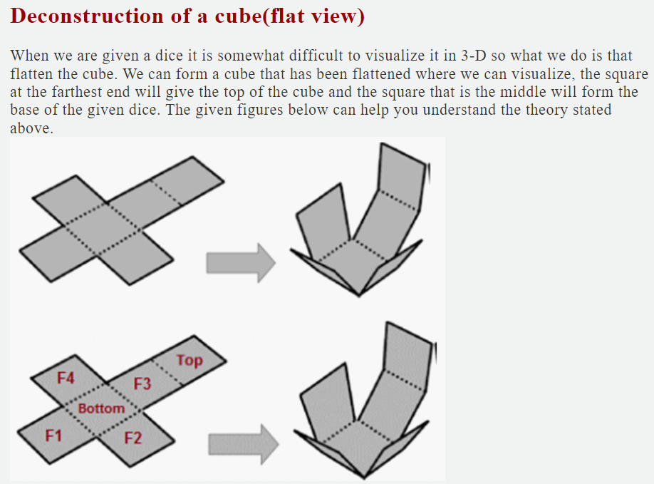

The rest of the square will give the adjacent sides of the dice. Note that we have to clearly visualize the adjacent sides and we have to figure out what exactly the question is asking. The flattening of dice is the easiest way that we can use to solve the dice problems.

**Example**: 1. Six faces of dice are marked with six numbers 1, 2, 3, 4, 5, and 6. This die is rolled three times and it shows three places:

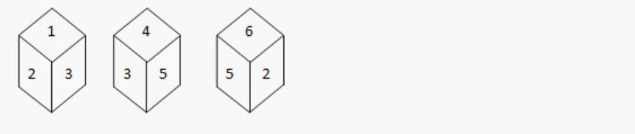

1. 2
2. 6
3. 5
4. 4

**Answer**: c) 5

**Solution**: 2 and 3 are adjacent to 1. So for the number opposite to 1, it should be the same. We observe from the second and third figures that 2 and 3 are adjacent to 5 . therefore the answer is 5.

**Example**: When the given figure is folded to form a cube then which face is opposite to the face with 2?

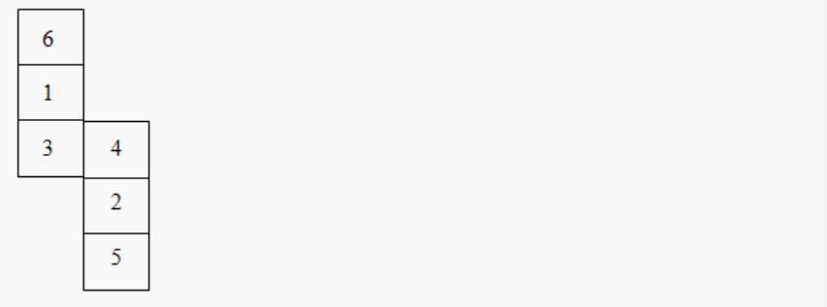

1. 2
2. 4
3. 1
4. 6

**Answer**: c) 1

**Solution**: Now, this is a peculiar type of flattened cube. However, the rules to solve the questions remain the same. Now, if you want to find the face that is opposite to the face with 2, you should consider it as the base. So, the top face (opposite face) will be the 1.

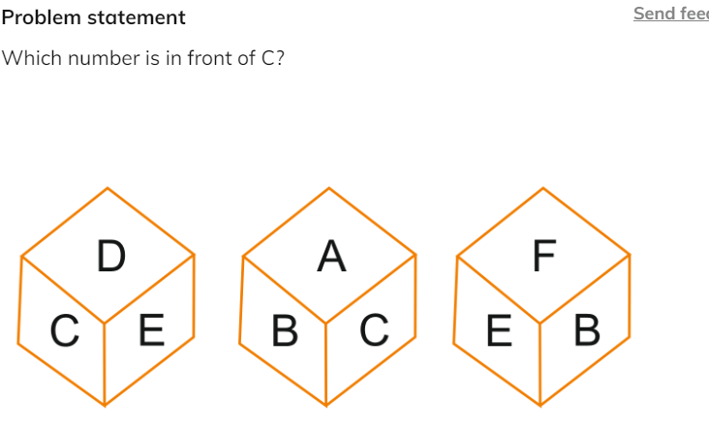

**Options:**Pick one correct answer from below

**B**

**F**

**D**

**E**

**Solution description**

From the second figure we found out that the answer could not be A, B, D, and E because they are adjacent to C. Therefore, the answer is f.

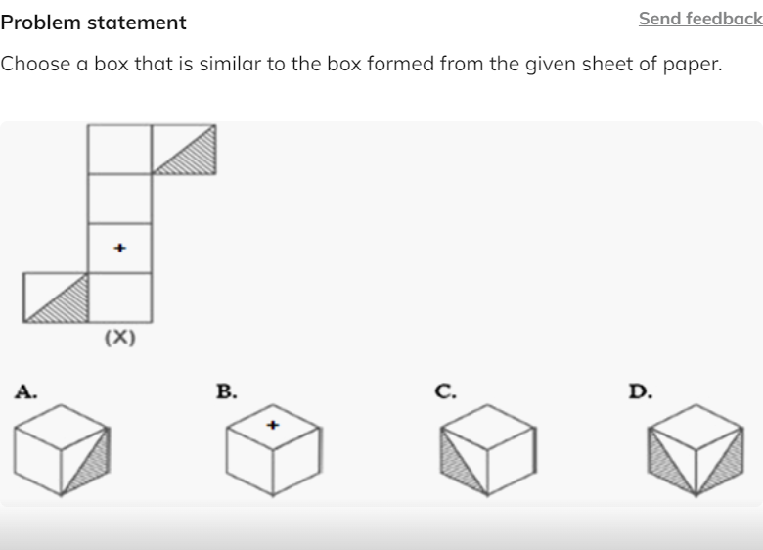

**Options:**Pick one correct answer from below

**B & D only**

**A & D only**

**A & C only**

**C & D only**

**Solution description**

Figure A: the sheet can be folded to form a hollow cube in this particular way only if you use the following configuration given in the figure. But A is possible. Figure B: if you take the face having + on the top, then the non-adjacent blank face will be on the bottom face of the hollow cube. Then, the two adjacent blank faces will form the faces adjacent to the face having + on it, but opposite to each other in this particular scenario. Since there are absolutely no other blank faces left, figure B is not possible in a given way. Figure D: From the figure given above in the diagram, we can clearly see that the two shaded faces can never be adjacent to each other in this case. So, this figure is not at all possible in any condition.

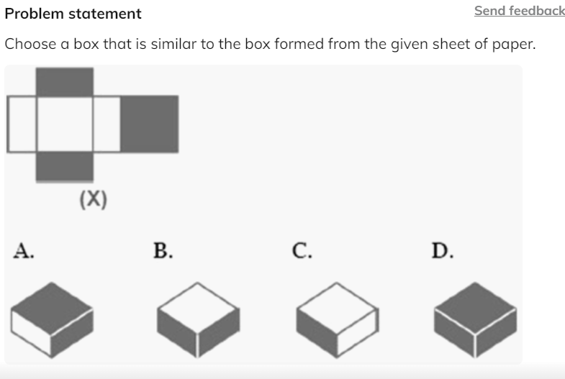

**Options:**Pick one correct answer from below

**A&C only**

**A&D only**

**B&C only**

**C&D only**

**Solution description**

Looking at the figure given, the two square sides will form the top and bottom faces of the cube. Also, the two rectangular blank strips will form opposite faces to each other. In figure B and figure D, the two filled rectangular faces have been shown adjacent to each other, so these figures are obviously not accurate. However, options A & C are completely possible.

Embedded images Problemsfooter line

**Introduction to Embedded images problems**

Embedded figures are the figures hidden inside another figure. In other words, a figure (x) is said to be embedded inside figure (y), if figure (y) contains figure (x) in it.

Embedded figure questions consist of a unique figure which is hidden or embedded in one of the four option figures. In such questions, all the options look the same and confusing. So candidates need to be careful while attempting such questions. Anyhow with practice, we can master these embedded figures. We must basically understand the structure of the given question figure and then proceed to find the correct answer figure.

The embedded Images test is to assess how quickly a candidate can recognize a figure that is hidden among other figures. In each question, there is a model figure and four answer figures. The candidate has to look for the model from the answer figures.

**Types of embedded image problems**

**Type 1: Complex answer figure**

A question figure (x) is given followed by four complex option figures in such a way that the question figure (x) is embedded in only one of the given four options. The candidate must identify the correct figure in which figure (x) is hidden.

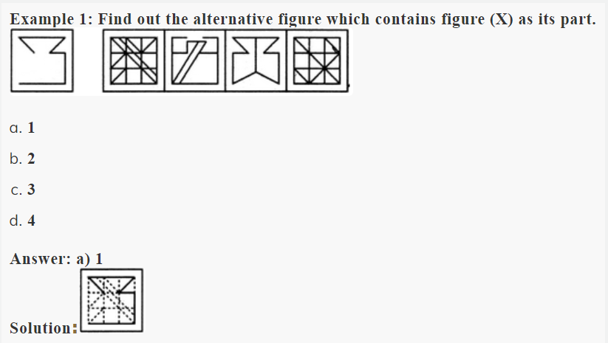

**Type 2: Complex question figure**

A complex question figure (x) is given followed by four option figures in such a way that only one of the option figures is embedded inside the given question figure. The candidate must identify the correct option figure which is hidden inside the question figure (x).

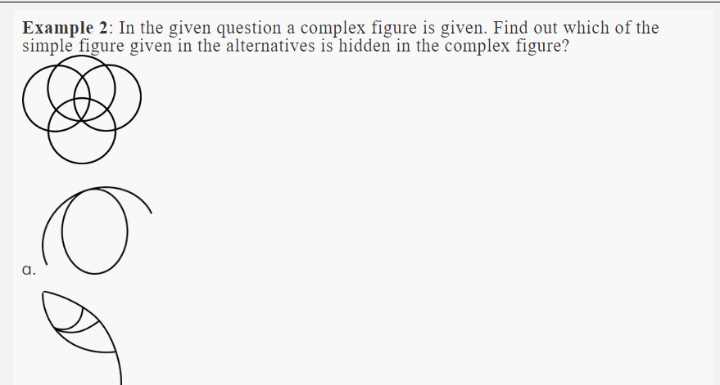

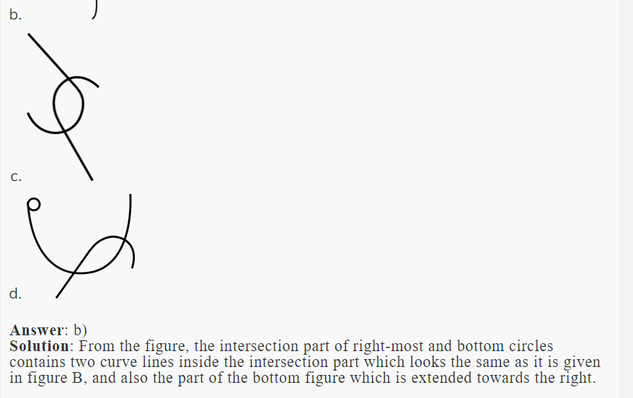

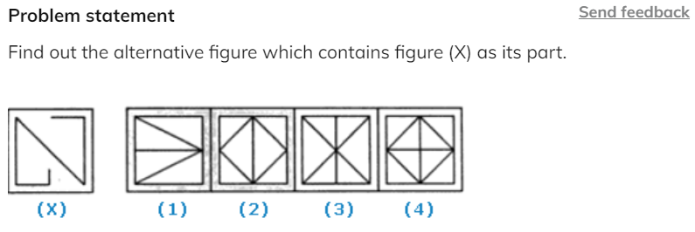

**Options:**Pick one correct answer from below

**1**

**2**

**3--**

**4**

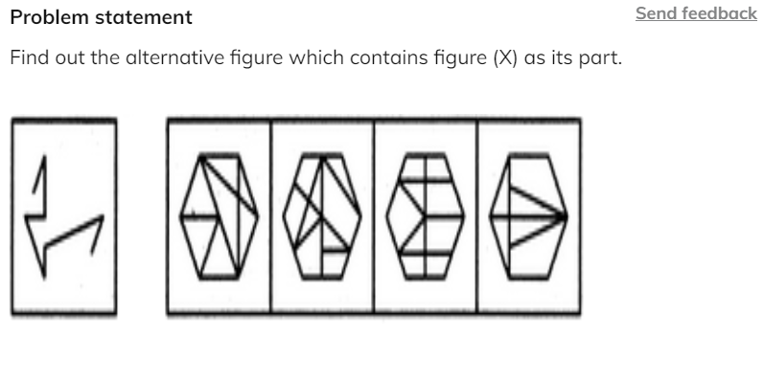

**Options:**Pick one correct answer from below

**1**

**2**

**3**

**4 --**

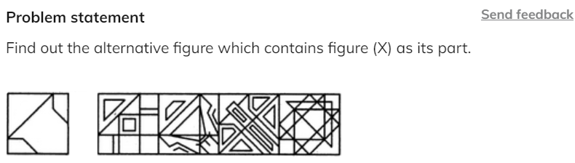

**Options:**Pick one correct answer from below

**1**

**2**

**3**

**4 --**

Figure matrixfooter line

**Introduction to Embedded images problems**

Figure Matrix questions contain a grouping of diagrams or figures in the shape of a rectangular matrix. This arrangement of diagrams in the form of a [matrix](https://www.toppr.com/guides/maths/matrices/matrix/) forms the Figure Matrix. Each diagram in the figure matrix is there as a result of some rule. You will have to figure out this rule and make necessary decisions using this knowledge.

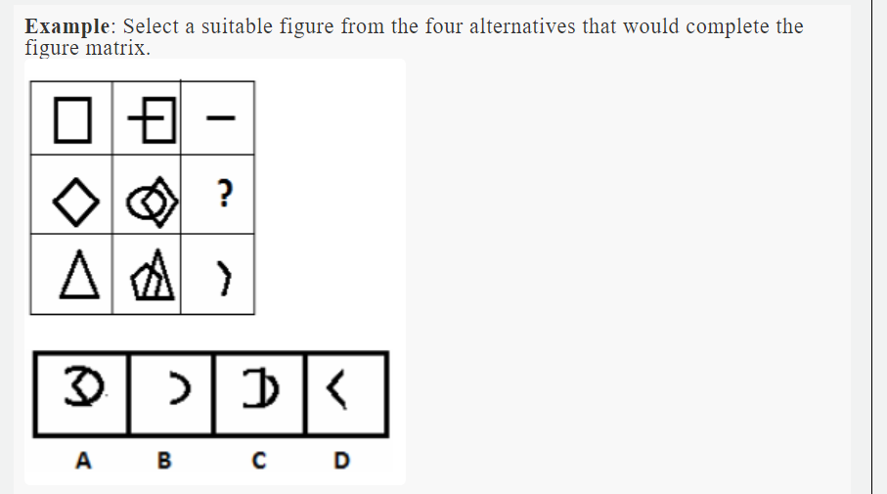

1. A
2. B
3. C
4. D

**Answer**: b) B

**Solution**: From the figure, we observe that the last column of the matrix contains the shape inside the second column image. Therefore, the missing figure will be a semicircle.

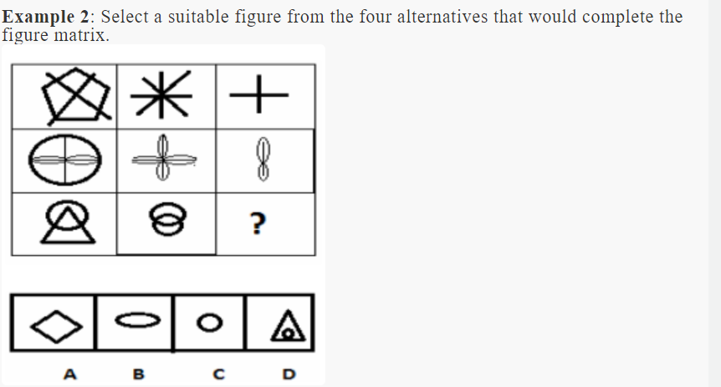

1. A
2. B
3. C
4. D

**Answer**: c) C

**Solution**: The third column contains the figure which is in the second column but not in first. Therefore, the missing figure will be a circle.

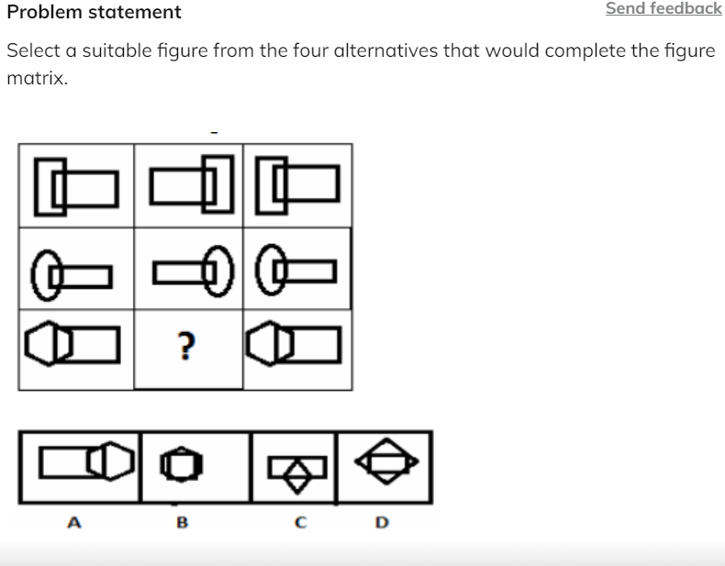

**Options:**Pick one correct answer from below

**A**

**B**

**C**

**D**

**Solution description**

The second column is the mirror image of the first column. Thus, the answer is A.

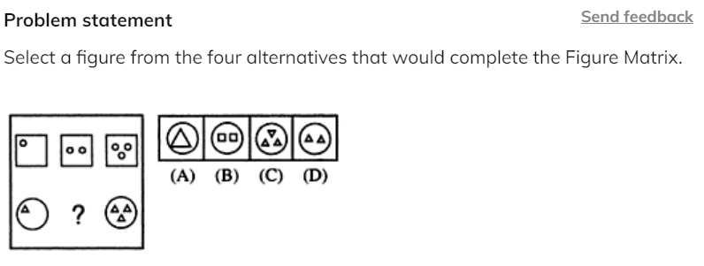

**Options:**Pick one correct answer from below

**A**

**B**

**C**

**D --**

**Solution description**

Similar small figures are increasing by one in each of the bigger figures

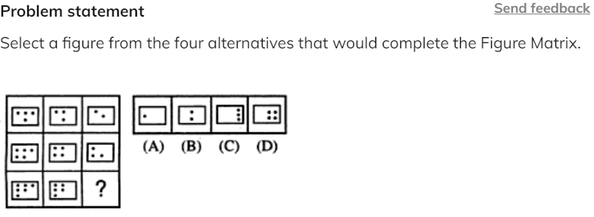**Options:**Pick one correct answer from below

**A**

**B**

**C**

**D --**

Input/output problemsfooter line

**Introduction to Embedded images problems**

In such a type of reasoning-based question, you are given a word and number arrangement. With each subsequent operation, the arrangement of the words and numbers changes following a particular pattern. These operations are performed until a final arrangement is reached or is performed in a loop. You are required to identify the hidden pattern in the rearrangement and apply it to the questions.

**Types of input-output problems**

**Ordering**

Either the words are arranged alphabetically (forward/ reversed) or numbers are arranged in ascending/ descending order. The arrangement is usually based on the first letter of every word. Sometimes it is based on the last letter of every word. Both words and numbers could be arranged individually or simultaneously in each step. The rearrangement can start from the left or right side of the sentence and sometimes even simultaneously from both ends. The rearrangement could either start with a word or a number etc.

Example: Input: Cat Rail Snow Moon Fear

Step 1: Snow Cat Rail Moon Fear

Step 2: Snow Rail Cat Moon Fear

Step 3: Snow Rail Moon Cat Fear

Step 4: Snow Rail Moon Fear Cat

This is the final arrangement and STEP IV is the last step for this input.

What will be the last step of the following input?

INPUT: Care Steel Brick Nap Bomb Cry

Solution: The given rearrangement has a pattern that can be followed from the input step to the final step, which is Step IV. Observe carefully. The rearrangement follows the following patterns:

The rearrangement is taking place from left to right.

The rearrangement is taking place one word at a time.

The rearrangement is done on the basis of descending alphabetical order based on the first letter of the word.

**Mathematical Operations**

Some mathematical operations (like squaring the number, adding the digits within the number, some common number added/subtracted/multiplied/divided to each number, etc.) are applied to the numbers in each step.

Example: Input : 26 34 56 78 63 99

Step 1: 20 34 56 78 63 90

Step 2: 20 30 56 78 60 90

Step 3: 20 30 50 70 60 90

Step III is the final step. Explain the operation.

Solution: In this example, the unit's digits of the left-most and right-most numbers are simultaneously being subtracted from the numbers themselves. This is followed by the number to the right of the left-most one, and to the left of the right-most one.

**Shifting or interchanging**

In this type the positions of characters/alphabets/words etc., in the input changes according to questions, following a particular pattern which repeats itself e.g. 'shift 1st character to last' or 'interchange 1st & last' etc.

Example: A computer rearranges a particular input using some operations 01, 02, 03, and 04.

Input: I am not coming home for dinner

Step 01: dinner not am coming home for I

Step 02: not dinner coming am home I for

Step 03: for coming dinner am home I not

Step 04: coming for am dinner home not IIf

Step 4 gives "I know you will not come back" what step will have "you back I come not will know"

Solution: Since the words remain unchanged here, so this is a case of either rearrangement or shifting. Let us number each word for our convenience.

I = 1, am = 2, not = 3, coming = 4, home = 5, for = 6, dinner = 7

Input: 1 2 3 4 5 6 7

Step 01: 7 3 2 4 5 6 1

Step 02: 3 7 4 2 5 1 6

Step 03: 6 4 7 2 5 1 3

Step 04: 4 6 2 7 5 3 1

So, the logic being followed is: -

Step 01 = Swap 1st & last; 2nd & 3rd

Step 02 = Swap 1st & 2nd, last two & 3rd and 4th

Step 03 = Swap 1st & last, 2nd & 3rd.

Step 04 = 1st & 2nd, last two, & 3rd and 4th.

Since after two steps, the operation is repeated, hence you can guess the 5th, 6th, 7thsteps.

**Problem statement**

Send feedback

Input: Chanakya Wind 23 43 56 Heir Beach 71  
How many steps will be required to complete the rearrangement?

**Options:**Pick one correct answer from below

**2**

**8**

**5**

**6--**

**Solution description**

The rearrangement follows the following pattern:  
Input: C W 23 43 56 H B 71  
Step 1: 71 C W 23 43 56 H B  
Step 2: 71 B C W 23 43 56 H  
Step 3: 71 B 56 C W 23 43 H  
Step 4: 71 B 56 C 43 W 23 H  
Step 5: 71 B 56 C 43 H W 23  
Step 6: 71 B 56 C 43 H 23 W  
Hence, there are six steps for this

**Problem statement**

A word and number arrangement machine when given an input line of words and numbers rearranges them by following a particular rule in each step. The following is an illustration of input and rearrangement.  
  
Input: british 32 71 greece firangi spanish 65 84  
Step I spanish british 32 71 greece firangi 65 84  
Step II spanish 84 british 32 71 greece firangi 65  
Step III spanish 84 greece british 32 71 firangi 65  
Step IV spanish 84 greece 71 british 32 firangi 65  
Step V spanish 84 greece 71 firangi british 32 65  
Step VI spanish 84 greece 71 firangi 65 british 32  
and Step VI is the last step of the rearrangement. As per the rules followed in the above steps, find out in the following question the appropriate step for the given input.

Step III of an input is: ‘yeast 92 umbrella 15 23 slate hanger 67’.  
How many more steps will be required to complete the rearrangement?

**Options:**Pick one correct answer from below

**1** **2** **3** **4 --**

**Solution description**

Step IV yeast 92 umbrella 67 15 23 slate hanger  
Step V yeast 92 umbrella 67 slate 15 23 hanger  
Step VI yeast 92 umbrella 67 slate 23 15 hanger  
Step VII yeast 92 umbrella 67 slate 23 hanger 15  
So, four more steps are required.

**Problem statement**

Directions:

A word and number arrangement machine when given an input line of words and numbers rearranges them by following a particular rule in each step. The following is an illustration of input and rearrangement.  
Input: british 32 71 greece firangi spanish 65 84  
Step I spanish british 32 71 greece firangi 65 84  
Step II spanish 84 british 32 71 greece firangi 65  
Step III spanish 84 greece british 32 71 firangi 65  
Step IV spanish 84 greece 71 british 32 firangi 65  
Step V spanish 84 greece 71 firangi british 32 65  
Step VI spanish 84 greece 71 firangi 65 british 32  
and Step VI is the last step of the rearrangement. As per the rules followed in the above steps, find out in the following question the appropriate step for the given input.

Input: ‘angry happy 49 24 fussy winky 34 69’.  
Which of the following steps will be the last but one?

**Options:**Pick one correct answer from below

**VI**

**VII**

**V**

**VIII**

**Solution description**

Input angry happy 49 24 fussy winky 34 69  
Step I winky angry happy 49 24 fussy 34 69  
Step II winky 69 angry happy 49 24 fussy 34  
Step III winky 69 happy angry 49 24 fussy 34  
Step IV winky 69 happy 49 angry 24 fussy 34  
Step V winky 69 happy 49 fussy angry 24 34  
Step VI winky 69 happy 49 fussy 34 angry 24  
So, Step V is the first step from last.

Odd one out problems

**Introduction to the odd one out problems**footer line

 In this, out of the given options, you have to choose, which one is different or odd one out, i.e. one which is not related to others. These problems are considered easier than the problems.

The idea is to solve it with the help of basic common sense

Example 1: 10, 25, 45, 54, 60, 75, 80

10

45

54

75

Answer: c)

Solution: Each of the numbers except 54 is a multiple of 5.

Example 2: In each of the following questions, four words have been given of which three are alike in some way and one is different. Choose the odd one out.

1. Dollar

2. Peso

3. Ounce

4. Euro

Answer: 3)

Solution: An ounce is a unit of weight

**Problem statement**

In the following question, four words are given out of which three are alike in some manner and one is different. Choose the odd one out.

**Options:**Pick one correct answer from below

**Faraday**

**Newton**

**Shashi Tharoor --**

**Edition**

**Solution description**

All except Shashi Tharoor were scientists, while Shashi Tharoor is a politician.

**Problem statement**

In the following question, four words have been given of which three are alike in some way and one is different. Choose the odd one out.

**Options:**Pick one correct answer from below

**Spoon**

**Sword**

**Knife**

**Fork**

**Solution description**

All except sword are used in kitchen

**Problem statement**

In the following question, four words have been given of which three are alike in some way and one is different. Choose the odd one out

396, 462, 572, 427, 671, 264

**Options:**Pick one correct answer from below

**396**

**427**

**671**

**264**

**Solution description**

In each number except 427, the middle digit is the sum of other two.

Picture series and sequencesfooter line

**Introduction to picture series and sequences**

This type of reasoning problem is based on a series of images, i.e. a question has five figures in a sequence; marked A, B, C, D, and E. These figures are called problem figures which depict a change step by step. The problem figures are followed by five answer figures; marked 1,2,3,4 and 5. You have to choose one figure out of five answer figures which will continue the series established by the problem figures.

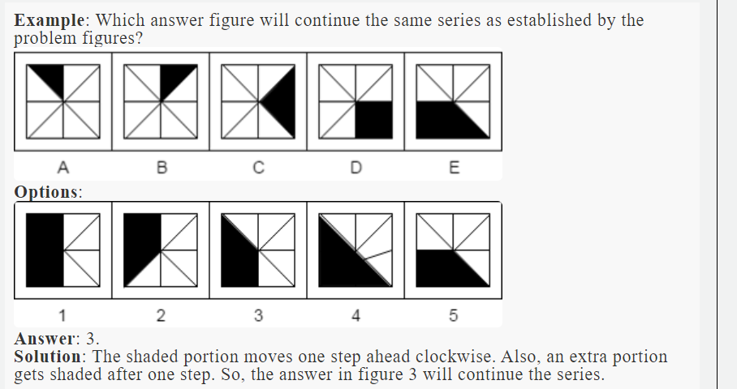

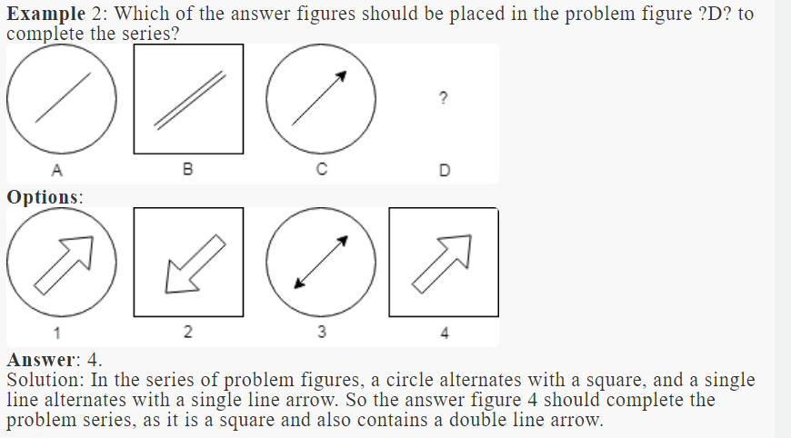

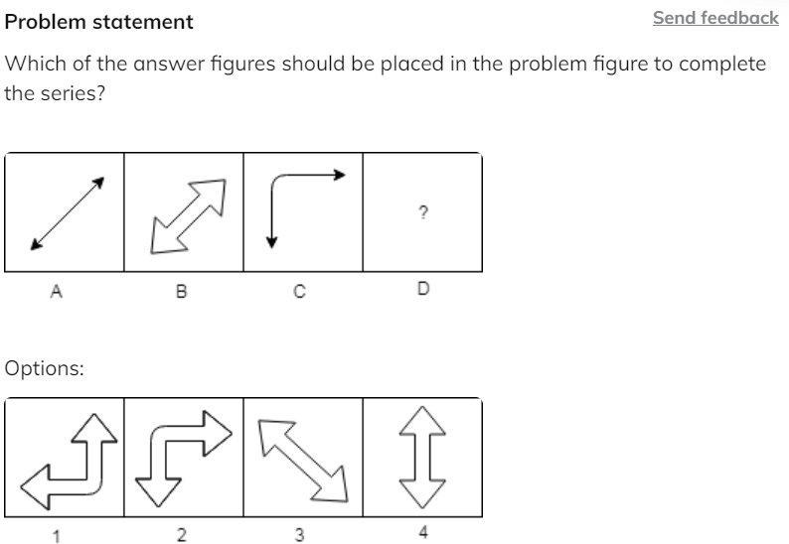

**Options:**Pick one correct answer from below

**1**

**2 --**

**3**

**4**

**Solution description**

In this series of problem figures, the alternate problem figure bends towards the left upper corner, so the second answer figure should complete the series as it is the only answer figure that bends in a similar way; towards the left upper corner.

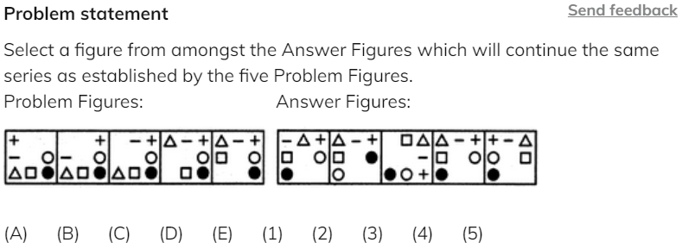

**Options:**Pick one correct answer from below

**1**

**2**

**3**

**4 --**

**5**

**Solution description**

In each step, the CW-end element moves to the ACW-end position.

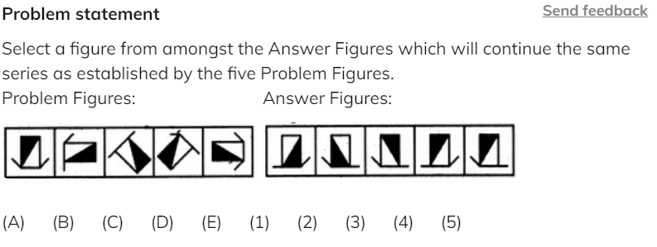**Options:**Pick one correct answer from below

**1** **2** **3--** **4** **5**

**Solution description**Similar figure reappears in every fourth step and each time a figure reappears, it rotates through 90oACW.

Paper folding

**Introduction to paper folding**footer line

In this section, a sheet of paper is folded in a given manner, and cuts are made on it. A cut may be of varying designs. We have to analyse how this sheet of paper will look when the paper is unfolded. Note that when a cut is made on folded paper, the designs of the cut will appear on each fold. In each of the following examples, figures A and B show a sequence of folding a square sheet. Figure C shows the manner in which folded paper has been cut. You have to select the appropriate figure from alternatives that would appear when the sheet is opened.

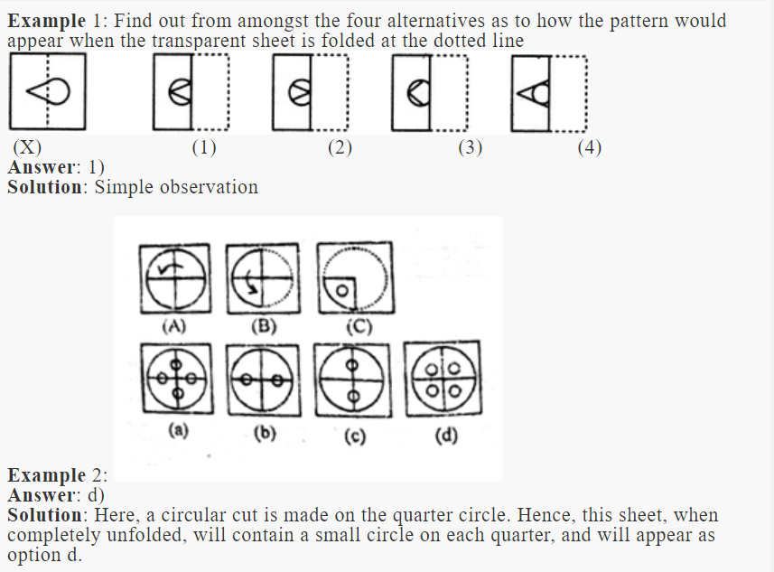

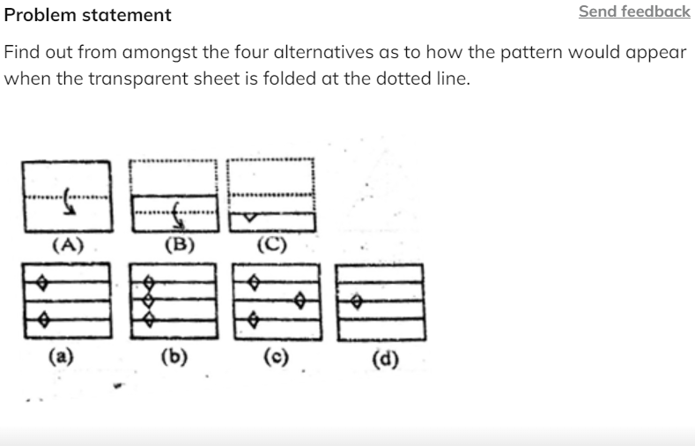

**Options:**Pick one correct answer from below

**A --**

**b**

**c**

**d**

**Solution description**

When sheet (c) is unfolded once, it will appear as option (a)

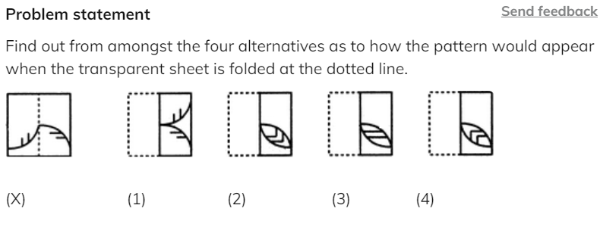

**Options:**Pick one correct answer from below

**1**

**2**

**3**

**4 --**

**Solution description**

simple observation

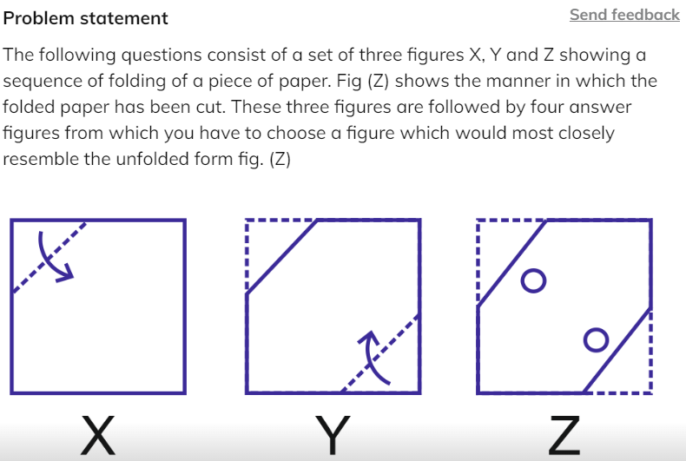

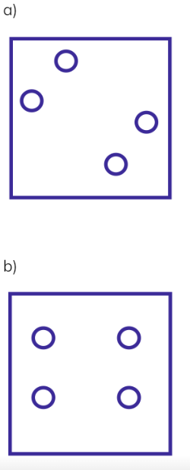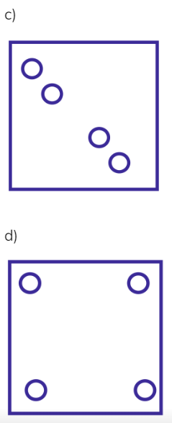

**Options:**Pick one correct answer from below

**A** **b** **c--** **d**

**Solution description**

The diagonal corners were folded and then 2 circles were cut out. So there must be 4 circles in a row. Hence the answer is option c.

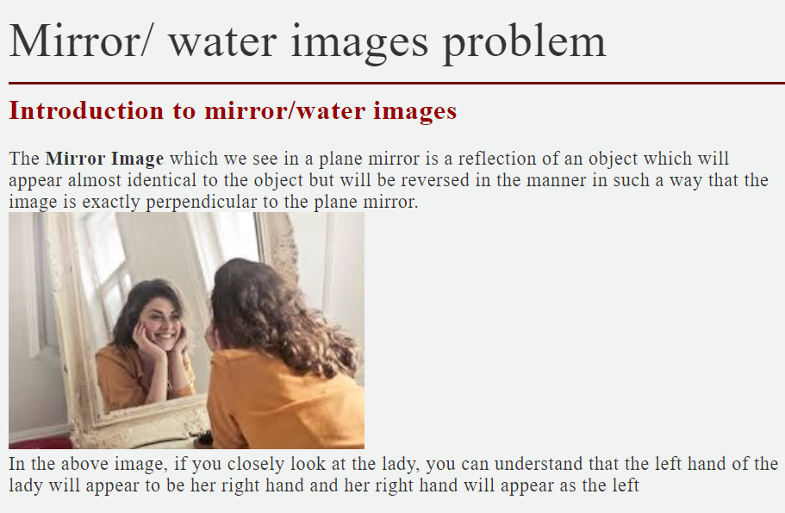

**Difference between a mirror image and a water image**

Water images in non-verbal reasoning are the same as the mirror images method. Basically, water image is just a reflection where the top and bottom part of the image changes where the left and right side of the image remains the same. In a mirror image, the left side and right side changes vice versa where the top and bottom remain the same.

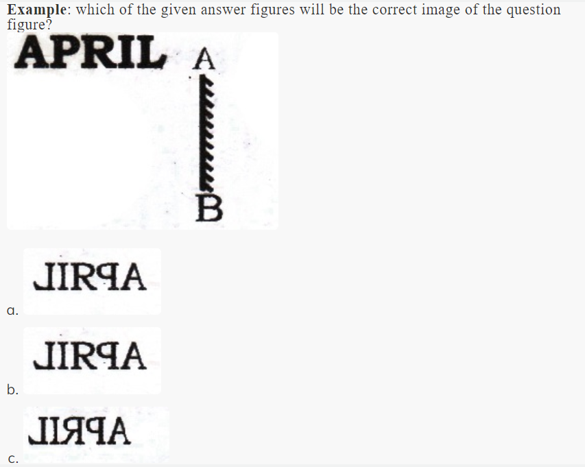

**Answer**: c)

**Solution**: Since the mirror is placed to the right of the word, we observe that option c can be the only answer.

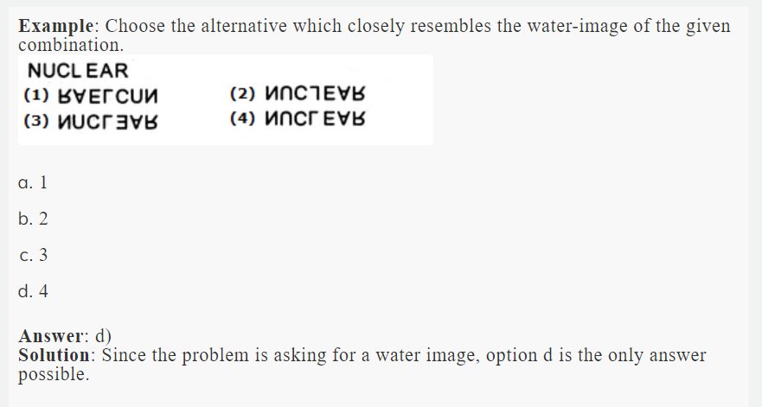

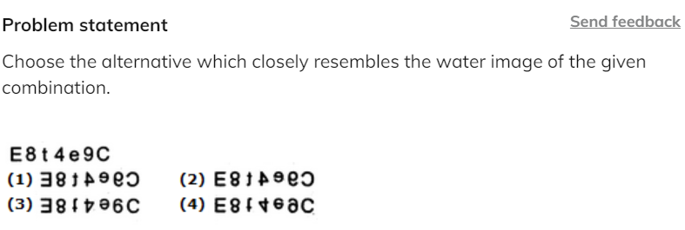

**Options:**Pick one correct answer from below

**1**

**2**

**3**

**4 --**

**Solution description**

Observation

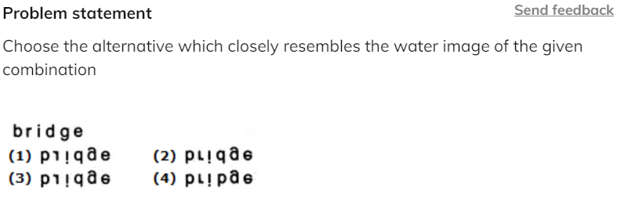

**Options:**Pick one correct answer from below

**1**

**2**

**3**

**4**

**Solution description**

Observation

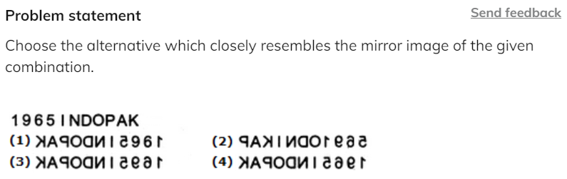

**Options:**Pick one correct answer from below

**1**

**2**

**3**

**4 --**

**Solution description**

Observation

Seating Arrangement footer line

**Introduction to Seating Arrangement**

The questions on seating arrangement are regular features of almost every competitive examination. In these questions, you have to arrange a group of persons fulfilling certain conditions. This is also written as sitting arrangement or sitting arrangement reasoning in some places.

**Types of Seating Arrangement**

1. **Linear Arrangement:** Here the arrangement of the persons is linear i.e. you have to arrange them in a line. Here generally a single row of arrangement is formed.

2. **Double row arrangement:** In these questions, there will be two groups of persons. You have to arrange one group in one row and the other group in other rows. The persons in these rows normally face each other.

3. **Circular arrangement:**In the circular seating arrangement questions, you have to arrange the persons around a circular table, etc. fulfilling certain conditions.

4. **Rectangular arrangement:** These arrangements are almost similar to the circular arrangements; the only difference is that the persons are sitting around a rectangular table.

**How to solve Seating Arrangement Problems**

Questions on seating arrangement are generally asked in blocks of 4 – 5 questions. You are given some information and then there will be 4 -5 questions based on the information. These questions have two types of information:

1. **Direct information:** This is the information that is clearly mentioned in the statement of the question. This is the information that you will use when you start solving the questions.

2**. Indirect information:** After filling in the direct information you will look for the connection between different parts of the information. These connections form indirect information.

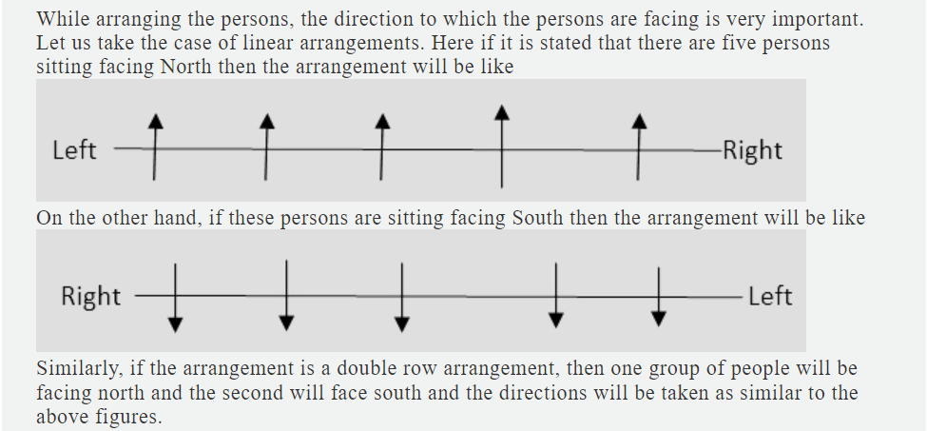

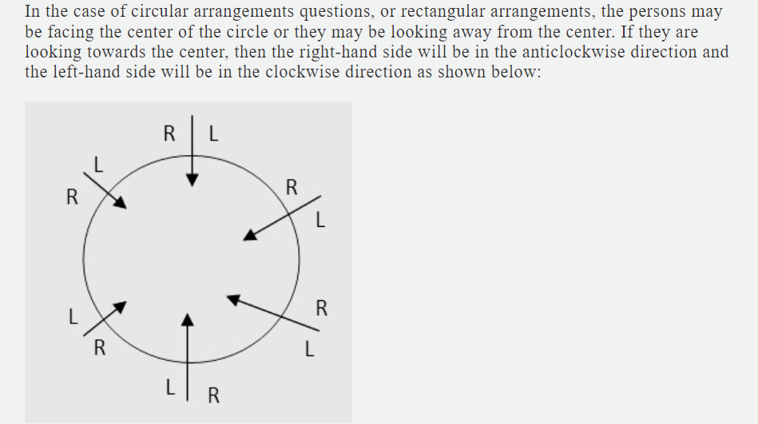

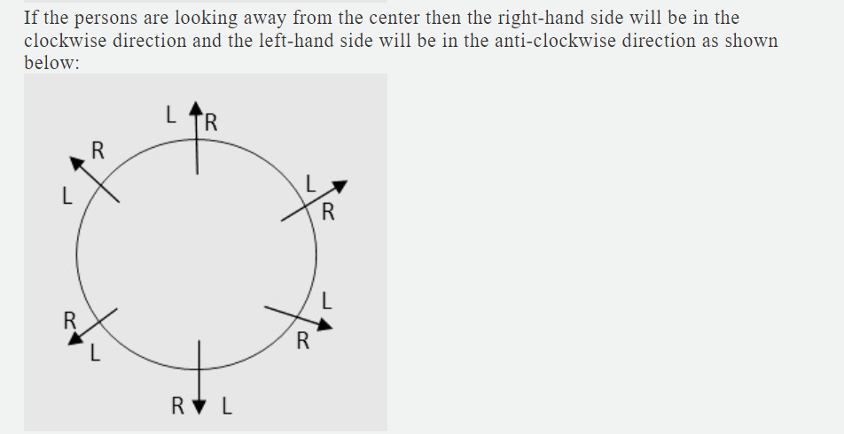

Next, while solving the questions related to linear arrangements or double row arrangements, the information regarding the position of the persons is very important. If it is written that A is sitting next to B, then it means that A and B are sitting together. B may be to the right or left of A. Further, if it is given that B is sitting to the right/left of A, then it does not mean that B is sitting immediately right/left of A. There may be some other persons sitting between A and B. If B is sitting immediate right/left of A then it will be mentioned in the statement of the question.

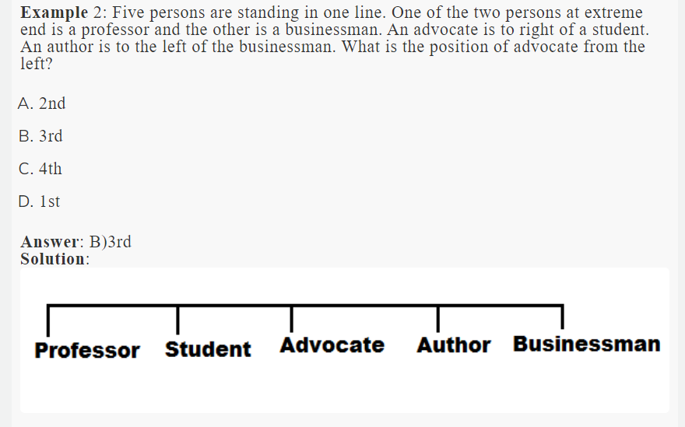

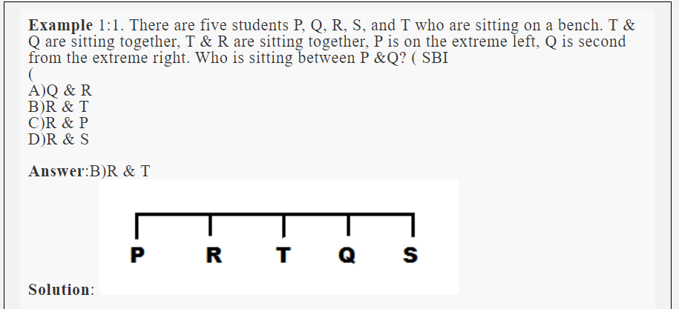

**Example:**Twelve persons were seated in two parallel rows containing six persons each, in such a way that there is an equal distance between adjacent persons. In row 1 – A, B, C, D, E, and F were seated and all of them are facing south and in row 2 – P, Q, R, S, T, and U were seated and all of them were facing north.**(IBPS 2018)**

**solution**

P was seated second from the end. One person was seated between P and the one who faces A. B was seated to the immediate right of A. C was seated third to the right of D.  Q faces the one who sits second to the left of B. One of the immediate neighbours of D faces S. T was seated second to the right of S. One person was seated between E and the one who faces U.

1. Who was seated second to the left of U?
2. S
3. P
4. Q
5. R
6. T

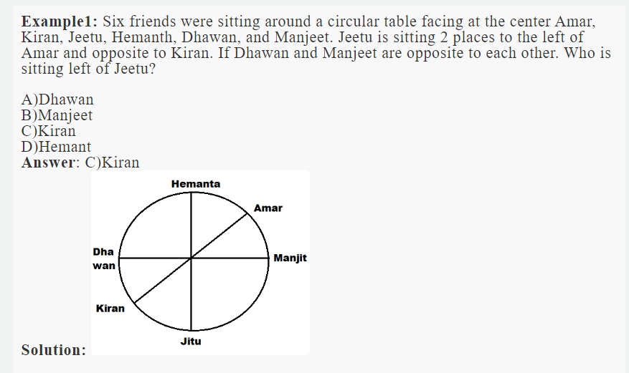

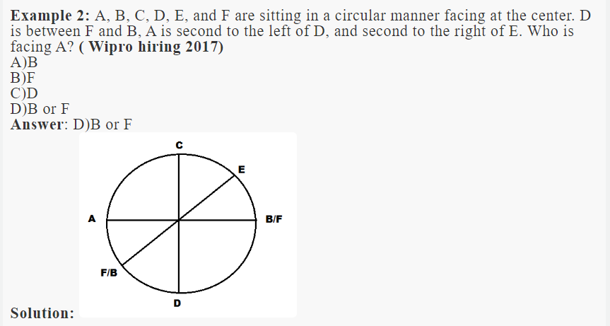

**Example**1: Study the following information and answer the questions given below.

There are eight people viz. D, E, R, N, P, T, V, and A sitting around a square table. They have a different profession viz. Engineer, Soldier, Teacher, Pilot, Artist, Doctor, Politician, and Player but not necessarily in the same order. Four of them sit on the middle of the four sides while four of them sit on the four corners of the square table. All persons who sit at the four corners are facing the center except one, while those who sit in the middle of the sides are facing outward the center except one. T is neither Politician nor a Pilot. E is immediately left to the Player. N is not facing towards the center. Soldiers and Engineers are the neighbors of the Doctor. D is a Teacher but not facing towards the center. The Politician is the neighbor of both E and Soldier. The doctor is not facing towards the center. R and A are facing each other but none of them is in the middle of the sides. The Player is facing towards the center but not sitting in the middle of any side of the table. E sits second to the right of P, who is a Soldier. Z is not the neighbor of either E or P and sits second to the right of N.V is between Artist and teacher. **( SBI 2016 )**

1. Who among the following is a Pilot?
2. T
3. N
4. R
5. Z

**Answer**: D) Z

    2. The profession of N is

1. Artist
2. Pilot
3. Doctor
4. Teacher

**Answer**: A) Artist

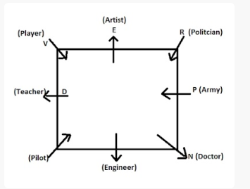

**Problem statement**

Send feedback

Direction:  
Study the following information and answer the questions given below.  
  
8 person E, F, G, H, I, J, K, and L are seated around a square table - two on each side. There are 3 ladies who are not seated next to each other. J is between L and F.G is between I and F. H, a lady member is second to the left of J.F, a male member is seated opposite to E, a lady member. There is a lady member between F and I.  
Who among the following is to the immediate left of F ? (CISCO)

**Options:**Pick one correct answer from below

**G**

**I**

**J--**

**H**

**Problem statement**

Send feedback

Direction:  
Study the following information and answer the questions given below.  
  
8 person E, F, G, H, I, J, K, and L are seated around a square table - two on each side. There are 3 ladies who are not seated next to each other. J is between L and F.G is between I and F. H, a lady member is second to the left of J.F, a male member is seated opposite to E, a lady member. There is a lady member between F and I.

What is true about J and K ? (CISCO)

**Options:**Pick one correct answer from below

**J is male, K is female**

**J is female, K is male**

**Both are female**

**Both are male --**

**Problem statement**

Send feedback

Direction :

Study the following information and answer the questions given below.

Eight people E, F, G, H, J, K, L and M are sitting around a circular table facing the centre. Each of them is of a different profession: Chartered Accountant, Columnist, Doctor, Engineer, Financial Analyst, Lawyer, Professor and Scientist but not necessarily in the same order. F is sitting second to the left of K. The Scientist is an immediate neighbour of K. There are only three people between the Scientist and E. Only one person sits between the Engineer and E. The Columnist is to the immediate right of the Engineer. M is second to the right of K. H is the Scientist. G and J are immediate neighbours of each other. Neither G nor J is an Engineer. The Financial Analyst is to the immediate left of F. The Lawyer is second to the right of the Columnist. The Professor is an immediate neighbour of the Engineer. G is second to the right of the Chartered Accountant.

Which of the following statements is true according to the given arrangement?(AWS 2016)

**Options:**Pick one correct answer from below

**The Lawyer is second to the left of the Doctor**

**E is an immediate neighbour of the Financial Analyst**

**H sits exactly between F and the Financial Analyst**

**Only four people sit between the Columnist and F**

**Problem statement**

Send feedback

Direction:

Study the following information and answer the questions given below. Eight people E, F, G, H, J, K, L and M are sitting around a circular table facing the centre. Each of them is of a different profession: Chartered Accountant, Columnist, Doctor, Engineer, Financial Analyst, Lawyer, Professor and Scientist but not necessarily in the same order. F is sitting second to the left of K. The Scientist is an immediate neighbour of K. There are only three people between the Scientist and E. Only one person sits between the Engineer and E. The Columnist is to the immediate right of the Engineer. M is second to the right of K. H is the Scientist. G and J are immediate neighbours of each other. Neither G nor J is an Engineer. The Financial Analyst is to the immediate left of F. The Lawyer is second to the right of the Columnist. The Professor is an immediate neighbour of the Engineer. G is second to the right of the Chartered Accountant.

What is the position of L with respect to the Scientist ? (AWS 2016)

**Options:**Pick one correct answer from below

**Third to the left**

**Second to the right --**

**Second to the left**

**Third to the right**

**Problem statement**

Send feedback

Direction:

Eleven friends M, N, O, P, Q, R, S, T, U, V and W are sitting in the first row of the stadium watching a cricket match. T is to the immediate left of P and third to the right of U. V is the immediate neighbour of M and N and third to the left of S. M is the second to the right of Q, who is at one of the ends. R is sitting next to the right of P and P is second to the right of O.

Who is sitting in the center of the row?( GATE 2018)

**Options:**Pick one correct answer from below

**N**

**O**

**S**

**U**

**Solution description**

The arrangement of the persons is Q W M V N U S O T P R U is sitting in the center of the row.

**Problem statement**

Send feedback

Direction:

Eleven friends M, N, O, P, Q, R, S, T, U, V and W are sitting in the first row of the stadium watching a cricket match. T is to the immediate left of P and third to the right of U. V is the immediate neighbour of M and N and third to the left of S. M is the second to the right of Q, who is at one of the ends. R is sitting next to the right of P and P is second to the right of O.

Which of the following people are sitting to the right of S? (GATE 2018)

**Options:**Pick one correct answer from below

**OTPQ**

**OTPR--**

**UNVM**

**UOTPR**

**Solution description**

The arrangement of the persons is Q W M V N U S O T P R OTPR are sitting to the right of S.

Ordering and ranking

**Introduction to ordering and ranking**footer line

In Ordering and Ranking questions, the rank or position of a person from right/left, top or bottom of a class, or a row is determined. Also, a position or rank of the total number of people is to be calculated. Also, you may be asked to calculate the floor on which a person lives from the data given.

**Points to remember while solving problems**

1.The total number of a person/objects in a group or class is equal to one less than the sum of the positions of the same person from both the ends (either right and left or top and bottom). Since the same person is counted twice in the sum, the final answer is one less than the total sum.

Total number of objects/persons = [(sum of positions of the same person/object from both sides) – 1]

Example: In a row of persons, the position of Saket from the left side of the row is 27th, and the position of Saket from the right side of the row is 34th. Find the total number of students in the row? ( IBPS PO 2019)

60

61

62

59

Answer: a) 60

Solution: Total number of students

= (Position of Saket from left + Position of Saket from right) -1

Total number of students = (27 + 34) – 1 = 61 – 1 = 60.

Hence the correct answer is option A.

2. The total number of persons/objects in a group is the sum of before or after the given person in a row and the position of the same person from the other side.

Total no. of persons/objects = No. of persons/objects before or after the given person in a row + Position of the same person from the other side.

Example: In a row of persons, the position of Aparna Nair from the left side of the row is 27th and there are 5 persons after her in the row. Find the total no. of persons in the row?

Solution: No. of persons in the row = Position of Aparna from left + No. of persons after Aparna

⇒ Total no. of persons = 27 + 5 = 32

3. If the positions of two objects/persons are given from the opposite ends and also the total number of persons/objects, then the problem can be addressed in two different ways to determine the number of persons between these two persons/objects.

**Case 1:  Overlapping**

   The total number of objects or persons in a group is always lesser than the addition of the position of two objects or persons from ends.

Example: The number of objects between two different persons = Total number of books – (Sum of positions of two different persons from opposite sides)

There are 24 students in the dance class, and the teacher is planning for an arrangement of students on stage. Samantha is 9th from the left side of the row and Supreetha is 22nd from the right side of the row. Find the number of dancers standing between the sisters Sampratha and Supreetha? ( Asked in bank exams)

4

5

6

7

Answer:b) 5

Solution:Adding the position of Sampratha and Supreetha we get:

= 9 + 22 = 31

The result ‘31’ is greater than the total number of students in a dance class.

Therefore the number of dancers standing between the sisters will be = [(Position of Sampratha from left + Position of Supreetha from right) – Total number of dancers – 2]

The number of dancers between Sampratha and Supreetha

= (9+22) – 24 – 2 = 31 – 24 – 2 = 5.

Hence the correct answer is option B.

**Case 2: Non-Overlapping**

The total number of objects or persons in a group is always greater than the addition of the position of two objects or persons from ends.

Example: There are 64 history books arranged in a row at central library Bangalore. Ancient history is 25th from the left side of the row and Medieval history is 30th from the right side of the row. What is the total number of books between Ancient and Medieval history?

6

7

8

9

Answer: d) 9

Solution: Adding the position of ancient and medieval history books, we get:

Ancient history Medieval history = 25 + 30 = 55

Hence the number ‘55’ should be less than the total number of books.

∴ The number of books between ancient and medieval history = Total number of books – (Place value of Ancient history book from left + Place value of Medieval history from right)

The number of books between ancient and medieval history = 64 – (25+30) = 64 – 55 = 9

Hence the correct is option D.

4. If the data in the question provides only information of position of different objects or persons then it is impossible to find the total number of objects or people in a group or class. As the cases can either be overlapping or non-overlapping. In such a situation, the final answer will always be found. Save time by not trying to solve these types of questions.

Example: Deepavali or Diwali a festival lights in India. One can find the row of lamps in every house these days. Chaitra lights a row of the lamp in her home. A square-shaped lamp is at 18th from left, and a circular-shaped lamp is at 25th position in a row from right. Find the total number of lamps Chaitra had lit?( Infosys 2019)

27

30

43

Can’t be determined

Answer: d) Can’t be determined

Solution: The scenario can be either be of Overlapping or non-overlapping one. Hence the correct answer is option D.

5. Swapping of position to find the order/ ranking

In this section, the placement or the position of the two objects/persons are interchanged. The position of the two people or objects is examined before and after the interchanged.

The place value or the position of the second person from the same side as before interchanging

= Position of 2nd person from the same side before interchanging + (Position of 1st person after interchanging – position of 1st person before interchanging from the same side)

Example: Soldiers Punita and Mitali and are standing in a row of female soldiers. Punita is 18th from the left side of the row, and Mitali is 24th from the right side of the row. If they interchange their positions, Punita becomes 31st from left. Find:

The new position of Mitali from the right side

The total number of female soldiers in a row

Number of soldier between Punita and Mitali

Solution 1: The new position of Mithali from right side = Position of Mithali from the right side before interchanging + (Position of Punita from the left side after interchanging – Position of Punita from the left side before interchanging)

New position of Mithali from right side = 24 + (31 – 18) = 24 + 13 = 37

The new position of Mithali is 37th.

Solution 2: Total no. of persons = (B’s position from right after interchanging + A’s the position from left before interchanging) – 1

The Total number of female soldiers = (Mithali’s position from right before interchanging + Punita’s position from left before interchanging) – 1

= 37+18 -1 = 54.

Solution 3: To find the total number of people between any two persons.

No. of persons between A & B = (Position of A from left after interchanging– Position of A from left before interchanging) – 1

The total numbers of soldiers between Punita & Mithali = (Position of Punita from left after interchanging– Position of Punita from left before interchanging) – 1

= (31 – 18) – 1 = 13 – 1 = 12

6. If the positions of two objects from opposite sides of the row are known there is a third object right in the middle of the two, then the total number of objects can be evaluated based on the position of the third object.

Example: There is a pride of lions and their cubs in a row, the position of eldest lioness from the left side of the row is 9th & position of youngest lioness from the right side of the row is 8th. If the newborn cub is sitting just in the middle of eldest & youngest and position of cub from the left side of the row is 15th. Find the total number of lions in the row ? (Asked in Google)

Solution: The position of a cub from left is 15th, and the eldest lioness from left is 9th so there are 15 – 9 – 1 = 5 lions are sitting between eldest and youngest lioness. As the cub is sitting in the middle of the eldest and youngest lioness so there must also be 5 persons sitting between the youngest lioness and a cub.

Thus the position of a cub from right =

Position of youngest from right + 5 + 1 == 8 + 6 = 14

Total number of lions = (Sum of positions of cubs from both sides – 1)

= (15 + 14) – 1 = 29 – 1 = 28

**Problem statement**

Send feedback

The positions of how many digits in the number 2451479638 will remain the same when the first half and the second half of the digits are arranged in ascending order separately?

**Options:**Pick one correct answer from below

**1**

**2**

**3**

**None --**

**Solution description**

The given number: 2 4 5 1 4 7 9 6 3 8 After arranging the first half and the second half of the digits of a given number in ascending order, we get a new number as 1 2 4 4 5 3 6 7 8 9 Now, 2 4 5 1 4 7 9 6 3 8  
1 2 4 4 5 3 6 7 8 9 Comparing both the numbers, we can say that there is no number whose position remains unchanged. Hence, the correct answer is option C.

**Problem statement**

Send feedback

In a row where all are facing north, Priya is 15th from the left end and Garima is 19th from the right end. They interchange their positions, and Ram who sits 24th from the left end sits at the 5th place to the left of Priya's new position. How many persons were there in the row? ( Sapient 2019)

**Options:**Pick one correct answer from below

**32**

**42**

**47**

**54**

**Solution description**

Using the given information we can create the following figure: ![alt text]( https://ninjasfiles.s3.amazonaws.com/asset_0000000000000381_1617788656_img-1.png ) Here the total number of persons in the queue = (*29 + 19 - 1) = 47

**Problem statement**

Send feedback

In a north-facing row of NCC Cadets, Trisha is 9th from the left end and Tina is 12th from the right end. There are 5 cadets between Trisha and Tanya who are equidistant to Tina. Find how many cadets are there in the row? ( Goldman Sachs campus hiring drive)

**Options:**Pick one correct answer from below

**34**

**32**

**24**

**52**

**Solution description**

![alt text]( https://ninjasfiles.s3.amazonaws.com/asset_0000000000000383_1617789098_img-3.png ) Adding all the persons in the above image, we get: 8 + 1(Trisha) + 5 + 1(Tanya) + 5 + 1(Tina) + 11 = 32 Thus there are 32 cadets in the row.

**Problem statement**

Send feedback

.In a queue of students facing north, Ayesha and Anisha are standing at the 10th and 8th position from the left and right end respectively. If another student Ariva who is 12th from the left end is exactly in between Ayesha and Anisha then find the position of Ayesha from the right end?

**Options:**Pick one correct answer from below

**14th**

**12th**

**8th**

**7th**

**Solution description**

From the given image it is clear that Ayesha is 12th from the right end. ![alt text]( https://ninjasfiles.s3.amazonaws.com/asset_0000000000000384_1617789257_img-4.png ) Position of Ayesha from right end = 7 + 1(Anisha) + 1 + 1(Ariva) +1 + 1 = 12 Hence option B is the correct answer.

**Problem statement**

Send feedback

During a prize distribution ceremony, Vikram was ninth from the left while Janhvi was eighth from the right in the front row. If Hariom was thirteenth from the left and was exactly in the middle of Vikram and Janhvi in the same row then what was the total number of people in the front row?

**Options:**Pick one correct answer from below

**56**

**44**

**24**

**34**

**Solution description**

Here, we know that Vikram was ninth from the left while Hariom was thirteenth from the left. So, we can say that there were 3 persons between Vikram and Hariom. And, we also know that Hariom was exactly in the middle of Vikram and Janhvi so the number of persons between Hariom and Janhvi will also be 3. At this point, using the given information we can create the following figure: ![alt text]( https://ninjasfiles.s3.amazonaws.com/asset_0000000000000382_1617788882_img2.jpg ) Now, total number of people in the queue = (8 + Vikram + 3 + Hariom + 3 + Janhvi + 7) = (8 + 1 + 3 + 1 + 3 + 1 + 7) = 24 Thus, the total number of people in the queue was 24.

Shape Constructionfooter line

**Introduction to Shape Construction**

In this type of reasoning problem, you have to construct the shape by joining three pieces out of the five pieces given in the question.

**Types of shape construction problems**

1. **Polygon forming**

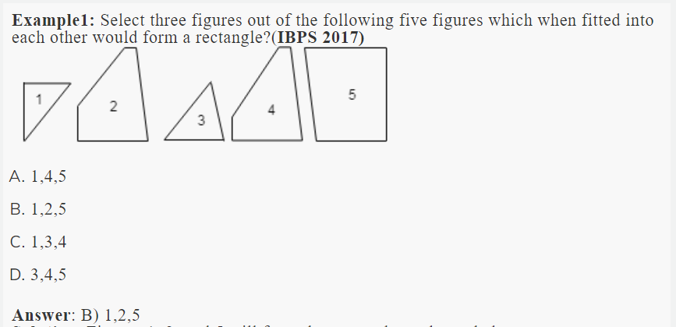

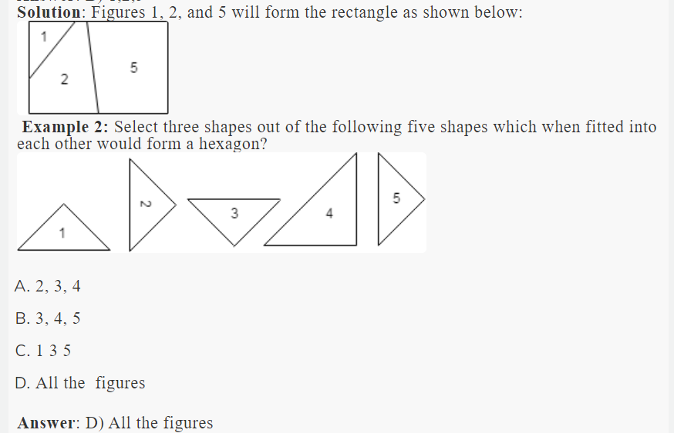

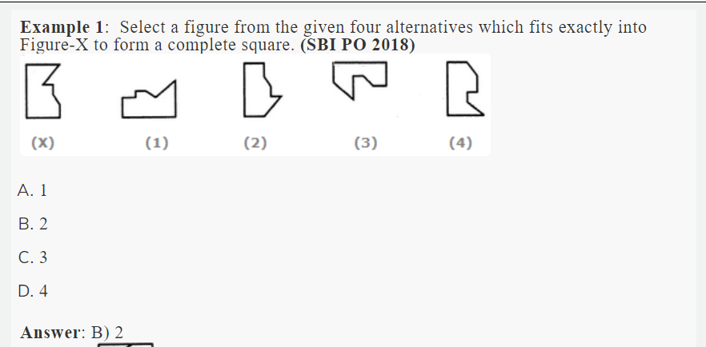

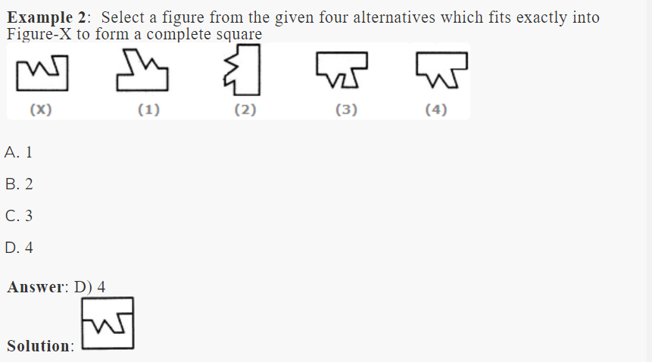

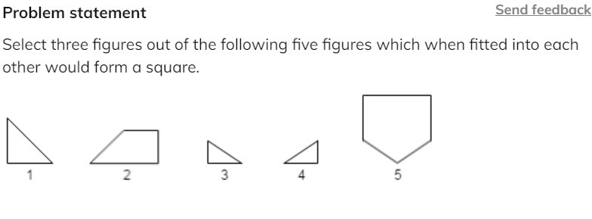

**Options:**Pick one correct answer from below

**1,5,3**

**2,3,4**

**1,2,3**

**3,4,5 --**

**Solution description**

Figures 3, 4, and 5 will form the square as shown in the following image; ![alt text]( https://ninjasfiles.s3.amazonaws.com/asset_0000000000000386_1617789766_sc_q1sol.png )

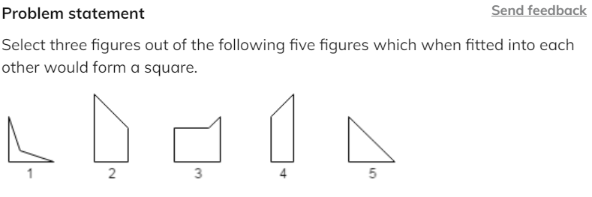

**Options:**Pick one correct answer from below

**1, 2, 4**

**1, 4, 5**

**2, 3, 4 --**

**1, 2, 5**

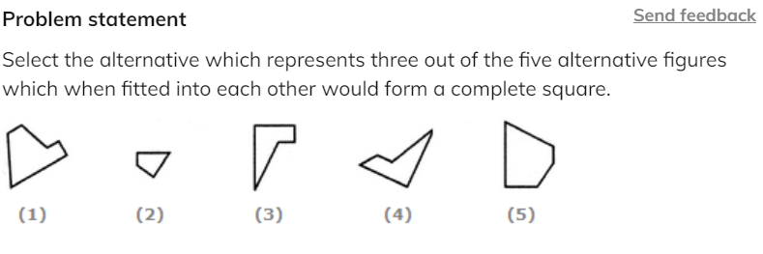

**Options:**Pick one correct answer from below

**1, 2, 3**

**4, 3, 5**

**2, 4, 5 --**

**2, 3, 4**

**Solution description**

![alt text](https://ninjasfiles.s3.amazonaws.com/asset_0000000000000389_1617789809_sc_q3sol.png)

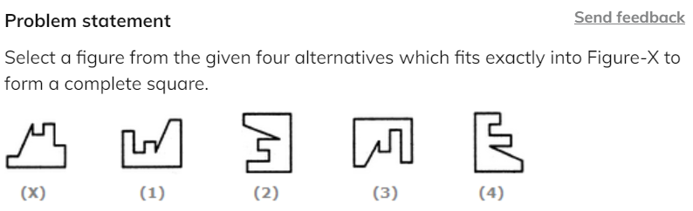

**Options:**Pick one correct answer from below

**1--**

**2**

**3**

**4**

Statement and Assumptionfooter line

**Introduction to Statement and Assumption**

In a statement and assumption question, a statement is given in the question followed by a few assumptions made on the basis of them. Candidates need to pick the assumption which most appropriate and logically is correct.

**Understanding the terms**

The first step to solve questions based on Statement, Assumption is to acquaint yourself with terms associated with such questions.

**Statement**Anything one says is a statement. But, in logic, a statement is either a meaningful declarative sentence that is either true or false or that which a true or false declarative sentence asserts. There may be several ways of framing the same statement. For instance, ‘It is desirable to put a child in school around 3 or so.’

**Assumption**An assumption is an unstated premise that we take for valid or granted or that supports the conclusion. The assumption is stated implicitly and needs to be identified. For example, in the above statement, that ‘ it is desirable to put a child in school around 3 or so’, the assumption is that ‘At that age, the child reaches appropriate level of growth and development and is ready to learn.’

**How to solve Statement and assumption problems**

Given below is a list of tips to solve the statement and assumption questions:

* Read the statement with an approach that the assumptions would be true with regard to the statement
* Do not go too logical with the statements. Analyze the information given and the assumption must only be made based on the information in the statement. Do not overcomplicate it
* Common assumptions can always be followed but other than that do not align the statement with General Knowledge or other facts
* Use the elimination method if you are unable to apprehend the answer. Read the statement and then the assumptions given in the options, you shall notice that a few of them will most definitely not follow. Eliminate them and then choosing from lesser options may prove to be more convenient
* One thing to make a note of is that the assumption is something that the Author believes to be true so while choosing the correct option, keep this thought in mind as well. If any option contradicts the statement, then that assumption will not follow

Example 1: Statement: Food poisoning due to the consumption of liquor is very common in rural areas

Assumption I: There are more illegal and unauthorised shops selling liquor in villages and rural areas

Assumption II: The ratio of people drinking liquor in villages is much more than that in towns

Both assumptions I and II follow

Neither assumption I nor II follows

Only assumption I follows

Assumptions II follows but assumptionI does not follow

Either assumption I or assumption II follows

Answer: Only assumption I follows

Solution:The statement is talking about food poisoning due to liquor so the number of people consuming liquor in towns or villages is not the main concern here. Which is why the only assumption I follow

Example 2: Statement: In an election conducted in Village X, only 20% of the total number of women in the village came to vote.

Assumption I: The number of men in the village is more than the number of women in the village X

Assumption II: Women had to cook food and could not come to vote

1.Both assumptions I and II follow

2.Neither assumption I nor II follows

3.Only assumption I follow

4.Only assumption II follows

5. Either assumption I or assumption II follows

Answer: Neither assumption I nor II follows

Solution:The statement clearly indicates that out of the total number of women in the village only 20% came around to vote so the ratio between the number of men and women is not applicable here and the second assumption is not applicable as well.

Example 3: Statement: "You are hereby appointed as a programmer with a probation period of one year and your performance will be reviewed at the end of the period for confirmation." - A line in an appointment letter.

Assumption 1: The performance of an individual generally is not known at the time of appointment offer.

Assumption 2: Generally an individual tries to prove his worth in the probation period.

Only assumption I is implicit

Only assumption II is implicit

Either I or II is implicit

Neither I nor II is implicit

Both I and II are implicit

Answer: 5. Both I and II are implicit

Solution: The performance of the individual has to be tested over a span of time as the statement mentions. So, I is implicit. The statement mentions that the individual's worth shall be reviewed (during the probation period) before confirmation. So, II is also implicit.

**Problem statement**

Send feedback

Statement: "In order to bring punctuality in our office, we must provide conveyance allowance to our employees." - In charge of a company tells Personnel Manager.  
  
Assumption 1: Conveyance allowance will not help in bringing punctuality.  
Assumption 2: Discipline and reward should always go hand in hand.  
(asked in Ericsson hiring 2020)

**Options:**Pick one correct answer from below

**Only assumption I is implicit**

**Only assumption II is implicit**

**Either I or II is implicit**

**Neither I nor II is implicit**

**Both I and II are implicit**

**Solution description**

Assumption I goes against the statement. So, it is not implicit. The allowance will serve as a reward to the employees and shall provoke them to come on time. So, II is implicit.

**Problem statement**

Send feedback

Statement: "If you trouble me, I will slap you." - A mother warns her child.

Assumption 1: With the warning, the child may stop troubling her.

Assumption 2: All children are basically naughty.

**Options:**Pick one correct answer from below

**Only assumption I is implicit**

**Only assumption II is implicit**

**Either I or II is implicit**

**Neither I nor II is implicit**

**Both I and II are implicit**

**Solution description**

The mother warns her child with the expectation that he would stop troubling her. So, I is implicit. The general nature of children cannot be derived from the statement. So, II is not implicit.

**Problem statement**

Send feedback

Statement: Because of the large number of potholes in road X, reaching airport in time has become difficult.

Assumption 1:Reaching airport in time may not be always necessary.  
Assumption 2: There is no other convenient road to the airport. (Asked in Sapient )

**Options:**Pick one correct answer from below

**Only assumption I is implicit**

**Only assumption II is implicit**

**Either I or II is implicit**

**Neither I nor II is implicit**

**Both I and II are implicit**

**Solution description**

The statement presents the issue of 'not reaching airport in time' as a problem. This means that reaching airport in time is necessary. So, I is not implicit. Besides, it is mentioned that reaching airport in time has become difficult due to large number of potholes in road X. This implies that road X is the only possible way. So, II is implicit.

**Problem statement**

Send feedback

Statement: Please note that the company will provide accommodation to only outside candidates if selected.' - A condition in an advertisement.  
  
Assumption 1:The local candidates would be having some other arrangement for their stay.  
Assumption 2: The company plans to select only local candidates

**Options:**Pick one correct answer from below

**Only assumption I is implicit**

**Only assumption II is implicit**

**Either I or II is implicit**

**Neither I nor II is implicit**

**Both I and II are implicit**

**Solution description**

The statement mentions that the company intends to provide accommodation only to outside candidates. This means that local candidates would have to arrange accommodation on their own and that the company may select local as well as outside candidates. Thus, only I is implicit.

**Problem statement**

Send feedback

Statement: Sachin's mother instructed him to return home by train if it rains heavily.  
  
Assumption 1:Sachin may not be able to decide himself if it rains heavily.  
Assumption 2:The trains may ply even if it rains heavily.

**Options:**Pick one correct answer from below

**Only assumption I is implicit**

**Only assumption II is implicit**

**Either I or II is implicit**

**Neither I nor II is implicit**

**Both I and II are implicit**

**Solution description**

Sachin's mother has instructed him as a matter of caution and out of care for her child, and not because Sachin himself would not be able to decide. So, I is not implicit. Besides, Sachin's mother instructs him to take to train journey in case it rains heavily. So, II is implicit.

Statement and Conclusion

**Introduction to statement and conclusion**footer line

A statement is a group of words arranged to form a meaningful sentence. A conclusion is a judgment or decision reached after consideration of the given statement.

A conclusion is an opinion or decision that is formed after a period of thought or research on some facts or sentence stated by someone. A consequent effect has always to be analyzed before reaching the final result or conclusion of a given premise. This requires a very very systematic and logical approach.

**How to solve statement and conclusion problems**

* If there are two or more sentences that are used to frame a statement, then, the sentences must be interrelated, and mutual contradiction should be there.
* Do not look for truthful notions. The information provided in the statement is the only requirement for a candidate to answer the question. No assumptions must be made.
* Read the statement carefully and look for keywords that are common between the statement and the conclusions
* If there is more than one conclusion that is applicable to the statement, candidates must ensure that the conclusions they opt for have some relation with each other.
* Do not go by the length of the statement or statements. Make sure that you read the statement carefully before you make a conclusion.
* Candidates happen to lose a lot of marks in negative marking in such questions. So ensure that you do not guess the answers in this topic.

Example1 : Statements: The best way to escape from a problem is to solve it

Conclusions:

Your life will be dull if you don't face a problem.

To escape from problems, you should always have some solutions with you

Only conclusion 1 follow

Only conclusion 2 follow

Either conclusion 1 or 2 follows

Neither conclusion 1 nor 2 follows

Both conclusions 1 and 2 follows

Answer: D. Neither conclusion 1 nor 2 follows

Solution:Clearly, both I and II do not follow from the given statement

Example 2: Statements: Irregularity is a cause for failure in exams. Some regular students fail in the examinations

Conclusions:

All failed students are regular

All successful students are not regular

Only conclusion 1 follow

Only conclusion 2 follow

Either conclusion 1 or 2 follows

Neither conclusion 1 nor 2 follows

Both conclusions 1 and 2 follows

Answer: D. Neither conclusion 1 nor 2 follows

Solution: The given statement clearly implies that all irregular and some regular students fail in the examinations. This, in turn, means that all successful students are regular but not all regular students are successful. So, neither I nor II follows.

Example 3: Statements: The XYZ Medical College has started a cell which will conduct counselling workshops in the field of stress management to patients and general public

Conclusions:

The hospital has needed resources to start such activity

Patients and general public feel a need to have such cell in the hospital.

Only conclusion 1 follow

Only conclusion 2 follow

Either conclusion 1 or 2 follows

Neither conclusion 1 nor 2 follows

Both conclusions 1 and 2 follows

Answer: E. Both conclusions 1 and 2 follows

Solution: Since the hospital has started the activity, it must have been well-equipped for the same. So, I follows. Also, any new activity is started keeping in mind the need for it. So, II also follows

**Problem statement**

Send feedback

Statements: Today out of the world population of several thousand million, the majority of men have to live under governments which refuse them personal liberty and the right to dissent.  
  
Conclusion 1: People are indifferent to personal liberty and the right to dissent Conclusion 2: People desire personal liberty and the right to dissent

**Options:**Pick one correct answer from below

**Only conclusion 1 follow**

**Only conclusion 2 follow**

**Either conclusion 1 or 2 follows**

**Neither conclusion 1 nor 2 follows**

**Both conclusions 1 and 2 follows**

**Solution description**

It is mentioned in the statement that most people are forced to live under Governments which refuse them personal liberty and the right to dissent. This means that they are not indifferent to these rights but have a desire for them. So, only II follows

**Problem statement**

Send feedback

In each of the following questions, a statement/group of statements is given followed by some conclusions. Without resolving anything yourself choose the conclusion which logically follows from the given statements).

Statement: Soldiers serve their country.

**Options:**Pick one correct answer from below

**Men generally serve their country.**

**Those who serve their country are soldiers**

**Some men who are soldiers serve their country.**

**Women do not serve their country because they are not soldiers**

**Solution description**

A and D are definitely not the answer. Not all whose serve the country are soldiers. So the answer can be option C.

**Problem statement**

Send feedback

Statements: The best evidence of India's glorious past is the growing popularity of Ayurvedic medicines in the West.  
  
Conclusions:  
1. Ayurvedic medicines are not popular in India  
2. Allopathic medicines are more popular in India.

**Options:**Pick one correct answer from below

**Only conclusion I follows**

**Only conclusion II follows**

**Either I or II follows**

**Neither I nor II follows**

**Both I and II follow**

**Solution description**

The popularity of Ayurvedic or allopathic medicines in India is not being talked about in the statement. So, neither I nor II follows

**Problem statement**

Send feedback

Statements: Wind is an inexhaustible source of energy and an aerogenerator can convert it into electricity. Though not much has been done in this field, the survey shows that there is vast potential for developing wind as alternative source of energy  
  
Conclusion:  
1. Energy by wind is comparatively newly emerging field  
2. The energy crisis can be dealt by exploring more in the field of aero-generation.

**Options:**Pick one correct answer from below

**Only conclusion I follows**

**Only conclusion II follows**

**Either I or II follows**

**Neither I nor II follows**

**Both I and II follow**

**Solution description**

The phrase 'not much has been done in this field' indicates that wind energy is a comparatively newly emerging field. So, I follows. The expression 'there is vast potential for developing wind as alternative source of energy' proves II to be true

Syllogism

**Introduction to Syllogism**footer line

Syllogism comes under the Verbal Reasoning Section and is a very important topic which is frequently asked in almost all the competitive exams. These types of questions are very simply framed. They contain generally two or more statements. These statements are then followed by a number of conclusions. Based on the statements, you have to find the authenticity of the conclusions. In simple words you have to find that from the given statements.which conclusions logically follows them. The most widelu used approach in solving these types of questions is the Venn diagram approach.

**Types of Syllogism problem**

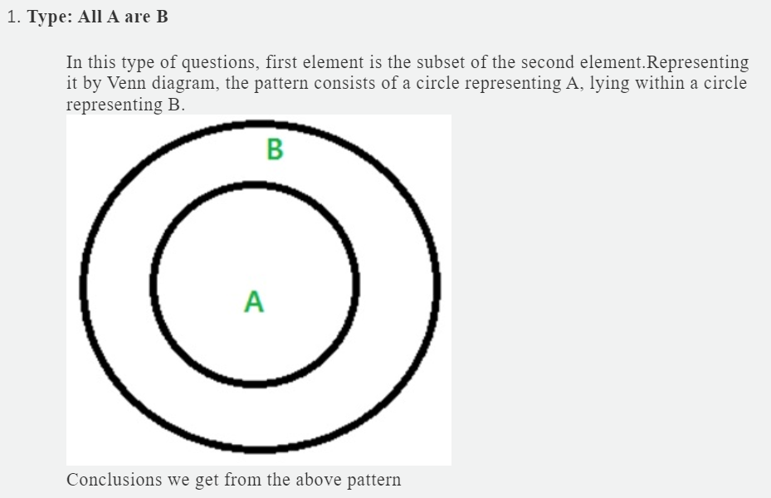

* Some B are A.
* Some A are B.

Example: All cats are animals. Conclusion 1: Some animals are cats Conclusion 2: Some animals are cats Only conclusion 1 follows Only conclusion 2 follows Either 1 or 2 follows Neither 1 nor 2 follows Both 1 and 2 follows Answer: Both conclusions follows

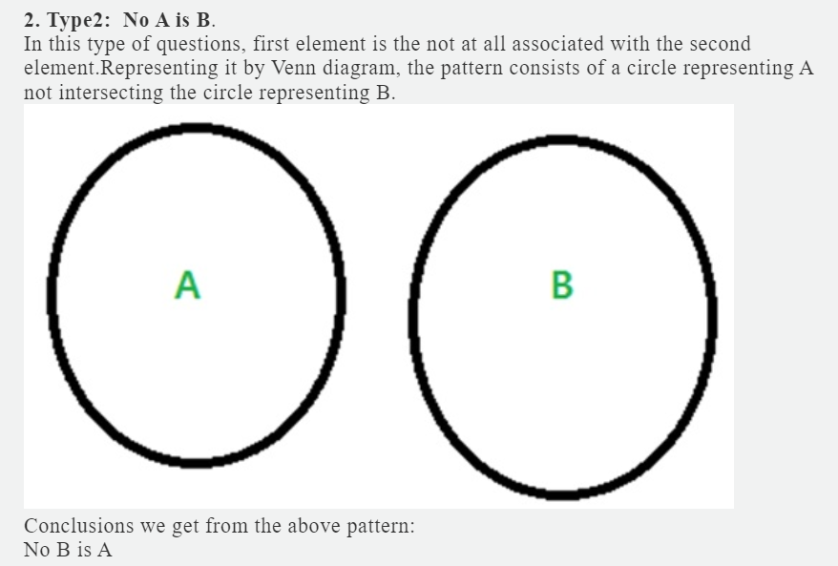

Example: No cats are animals. Conclusion : No animals are cats. Answer: The conclusion is correct

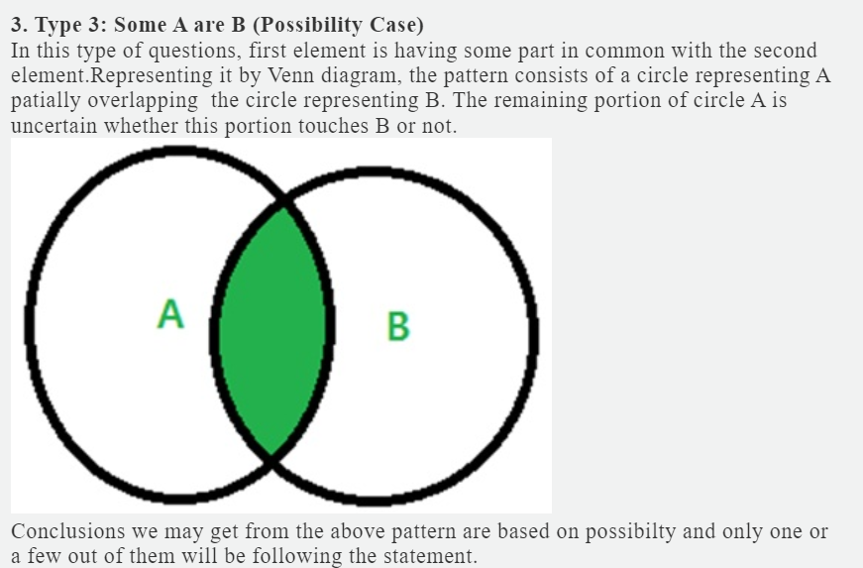

* Some A are not B
* All A are B.
* All B are A.
* All A are B and All B are A.
* Example: Some bats are cats.
* Conclusions:
* Some bats are not cats
* All bats are cats
* All cats are bats
* All bats are cats and All cats are bats
* Answer: All of them

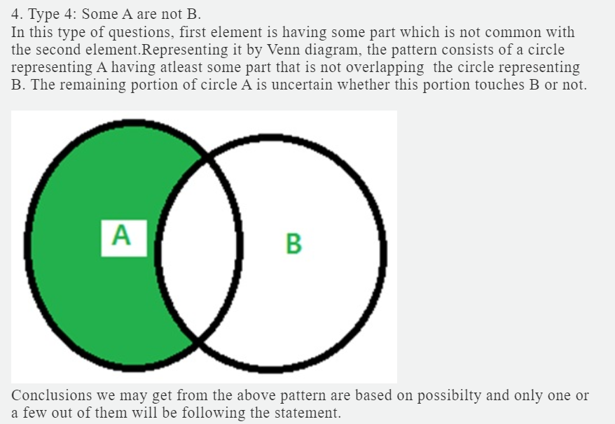

* Some A are not B
* All A are B.
* All B are A.
* All A are not B and All B are not A.

Example: Some bats are not cats. Conclusions: Some bats are cats All bats are not cats All cats are not bats All bats are not cats and All cats are not bats Answer: All the conclusions follow

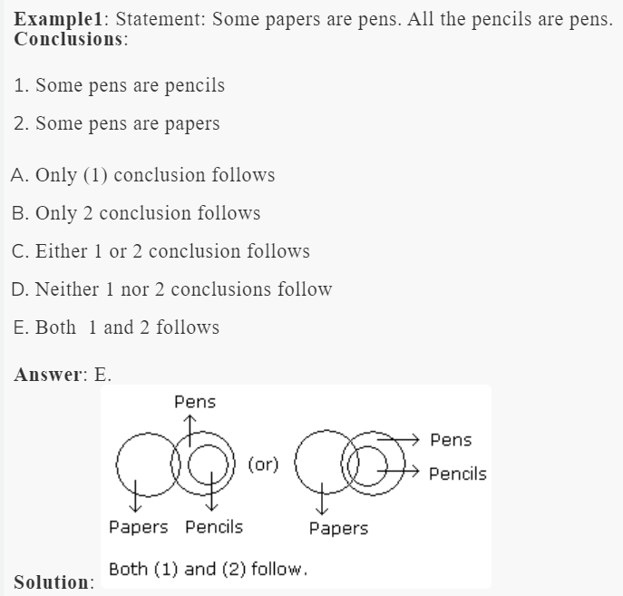

**Problem statement**

Send feedback

Statements: Some actors are singers. All the singers are dancers.  
Conclusions:  
1.Some actors are dancers.  
2. No singer is an actor.

**Options:**Pick one correct answer from below

**Only (1) conclusion follows --**

**Only (2) conclusion follows**

**Either (1) or (2) follows**

**Neither (1) nor (2) follows**

**Both (1) and (2) follows**

**Problem statement**

Send feedback

Statements: Some mangoes are yellow. Some tixo are mangoes.  
Conclusions:  
1.Some mangoes are green.  
2.Tixo is a yellow.

**Options:**Pick one correct answer from below

**Only (1) conclusion follows**

**Only (2) conclusion follows**

**Either (1) or (2) follows**

**Neither (1) nor (2) follows--**

**Both (1) and (2) follows**

**Problem statement**

Send feedback

Statements: All the harmoniums are instruments. All the instruments are flutes.  
Conclusions:  
1.All the flutes are instruments.  
2.All the harmoniums are flutes.

**Options:**Pick one correct answer from below

**Only (1) conclusion follows**

**Only (2) conclusion follows ---**

**Either (1) or (2) follows**

**Neither (1) nor (2) follows**

**Both (1) and (2) follows**

HCF and LCMfooter line

**Introduction to HCF and LCM**

HCF:

The greatest number which divides each of the two or more numbers is called **HCF or Highest Common Factor**. It is also called the **Greatest Common Measure(GCM)** and **Greatest Common Divisor(GCD)**.

LCM:

**Least Common Multiple(LCM)** is a method to find the smallest common multiple between any two or more numbers. A [common multiple](https://byjus.com/maths/multiples/) is a number which is a multiple of two or more numbers.

**How to find HCF**

1. **By Prime factorization method:**

i) Write down the ***prime factors*** of the given numbers.

ii) Write down the***prime factors***which are common to both.

            iii) And products of the common factors will give you HCF of the numbers.

Example: Find the HCF of 150 & 375.

Answer: 75

Solution:

Step 1: Write down the prime factors of the given numbers.

150 =

375 =

Step 2: Write down the prime factors which are common to 150 & 375.

3,5 & 5.

Step 3: Products of the common factors are

Hence, HCF = 75.

**Note: To find HCF of more than 2 numbers**

Let us take three numbers a,b & c.

To find their HCF, what you need to do is, first find out the prime factors of each of the numbers.

Say,

           a =

           b =

c =

**HCF (a,b,c)**All common prime factors with their ***lowest*** available power.

Thus, HCF of a,b,c will be

          HCF=

1. **By division method:**

        If we were given two numbers, then

* First, divide the large number by a small number.
* If the remainder is left, then divide the first divisor by remainder.
* If the remainder divides the first divisor completely, then it is the HCF or highest common factor of the given two numbers.
* If the remainder does not divide the first divisor completely, then repeat the steps.

Example: What is the HCF of 120 and 100.

Answer: 20

Solution: Divide 120 by 100.

120/100 → 1 and remainder is 20

Now, divide the first divisor 100 by the first remainder 20

100/20 → 5 and remainder is 0.

Therefore, 20 is the HCF of 120 and 100.

1. **By shortcut method:**

When you talk about the common factor of two numbers X & Y. then the common factor has to leave the same remainder “zero”. Which means

Let two numbers X & X+12, the only numbers that will have the possibility of leaving the same remainder zero would be factors of 12.

All the common factors of these two numbers would come in the factors of 12, they can’t come from any outer range. And hence, if all the common factors of X & X+12 are inside the factors of 12, So the HCF of X & X+12 would also come from the factors of 12. Which means HCF of X & X+12, can only be one of (1,2,3,4,6 & 12) these numbers.

Example: Find the HCF of 38 & 50?

Answer: 2

Solution:50-38=12, factor of 12 are 12,6,4,3,2&1.

12 Does Not divide 38, so this is not HCF of these two numbers.

6Does Not divide 38, so this is not HCF of these two numbers.

4 Does Not divide 38, so this is not HCF of these two numbers.

3 Does Not divide 38, so this is not HCF of these two numbers.

2 Divide 38, so this is the HCF of these two numbers.

Then it is obvious it will divide 38+12 and hence HCF is 2.

**Note: To find HCF of more than 2 number by shortcut method**

Let us consider the numbers are x, x+12, y, z.  
For finding the HCF of these numbers, take the differences between the numbers. Here, many differences are possible, but you have to choose the smallest difference between any pair of these numbers.

Write the factors of that number and the HCF of all these numbers would be from the factor list.

Sometimes you might want to go for prime number difference instead of the smallest difference,

For example, suppose the numbers are 44,56 & 93.

So, 56 - 44=12

93 - 56=37

               93 - 44=49

Here, a better difference to take here is 37 because 37 is a Prime number, then the factors of 37 are either 1 or 37.So, HCF, in this case, is either 1 or 37. 37 does not divide any number, so, the HCF=1.

Example: A nursery has 363,429 and 693 plants respectively of 3 distinct varieties. It is desired to

place these plants in straight rows of plants of 1 variety only so that the number of rows required is the minimum. What is the size of each row and how many rows would be required?

Answer: 45 rows

Solution: The size of each row would be the HCF of 363, 429, and 693.

Difference between 363 and 429 =66.

Factors of 66 are 66, 33, 22, 11, 6, 3, 2, 1.

66 need not be checked as it is even and 363 is odd. 33 divides 363, hence would automatically divide 429 and also divides 693.

Hence, 33 plants are the correct answer for the size of each row.

For the number of rows that would be required = Minimum number of rows required = 363/33 + 429/33 + 693/33 = 11 + 13 + 21 = 45 rows.

**How to find LCM**

1. **By prime factorization:**

**Step1:**Find the prime factor of two numbers a & b.

**Step2:**Write down all the prime factors that appear at least once in the numbers a & b.

**Step3:**Write all the prime factors with their highest power.

**Step4:**Products of all the prime factors with their highest power will give you LCM of a & b.

Example: Let's have two numbers 12 & 80.

Answer: 240

Solution: Step1: List the prime factors

12=

80=

Step2: Write down all the prime factors that appear, at least once in the numbers: 2,3,5.

Step3: Write all the prime factors with their highest power:

Step4: The LCM =

= 240.

1. **By shortcut method:**

As you saw LCM is the product of the highest power of all the prime factors, but that process would be very tedious, especially when the numbers are small.

When the numbers are small the logic of LCM builds around the ***Co-prime numbers***.

**Co-prime Number:**Two numbers are Co-prime to each other when they have no common factor among each other.

For example: (6, 13), (7, 11), (9, 19) etc.

Three numbers are Co-prime to each other when pairwise, each pair is Co-prime.

For example: Three numbers be a,b and c are Co-prime when,

                      a,b are Co-prime,

                      a,c are Co-prime,

                  & b,c are Co-prime.

All three pairs should be Coprime to each other, only then,  a, b and c will be Co-prime.

NOTE: When a & b is Co-prime then the HCF should be 1.

**Some important points about the Co-prime numbers:**

(i)  Two consecutive natural numbers are always co-prime (Example 5, 6; 82, 83; 749, 750 etc.)

(ii) Two consecutive odd numbers are always co-prime (Examples: 7, 9; 51, 53; 513, 515 etc.)

(iii) Two prime numbers are always co-prime (Examples: 13, 17; 53, 71 and so on)

(iv) One prime number and another composite number (such that the composite number is not a

multiple of the prime number) are always co-prime (Examples: 17, 38; 23, 49 and so on, but note

that 17 and 51 are not co-prime, as 51 is a multiple of 17)

**Shortcut for LCM:**

**Step1:**When the numbers are co-prime, then LCM is simply their product.

So, 7, 9 and 11 are co-prime, The LCM is .

**Step2:**What to do when you have a mix of prime and Co-prime.

**NOTE**: (i). LCM has to be the multiple of HCF.

            (ii). For any two numbers a & b, Product of two numbers (=

                   (this formula is valid for two numbers)

Example: LCM of four numbers 42, 44, 18, 25.

Answer: 69300

Solution:(i) If you see any co-prime put them down in your LCM. Here you can see 18 & 25 are Co-prime (and 25,42 ; 25,44 are also Co-prime).

(ii) LCM of these numbers starts with …. And

(iii) Now the logic of LCM should contain all the other numbers from the given numbers.

(iv) Out of the LCM, you should be able to construct 42 and 44 also.

(v) The factor of 42= . Inside 18 you have 2 & 3, But you don't have 7 in 25 and 18. To construct 42, you should have a 7 in your LCM. ( LCM=)

(vi) The factor of 44= . Inside 18, you have one 2, but there is no 11 and other 2 in this LCM; so, to construct 44 you need to introduce 2 & 11 into the LCM.

So, LCM will be = .

**HCF and LCM of fraction**

**HCF of a Fraction:**

**LCM of a Fraction:**

Example: LCM & HCF of 1/2 ,5/7 and 8/11 are:

Answer: LCM= 40/1

HCF= 1/(2 x 7x 11)

Solution:LCM = LCM(1,5,8) / HCF(2,7,11)

HCF = HCF(1,5,8) / LCM(2,7,11)

So,

LCM= 40/1

HCF= 1/()

Example: Six bells commence tolling together and toll at intervals of 2, 4, 6, 8 10 and 12 seconds respectively. In 30 minutes, how many times do they toll together ?

4

10

15

16

Answer: d) 16

Solution: L.C.M. of 2, 4, 6, 8, 10, 12 is 120.

So, the bells will toll together after every 120 seconds(2 minutes).

In 30 minutes, they will toll together (30/2)+1 16 times.

**Problem statement**

Send feedback

The sides of a pentagonal field are 918, 2160, 2244, 2358 & 1431 meters. Find the greatest length of tape that would be able to exactly measure each of these sides? ( Goldman Sachs campus hiring 2020)

**Options:**Pick one correct answer from below

**3 --**

**6**

**8**

**4**

**Problem statement**

Send feedback

A milkman has milk of three varieties. He has 403L, 465L & 651L of the three varieties of milk with him.  
1. What is the largest size of bottle in which he can bottle each of the three types of milk completely without mixing the milk?  
2. What is the minimum number of bottles required?  
3. How many different sizes of bottles (with the integral number of litres) can be used in order to bottle all three varieties of milk?  
(write comma-separated integers with spaces, eg: x, y, z)  
( Sapient hiring drive 2018)

31,49,2

This is the answer.

Answer. a) The largest size of bottle in which he can bottle each of the three types of milk completely without mixing the milk :- 31 L

Use HCF method and 31 will divide all three numbers and it is a prime number

b) What is the minimum no:of bottles required:-

let a bottle size be 'b'

Minimum no:of bottle required = 403/b + 465/b + 651/b

To minimize this equation 'b' should be maximized

So maximum value of b= 31

Thus minimum number of bottle required

= 403/31 + 465/31 + 651/31 = 13+15+21 = 49 L

c) This part is asking about how many factors do 31 have so , 31 has two factors 31, 1.

Hence 2 size of bottle can be used.

**Problem statement**

Send feedback

4 Bells toll together at 9:00 A.M. They toll at intervals of 7, 8, 11 and 12 seconds respectively. After 9:00 A.M., how many times will they toll together again in the next 3 hours?

**Options:**Pick one correct answer from below

**1**

**3**

**5--**

**7**

**Solution description**

4 Bells toll at an interval of 7, 8, 11 & 12 sec. 7-sec bell tolls at multiples of 7; 8-sec bell tolls at multiples of 8; 11-sec bell tolls at multiples of 11 and 12-sec bell tolls at multiples of 12. To find, at what time will these bells toll together the first time after 9 AM, you need to find the LCM of these intervals.  
  
So, LCM(7,8,11 & 12) = 1848 sec. Thus, after 9 AM bells toll together for the first time at 9:30:08.  
  
In 3 hr i.e. 10800 sec: Number of times the bells toll together in the next 3 hours= 10800/1848 = 5.84 ~5 times.

**Problem statement**

Send feedback

The greatest number of four digits which is divisible by 15, 25, 40 and 75 is:

**Options:**Pick one correct answer from below

**9000**

**9400**

**9600---**

**9800**

#### **Greatest number of 4−digits is 9999.**

#### **Now, 15=3×5**

#### **25=5×5**

#### **40=2×2×2×5**

#### **and 75=3×5×5**

#### **L.C.M. of 15,25,40 and 75 is 2×2×2×3×5×5=600.**

#### **On dividing 9999 by 600, the remainder is 399.**

#### **Required number =(9999−399)=9600.**

#### **Hence, C is the correct option.**

Averages

**Introduction to Averages**footer line

An average is a number that measures the central tendency of a set of numbers. In other words, it is an estimate where the centre point of the set of numbers lies. Average is also known as the mean.

**Another meaning of average** is, the average is that single number, that can replace each of the given numbers present in the set with the average number and still get the same total.

For Example:

                     The average of 5 numbers 11, 14, 17, 18, and 20 is:

                      Average =  = 80/5=16

This means that if you replace all the 5 numbers with 16 (average number), even then the sum will be 80, there would be no change in the total.

**How to find the average**

1. **Formula**

In mathematics, the average is equal to the sum of the set of numbers divided by the numbers of values in the sets

1. **Assumed Average Approach**

We already know that Average is that one number that can replace each of the numbers in a group of numbers and still keep the same total.

By using this concept the assumed average approach is a bypass for getting the average of the numbers.

Let us say 6, 10, 7 & 5 are the 4 numbers. So, Average is;

 Average = (6 + 10 + 7 + 5)/4 = 7

7 can replace all the 4 numbers.

If you see the deviation between the numbers and their average (between left column and the right column), the direction should be: left column - right column

**Left column**            **Right column**       **Deviation**

                                     6                             7                            - 1

                                     10                           7                            +3

                                     7                             7                              0

                                     5                             7                            - 2

The net sum of all these deviations is 0 (-1+3+0-2 = 0). This means the average value is correct.

The following are some steps to calculate the correct average from the assumed average:

**Step1.**You have to assume an average.

**Step2.**Calculate how much the given numbers deviate from the assumed average.

**Step3.**Calculate the sum of all the deviations (i.e. Total deviation).

**Step4.**Calculate the average deviation with the help of the following formula :

**Step5.**Now, the correct average will be equal to the sum of the assumed average and average deviation. i.e.

        Correct average = Assumed average + Average Deviation.

Example: Let 37, 75, 83, 94 & 46 are 5 numbers. You don't know the average and you want to find out the average for these numbers without doing the sum of these numbers.

Answer: 67

Solution: Step1. For this example, assume an average of letting us say, 60.

Step2. Deviation calculation

60 to 37 there is a deviation of -23.

60 to 75 there is a deviation of +15.

60 to 83 there is a deviation of +23.

60 to 94 there is a deviation of +34.

60 to 46 there is a deviation of -14.

Step3. Total deviation = -23+15+23+34-14 = 35.

Step4. Average deviation = 35/5 = 7.

Step5. Correct average = 60+7 = 67.

You can assume any value of average, but the assumed value should be nearly equal to the one of the given value for simple calculation.

In the above example, let us say you assume the average to be 70 instead of 60.

Step1. Assumed average = 70.

Step2. Deviation calculation

70 to 37 there is a deviation of -33.

70 to 75 there is a deviation of +5.

70 to 83 there is a deviation of +13.

70 to 94 there is a deviation of +24.

70 to 46 there is a deviation of -24.

Step3. Total deviation = -33+5+13+24-24 = -15.

Step4. Average deviation = -15/5 = -3.

Step5. Correct average = 70+(-3) = 67.

So you can see that the answer will be the same irrespective of what average you take.

The benefit of the assumed average method is that it is much faster in the case when numbers are bigger and they are clustered (for example,a group of numbers between the range of 300 to 400), then your calculation is much faster than what you normally do.

 NOTE : 1. Average of first n natural numbers = (n+1)/2

              2. Average of first n even numbers    =  n+1

              3. Average of first n odd numbers      = n

**Standard rules in average problems**

1. **Standard Language In Average**

Every chapter has standard language inside it. You can also observe that there is some standard language inside the Average chapter.

You can understand the standard language on average with the help of some examples. So, here we understand the standard language with the help of the following examples:

Example 1: Statement : The average of 5 numbers is 12.

Explanation: When you see this statement two reactions come to mind. The 1st one is that,. and 2nd is that, add 12 five times i.e. 12 + 12 + 12 + 12 + 12 = 60.

So, there are two approaches to tackle this statement.

Example 2: Statement 1: The average age of 24 students and principal is 15.

Solution: When you look at the statement you realize that there are 25 people with an average of 15. Your reaction is , that means the total age of 25 people is 375.

1. **Standard Situation In Averages**

**Situation 1:**

This chapter is about identifying those standard situations that are generally asked in exams with the help of some examples. In the above 3 examples (example No. 2, 3 & 4) one thing is common that one new number is entering into the group.

In example 2. A Group of 24 students and principal added to it.

In example 3. Group of 9 innings and added 10th innings to it.

In example 4. It has an 11 monthly income and added 12th-month income into it.

Here the situation is entering a new number.

Example: Let us say you got 5 numbers with an average of 12 and 6th number entered and the average of all 6 numbers becomes 15. What is the 6th number?

Answer:

Solution: There are two ways of solving this type of question.

The 1st way;

6th number = Total of 6 numbers - Total of 5 numbers

=

The 2nd way;

The addition of a 6th number increases the average by 3.

12 + 3 = 15

12 + 3 = 15

12 + 3 = 15

12 + 3 = 15

12 + 3 = 15

The +3 appearing 5 times is due to the 6th number, which is able to maintain the average of 15 first, and then ‘give 3’ to each of the first 5.

Hence, the 6th number in this case = maintain + contribute

= 15+

**Standard situation 2:**

The 2nd standard situation is about what happens if more than one number enters. This situation can also be explained with the help of examples:

Example: Let us say 8 numbers with an average of 10. Two new numbers enter due to that the average becomes 13. What is the average value of these two numbers?

Answer: 25

Solution: There are two approaches to solve this question;

Total difference approach:

Total of two numbers = 10- = 50

Thus, the average of two numbers = 50/2 = 25.

2nd approach;

The addition of 2 numbers, increases the average by 3.

Average of 8 numbers Average after 2 number entry

10 13

10 13

10 13

… …

… …

8 times… 10times…

Average of two number = maintain + average contribution

= 13 + (38)/2

= 13 + 24/2 = 25

The contribution 24 has to be brought by these two together.

You can understand this situation like when you and your friend go to a hotel and you are going to be paid equally. Bill comes out of 24, then you will divide the bill into 2. So, each individual will pay 12.

Example: After 120 innings batsman has an average of 55. And he realizes that he is going to play 180 innings more and he wants an average of 100 runs per inning. So what should be the average of the remaining 180 innings?

Answer: 130

Solution: Average increases by 45runs.

Average in first 120 innings Average after 300 innings

55 100

55 100

55 100

… 100

… …

120 times… 300 times…

180 new innings maintain the average 100 and make the average contribution in 120 innings.

Average of remaining 180 innings = maintain + average contribution

= 100 + (45120)/180

= 130

**Standard situation 3:**

The 3rd standard situation that you will see in the average chapter is replacement of a number.

Example: A set of 5 numbers with an average of 13 and one number is replaced. Average is increased by 4. The outgoing number is 32, then find the replaced number?

Answer: 52

Solution: In this situation, there is an outgoing number and an incoming number and the average changes by 4 for 5 numbers. The difference in the total = (517) - (513) = 20.

Incoming number how much larger = (change in average) (number of numbers)

= 4 5 = 20

If the average increases then it is obvious that the incoming number is larger.

Incoming number - outgoing number = difference in total

Incoming number = 20 + 32 = 52.

**Concept of weighted average**

The concept of a weighted average can be understood with the help of an example.

Suppose I had to buy a T-shirt and jeans and let us say that the average cost of a T-shirt was 600, while that of jeans was 1500.

In such a case, the average cost of a T-shirt and jeans would be given by (600 + 1500)/2 = 1050.

This can be observed on the number line as:

(midpoint) = answer.

  600                                1050                                 1500

From the figure it is observed that the average occurs at the midpoint of the two numbers.

Now, let us try to modify the situation:

Suppose I had to buy 3 T-shirts and 1jeans. In such a case I would end up spending (600 + 600 + 600 +1500) =  3300 in buying a total of 4 items. So,

Average = 3300/4 = 825. Clearly, the average has shifted.

On the number line :

 600              875              1050                               1500

It is clearly visible that the average has shifted towards 600 (which was the cost price of the T-shirts, the larger purchased item.)

In a way, this shift is similar to the way a two-pan weighing balance shifts when the weights are put on it. The balance shifts towards the pan containing the larger weight.

Similarly, in this case, the correct average (875) is closer to 600 than it is to 1500. Since, this is very similar to the system of weights, we call this a weighted average situation.

**Formula for weighted average:**

Let say, we have k groups with averages A1, A2 ... Ak and having n1, n2 ... nk elements then the weighted average is;

**Situations involving weighted average**

**Situation 1:** Purchasing two kinds or  k varieties of something and mixing them together, to form composite.

Example: Suppose I purchase 30Rs/kg rice and 70Rs/kg rice in the ratio 2:3. What is the average price of rice?

Solution : Average price = (n1A1 +n2A2)/(n1+n2)

Here, A1= 30 , A2 = 70 , n1 = 2 , n2 = 3

Average price = (2+370)/(2 + 3)

= 270/5 = 54Rs/kg.

**Situation 2:**

Example: Let's say you drive a car 30km/hr and 70km/hr and drive it for 2hr and 3 hr respectively. Find the average speed?

Solution : Average speed = (total distance)/(total time)

= (2+370)/(2 + 3)

= 270/5 = 54 km/hr.

Situation 1 and 2 are the same but the story is different.

**Situation 3:**

Example: Let say you invest 2 lac and give 30% return. Investment of 3 lac rupees, give70% return. What is the average % return?

Solution : Average % return = (n1A1 +n2A2)/(n1+n2)

Here, A1= 30% , A2 = 70% , n1 = 2 Lac , n2 = 3 Lac

Average % return = (2+370)/(2 + 3)

= 270/5 = 54 %.

**Situation 4:**

Example: There are two sections, in section 1 there are 20 students who scored 30 marks on an average in exam, while in section 2 there are 30 students who scored 70 marks on an average in exam. What is the average marks of both the sections?

Solution : Ratio of the quantities 20:30 = 2:3

So, Average marks = (2+370)/(2 + 3)

= 270/5 = 54.

This situation can be modified into Boys and Girls in a class with ratio 2:3 and Boys average marks is 30 and Girls average marks is 70. So what are the average marks of the class?

Average marks of the class will be 54.

**Situation 5: Alloys and Mixture**

Example: Let say two water and milk solutions of 2L and 3L, In one solution milk is 30% and other solution milk is 70% respectively. Mix both the solutions then what is the % of milk in the mixture?

Solution : % of milk in the mixture = (2+370)/(2 + 3)

= 270/5 = 54%.

Instead of water milk solution, we can take gold and copper alloy, 2kg gold and copper alloy with 30% of gold & 3kg gold and copper alloy with 70% of gold. If both the alloys are mixed and a new alloy is formed, then what is the % of gold in the new alloy?

Solution : % of gold in the new alloy = (2+370)/(2 + 3)

= 270/5 = 54%.

These are some important situations that are used in weighted averages.

**Problem statement**

A family consists of two grandparents, two parents and three grandchildren. The average age of the grandparents is 67 years, that of the parents is 35 years and that of the grandchildren is 6 years. What is the average age of the family?

**Options:**Pick one correct answer from below

**28 4/7 years**

**31 5/7 years --**

**32 1/7 years**

**None of these**

**Solution description**

Required average= (67 x 2 + 35 x 2 + 6 x 3)/2 + 2 + 3 =(134 + 70 + 18)/7 =222/7 = 31 (5/7) years.

**Problem statement**

Send feedback

A grocer has a sale of Rs. 6435, Rs. 6927, Rs. 6855, Rs. 7230 and Rs. 6562 for 5 consecutive months. How much sale must he have in the sixth month so that he gets an average sale of Rs. 6500?

**Options:**Pick one correct answer from below

**Rs. 4991 --**

**Rs. 5991**

**Rs. 6001**

**Rs. 6991**

**Solution description**

Solution: Total sale for 5 months = Rs. (6435 + 6927 + 6855 + 7230 + 6562) = Rs. 34009.  
Required sale = Rs. [ (6500 x 6) - 34009 ]  
= Rs. (39000 - 34009)  
= Rs. 4991.

**Problem statement**

Send feedback

A pupil's marks were wrongly entered as 83 instead of 63. Due to that, the average marks for the class got increased by half (1/2). The number of pupils in the class is:

**Options:**Pick one correct answer from below

**20**

**40**

**63**

**83**

**Solution description**

Let there be x pupils in the class. Total increase in marks =x . 1/2  
=x/2 x/2= (83 - 63) x/2= 20  
x= 40.

**Problem statement**

Send feedback

The average weight of 16 boys in a class is 50.25 kg and that of the remaining 8 boys is 45.15 kg. Find the average weights of all the boys in the class.

**Options:**Pick one correct answer from below

**50 kg**

**49.55 kg**

**48.55 kg**

**50.55 kg**

**Solution description**

Required average:  
(50.25x16 + 45.15x8)/(16+8)  
=48.55 kg

Alligation

**Introduction to Alligation**footer line

The concept of alligation is closely related to the weighted average.

Alligations is a visual approach to solve weighted averages, involving the mixing of two groups.

**For example:**

Two varieties of rice at 50 per kg and 80 per kg are mixed together in the ratio 3 : 7. Find the average price of the resulting mixture.

**Solution :**By using weighted average formula;Aw =  (n1A1 +n2A2) / (n1+n2)

                                                    Average price = (3+780) / (3 + 7)

                                                                           = 710 / 10

   = 70.

The weighted average approach is slightly slower than if we see the same situation through alligations. Alligations are a faster approach.

**The mathematical formula for alligation:**

In the case of a situation where just two groups are being mixed, we can write weighted average formula:

                          Aw = (n1A1 + n2 A2 ) / (n1 + n2)

Here, we have 2 groups with averages A1, A2 and having n1 and n2 elements respectively.

Rewriting this equation we get:

                         (n1 + n2) Aw = n1A1 + n2A2

                         n1(Aw – A1) = n2 (A2 – Aw) or

                                     n1/n2 = (A2 – Aw)/(Aw – A1) ……….. The alligation equation.

As a convenient convention, we take A1 < A2. Then, by the principal of averages,

we get A1 < Aw < A2.

**Situations in alligation problems**

**Situation 1: When**A1, A2, n1, and n2 are known and Aw is unknown.

A1                               Aw                                   A2

n1                                                                        n2

***For example:***

50                                 Aw                                  80

3                                                                            7

Since the total distance = (80 - 50) = 30. If we split 30 into 3:7, the value of 3 parts and 7parts are  9 and 21 respectively.

Thus the distance between Aw and 50 is corresponding to n2 (i.e. 7) and 7 parts are equal to 21.

I.e. Aw - 50 = 21     Aw = 71.

**Situation 2: When**A1, A2, and Aw are known and n1: n2 is unknown.

A1                               Aw                                   A2

n1                                                                        n2

***For example:***

70                                80                                   84

n1                                                                         n2

By using alligation equation,

n1/n2 = (A2 – Aw)/(Aw – A1)

n1:n2 = 4:10 or 2:5.

**Situation 3: When**A1, Aw, and n1:n2 are known and A2 is unknown.

A1                                Aw                                   A2

n1                                                                          n2

***For example:***

30                                 70                                    A2

3                                                                           5

By using alligation equation,

n1/n2 = (A2 – Aw)/(Aw – A1)

3/5 = (A2 - 70)**/(**70-30)

A2 = 94.

**Problems where we can use alligation-1**

Example 1:

Two varieties of rice at 40 per kg and 50 per kg are mixed together in the ratio 2 : 3. Find the average price of the resulting mixture.

Solution :

40 Aw 50

2 3

Since the total distance = (50 - 40) = 10. If we split 10 into 2:3, the value of 2 parts and 3 parts are 4 and 6 respectively.

Thus the distance between Aw and 40 is corresponding to n2 (i.e. 3) and 3 parts are equal to 6.

I.e. Aw-40 = 6

Aw = 46.

Hence, the average price of the resulting mixture is at 46 per kg.

Example 2:

A man has driven a car at 40kmph and 50kmph. He has driven for 2 hours and 3 hours respectively. Find the average speed of a car?

Solution :

40 Aw 50

2 3

Here, Aw is the average speed of the car.

Since the total distance = (50 - 40) = 10. If we split 10 into 2:3, the value of 2 parts and 3 parts are 4 and 6 respectively.

Thus the distance between Aw and 40 is corresponding to n2(i.e. 3) and 3 parts are equal to 6.

i.e. Aw-40 = 6

Aw = 46.

Hence, the average speed of the car is 46kmph.

These two questions are on the surface different from each other, the first one was talking about average price and the other is talking about the average speed, But structurally both are the same.

Equation in 1st question ;

Average price = (n1A1 +n2A2) / (n1 + n2).

Here, n1= 2kg, n2= 3kg , A1= 40per kg, A2= 50 per kg.

So,

Average price = (2*40 + 3*50)/(2+3)

Equation in 2nd question ;

Average speed = (t1S1 +t2S2) / (t1 + t2).

Here t1= 2hr, t2= 3hr , S1= 40kmph, S2= 50kmph.

So,

Average speed= (2*40 + 3*50)/(2+3)

By looking at these two equations you will observe that these both are the same, only difference is in variables.

**Problems where we can use alligation-2**

Example 1:

We have two mixtures of milk and water, the 1st mixture contains 40% milk & 60% water and the 2nd mixture contains 50% milk & 50% water. These two mixtures are mixed in ratio 2:3, then find the % of milk in the mixture?

Solution : Using milk %

40 Aw (% of milk) 50

2 3

Since the total distance = (50 - 40) = 10. If we split 10 into 2:3, the value of 2 parts and 3 parts are 4 and 6 respectively.

Thus the distance between Aw and 40 is corresponding to n2(i.e. 3) and 3 parts are equal to 6.

i.e. Aw-40 = 6

Aw (% of milk) = 46%.

Another way to solve this question is by using water %

The 1st mixture has 60% water and the 2nd mixture has 50% water.

According to convention, we need A1< Aw < A2 and the ratio of 1st mixture to 2nd mixture is 2:3, this will be inverted here because we have to flip the % here to make it according to the given convention.

50 Aw (% of water) 60

3 2

Since the total distance = (60 - 50) = 10. If we split 10 into 3:2, the value of 2 parts and 3 parts are 4 and 6 respectively.

Thus the distance between Aw and 50 is corresponding to n2(i.e. 2) and 2 parts are equal to 4.

i.e. Aw-50 = 4

Aw (% of water) = 54%.

Thus; % of milk = 100 - 54 = 46%.

Example 2:

Anjali mixes 2 alloys of gold and copper in ratio 2:3. The 1st alloy contains 40% gold and the 2nd alloy contains 50% gold. Find the gold % in the mixture?

Solution :

40 Aw (% of gold) 50

2 3

Since the total distance = (50 - 40 ) = 10. If we split 10 into 2:3, the value of 2 parts and 3 parts are 4 and 6 respectively.

Thus the distance between Aw and 40 is corresponding to n2(i.e. 3) and 3 parts are equal to 6.

i.e. Aw-40 = 6

Aw (% of gold) = 46%.

Another way to solve this question is by using copper %.

**Problems where we can use alligation-3**

Example 1:

A shopkeeper sold chairs and tables. The ratio of the cost price of chair and table is 1:2. He sold chairs at 30% profit and tables at 60% profit. What is the average % profit?

Solution :

30 Aw(average % profit) 60

1 2

Since the total distance = (60 - 30) = 30. If we split 30 into 1: 2, the value of 1 part and 2 parts are 10 and 20 respectively.

Thus the distance between Aw and 30 is corresponding to n2(i.e. 2) and 2 parts are equal to 20.

I.e. Aw-30 = 20

Aw (average % profit) = 50%.

Example 2:

A shopkeeper sold chairs and tables. He sold tables at 20% profit and chairs at 30% loss. Thereby he made no profit or no loss in the transaction. What is the cost price ratio of table to chair?

Solution :

Chair Table

-30 0 20

n1 n2

n1/n2 = (A2 – Aw)/(Aw – A1)

Here A1= -30, A2= 20, Aw= 0.

n1/n2 = (20 – 0)/(0 – (-30))

n1/n2 = 20/30 i.e. n1:n2 = 2:3.

Thus, table to chair cost price ratio = 3:2.

**Cross diagram approach**

A1                                           A2

A2-Aw                 :                     Aw-A1

    n1                     :                         n2

Note: That the cross method yields nothing but the alligation equation. Hence, the cross method is nothing but a graphical representation of the alligation equation.

As we have seen, there are five variables in the alligation equation.

The three averages A1, A2, and Aw. and the two weights n1 and n2.

Example 1:

On mixing two classes of students having average marks 25 and 40 respectively, the overall average obtained is 30 marks. Find

(a) The ratio of students in the classes

(b) The number of students in the first class if the second class had 30 students.

Solution :

25 40

A2-Aw : Aw-A1

10 : 5

(a) The ratio of students in class is 10:5 i.e 2:1.

(b) If the ratio is 2: 1 and the second class has 30 students, then the first class will have 60 students.

**Problem statement**

Send feedback

Class1 has 20 students having average marks of 60 and the class2 has 30 students having average marks of 70. Find the average marks of two classes combined?

66

**Problem statement**

Send feedback

A and B are two alloys of gold and copper prepared by mixing metals in the ratios 7 : 2 and 7 :11 respectively. If equal quantities of the alloys are melted to form a third alloy C, the ratio of gold and copper in C will be

7:5

#### **Gold in alloy A=7:9**

#### **copper in alloy A=2:9 Gold in alloy B=7:18 Copper in alloy B=11:18 Gold in alloy C=7:9+7:18 Copper in alloy C=2:9+11:18 Ratio of copper and iron in alloy C= 7:5**

**Problem statement**

Send feedback

Two varieties of gold and copper alloy mixed in ratio 3:5. The 1st alloy contains gold and copper in ratio 3:8 & 2nd alloy contains gold and copper in ratio 2:13. What is the final ratio of gold and copper in the mixture?

49:215

The final mixture is given as **3:5**  or we can say **3A/5B**

Therefore, the ratio of gold and copper would be :-

**Gold/**Copper = **[3*(3/11) + 5*(2/15)] /** [3*(8/11) + 5*(13/15)]

                                                            =  49/215

**Problem statement**

Send feedback

Tea worth Rs. 126 per kg and Rs. 135 per kg are mixed with a third variety in the ratio 1 : 1: 2. If the mixture is worth Rs. 153 per kg, the price of the third variety per kg will be:  
(answer up to 2 decimal places)

**Options:**Pick one correct answer from below

**Rs. 169.50**

**Rs. 170**

**Rs. 175.50 --**

**Rs. 180**

**Solution description**

Since the first and second varieties are mixed in equal proportions.  
So, their average price = Rs.(126 + 135)/2  
= Rs. 130.50 So, the mixture is formed by mixing two varieties, one at Rs. 130.50 per kg and the other at say, Rs. x per kg in the ratio 2: 2, i.e., 1: 1. We have to find x.  
By the rule of alligation, we have:  
(x - 153)/22.50= 1  
x - 153 = 22.50  
x = 175.50

Percentages

**Introduction to Percentages**footer line

The basic definition of percentage is essentially out of 100. The percentage is derived from the French word ‘cent’. The meaning of ‘cent’ in French is 100.

The percentage is used to compare data and numbers.

For example:

**(a)**  If there are 5 (A, B, C, D, E) students who have taken the 12th board exam from five different boards. The percentages they get is a defined thing i.e. comparison between 5 diverse students in 5 diverse boards.

  A                      B                   C                   D                  E

86%                  92%               94%              78%              52%

By seeing the percentage of these students we can compare which student is better.

**(b)** GDP defines how the world is doing in terms of Global world economies. GDP compares different countries' economies in terms of their percentage.

Mathematically;

                          Any ratio if you multiply by 100, it gives you its percentage value. The percentage is denoted by the sign “%”.

Why when the ratio is multiplied by 100, gives you a percentage value? You can see that from the unitary method.

**Unitary method:**It is a method which talks about a situation where two variables are moving linearly w.r.t. each other.

Example: You bought 10 bananas for 30 rupees then, how many rupees will you need to buy 15 bananas?

Solution: let x rupees you will need to buy 15 bananas.

10 bananas = 30Rs

15 bananas = x Rs

Cross multiply and equate;

10*x = 1530

x = 45.

So, 45 rupees is the amount that you will need to buy 15 bananas.

Example: You scored 10 out of 20 in a quiz and you want to put it in % then, how much out of 100 did you score?

Solution:

10 out of 20.

x out of 100.

So, by unitary method;

20 = 10100

x = (10/20) 100

x = 50%

NOTE: Any fraction multiplied by 100 gives its percentage value.

**Concept of percentage change**

Percentage always happens when you go from one number to the next number.

Basic structure of percentage change will always be in the situation, where you are talking about the difference between two numbers.

Let say we have number x becoming y. The percentage change between x to y.

**Formula for percentage change:**

1st you have to identify which number is the original number that depends on which direction you are looking at percentage change. So, percentage change is always a **directional input**.

If x changes to y the percentage change going from x to y, will be having x as the original value.

If y changes to x. So, in this situation the percentage change will have to be seen from y to x and will be having y as the original value.

For example;

If you have two numbers 20 & 40. So, going from 20 to 40.

Here change = 40 - 20 = 20, and original value = 20.

% change = (20/20)100 = 100%

 The change is +ve. So, % change is increasing by 100%.

20 to 40 have different % change than coming from 40 to 20.

Here change = 20 - 40 = -20, and original value = 40.

% change = (-20/40)100 = -50%

So, % change is decreasing by 50%.

NOTE: 1. In percentage change, there should be two numbers.

             2. You need to understand which number is the original number.

People make a very common mistake in the % change calculation.

In the question given that 50 to 75, instead of this they calculated 75 to 50. Because the language of  % change can get complex sometimes, where language structures are used especially in DI.

**Percentage change graphics**

It is an important concept in percentage change and important for chapters like interest, profit, and loss, etc. As the name suggests, percentage change graphics means the graphical method of doing the percentage change.

**Basics of percentage change:**

2. 10% of a number is a shift of 1 decimal point on the number towards left.

3. 1% of a number is a shift of 2 decimal points on the number towards left.

4. 0.1% of a number is a shift of 3 decimal points on the number towards left and so on….

For example:

Let say a number N=52123.

100% of the number N is 52123

10% of the number N is 5212.3

1% of the number N is 521.23

0.1% of the number Nis 52.123

**PCG has two structures:**

**Structure 1:**

Given the starting value and the ending value. You have to calculate:

1. Absolute change  (below the arrow).

2. % change(above the arrow).

**Example:**

Let us say, 40 changing into 52.

Absolute change = 52 - 40 = +12. Absolute change is +ve that means an increase in % change.

10% of the number 40 is 4, and the number 12, is 3 times the number 4 which means that the percentage increases by 30% (3 * 10% = 30%).

**Structure 2:**

1. Starting value is given to you,

2. Percentage change is given to you.

3. Absolute change you need to calculate.

4. And calculating the ending value.

Example1:

There is a number 40 that has to be increased by 30%.

Solution:

We were doing this problem by the unitary method.

40 is 100%

x is 130%

Cross multiply and equate;

x = (40130)/100.

Rather than this, a much easy calculation is done through percentage change graphics.

10% of 40 is 4. 30% increase means adding 4, 3 times. 4+4+4 = 12 i.e adding 12 in 40 so the ans is 52.

Example2:

The number 37 has to be increased by 13%.

Solution: In this question, you have to build up 13% by;

10% of 37 is 3.7

1% of 37 is 0.37

1% of 37 is 0.37

1% of 37 is 0.37

So, 13% of 37 is 4.81(3.7+0.37+0.37+0.37 = 4.81), adding 4.18 in 37. So, the answer is 41.81

**PCG applied to percentage change:**

The 1st structure under which you can use the percentage change in quantitative aptitude is product change situation.

Example1:

Let say a product . x is increased by 20% and y is increased by 30%. You want to find out what is the % change in the product?

Solution:

x would become x(1+ (20/100)) =

y would become y(1+ (30/100)) = 1.3

So, in product; 1.3= 1.56xy. This means, 56% change.

Same question can be done by PCG. If you assume your original product to be 100. And this product will go through two changes, 20% increase in x and 30% increase in y. You have to put two arrows,

One for ‘x’ and other for ‘y’.

If x increases by 20% the product also increases by 20% and then if y increases by 30% the product also increases by 30%.

i.e. 56% increase in the product.

**Problems on percentage change:**

**Area and volume-based problem:**

Problem 1:

The length of a rectangle goes up by 30% and the breadth of the rectangle comes down by 10%. What is the percentage change in area?

Solution:

Area = and now it becomes a product change situation.

Assume the original area = 100. Makes two arrows one for length and other is for breadth.

Hence 17% is the increase in the area of the rectangle.

Problem 2:

The length of a rectangle is decreased by 20% and the breadth of the rectangle is increased by 23%. What is the percentage change in area?

Solution:

Area = and now it becomes a product change situation.

Assume the original area = 100. Makes two arrows one for length and the other is for breadth.

For easy calculation, we put breadth on the 1st arrow and length on the 2nd arrow.

Hence, 1.6% is the decrease in the area of the rectangle.

We can do the same problem with the help of the following formula;

Percentage change = (a + b + ab/100)

Let us say, x increases by 20% and y increases by 10%. Then the percentage change;

Percentage change = 20 + 10 + ()/100

= 32%.

But rather than this PCG is a more easy way to solve this problem.

One other problem to this formula, if situation occurs then the formula can not make a change 3 components of the of product. PCG is always better for these problems.

**Expenditure and revenue problem:**

Problem 1:

The price of a commodity has gone up by 20% and a person reduces its consumption by 10%. What is the % change in the expenditure?

Solution :

Price consumption = expenditure.

Assume the original expenditure = 100. Makes two arrows one for price and the other is for consumption.

Hence, 8% is the increase in the expenditure of the commodity.

Problem 2:

A shopkeeper selling chairs, reduces the price of chairs by 20% due to which he gets an increment of 60% in the sale. What is the percentage change in the revenue?

Solution :

Price sale = revenue.

Assume the original revenue = 100. Makes two arrows one for price and other is for sale.

Hence, 28% is the increment in the revenue.

**PCG applied to product constancy:**

Product constancy is after the series of changes, you need to come back to the original value. Product constancy is applied in a lot of questions directly.

Problem 1:

Price of a commodity has gone up by 25% and the consumption is reduced such that the expenditure remains constant.

Solution :

Price consumption = expenditure.

Let 100 be the original expenditure after two change one on price and other on consumption, the expenditure should be back at 100.

After a 25% increment in price, expenditure becomes 125. So, 125 should be reduced by 25 to keep expenditure constant i.e consumption reduced by 20%.

25% increase in price is offset by a 20% decrease in consumption to keep expenditure constant.

Problem 2:

The length of a cuboid has increased by 20%, the breadth has increased by 50%. How much should you reduce the height to keep the volume constant?

Solution :

Volume =

After 20% and 50% increment in length and breadth respectively, the volume becomes 180. So, 180 should be reduced by 80 to keep volume constant i.e height dropped by 44.44%.

Drop in height = (80/180)100

= (4/9)100 = 44.44%

**PCG applied on successive percentage change :**

Successive percentage change use of PCG is structurally very similar to product change use of PCG. One small difference is that in product change we have seen that the arrows are interchangeable w.r.t. each other but in successive percentage change use of PCG we can not  interchange the arrows because sometimes we need intermediate value, if we interchange the arrows then we do not get the exact intermediate value. You can understand that difference through some examples/problems.

Problem 1:

Population of the town goes up by 20% in 1st year, comes down by 10% in 2nd year and goes up by 5% in 3rd year. What is the % change in population after 3 years ?

Solution :

Let the population of the town is 100. Population after one year becomes 120 with an increase of 20%. Population after 2 year will become 108 and after the 3rd year the population will become 113.4.

% change in the population after 3 years is 13.4%. But the intermediate value is important, if anyone asks what is the % change in population after 2 years.

If you interchange the arrows e.g 10% is placed on the last arrow.

Final value does not make a difference. But after two year the population value is wrong. If the question is built on intermediate value then you will go wrong if you do not keep the arrow constant as they are, that is the only difference in this.

**A to B to A problems ( compare two numbers) :**

Very often we  face a situation, where we compare two numbers, say A and B. In such cases, if we are given % change from A to B, then the reverse relationship can be determined by using PCG in the same way as the product constancy.

Problem 1:

A’s salary is 25% more than B’s salary. By what percent is B’s salary less than A’s salary?

Solution :

Let B’s salary = 100.

A drop of 25 on 125 gives a 20% drop.

Hence B’s salary is 20% less than A’s.

NOTE: Product constancy table is also useful for this situation.

Problem 2:

B gets 20% more marks than A and C gets 50% more marks than B, then how much % less than C does A get?

Solution :

Lets A’s marks = 100.

Coming back from C to A, a drop of 80 on 180 i.e 80/180 = 4/9. The fraction 4/9 is equivalent to 44.44%. Hence, A gets 44.44% marks less than C.

**Problem statement**

Send feedback

A shopkeeper increases the price of his goods by 3/13 and the selling price for his goods is 320. What was its cost price?(Pegasystems)

**Options:**Pick one correct answer from below

**260**

**360**

**460**

**160**

**Solution description**

We know the fractional implication of the product constancy table. If we go from A to B 3/13 increase, we will have to come back with a 3/16 decrease. ![alt text]( https://ninjasfiles.s3.amazonaws.com/asset_0000000000000399_1617822396_pg_q1.png ) 1/16 of 320 = 20 and 3/16 of 320 = 60. Hence, cost price = 320-60 = 260.

**Problem statement**

Send feedback

A shopkeeper gives 3 successive discounts of 20%, 30%, and 50%. What is the equivalent total single discount? (VMware, Inc)

**Options:**Pick one correct answer from below

**34%**

**27%**

**82%**

**72%**

**Solution description**

Let the original value of markup price of products is 100. ![alt text]( https://ninjasfiles.s3.amazonaws.com/asset_0000000000000401_1617822414_pg_q3.png ) Final price of the product is 28 when its original markup price is 100. 100 coming down to 28. Hence, equivalent single discount = 100 - 28 = 72%.

**Problem statement**

Send feedback

A machine depreciates in value each year at the rate of 10% of its previous value. However every second year there is some maintenance work, so that in that particular year depreciation is only 5% of its previous value. If at the end of the fourth year the value of the machine stands at Rs. 146205, then find the value of the machine at the start at the first year?

200000

**Problem statement**

Send feedback

Price of a commodity has gone up by 40% and Shubham wants to limit his expenditure increase to 5%. What is the reduction in consumption, so that expenditure increases 5%?(Salesforce hiring 2019)

**Options:**Pick one correct answer from below

**20%**

**25%**

**5%**

**10%**

**Solution description**

Price consumption = expenditure. Let 100 be the original expenditure and expenditure limited to 5% that means the final expenditure would be 105. ![alt text]( https://ninjasfiles.s3.amazonaws.com/asset_0000000000000405_1617822455_pg_q8.png ) % change in consumption = 35/140 = 1/4, fraction 1/4 equivalent to 25%.  
Hence consumption dropped by 25%, so that expenditure was limited to a 5% increase

**Problem statement**

Send feedback

A product abcd , a increased by 20%, b is increased by 30%, c is increased by 50% and d decreased by 10%. What is the percentage change in the product?

110.6

Ratio, proportions, variationfooter line

**Introduction to Ratio, proportion, variation**

The ratio is a method to compare quantities. When you compare the quantities the first thing that comes to mind is that the quantities should be in the same unit.

Example: 20kmph and 30kmph are the two quantities which are in the same unit.

So,

Ratio = 20/30 = 2/3

= 2:3.

If quantities are in different units, then they can’t be compared.

For example:

20 km and 18Rs/kg are the two quantities in different units. So, these two quantities can’t be compared.

Proportion basically equates to two or more ratios. When two ratios are equal, the four quantities composing them are said to be proportional. Thus if a/b = c/d, then a, b, c, d are proportional.

The proportion can be written as;

a:b::c:d, that means a is to b as c is to d. Also, it can be written as a:b = c:d.

NOTE: The terms a and d are called the extremes while the terms b and c are called the means.

* If four quantities are in proportion then the product of extremes and product of means are equal.

            Let a,b,c and d are in proportion. Then ;  i.e, ad = bc.

* Sometimes the mean proportion is the same.

Let say a:b::b:c is referred to as a continued proportion. Thus, the product of extremes is equal to the product of means.

 i.e or we can say that . So, b is called a geometric mean

             between a & c.

NOTE: Mean proportion is always the geometric mean of extremes.

Example: Let us say 2:3::a:33. What is the value of a?

Solution: the product of extremes = the product of means

=

a = 22.

**Some properties of ratio and proportion**

**Ratio:**

1. If we multiply the numerator and the denominator of the ratio by the same number, the ratio does not change.

Thus, multiplying ‘m’ by both numerator and denominator of the same ratio gives,

 a/b = ma/mb

For example :

For Ratio = 3/4

Multiply the numerator and the denominator by 6 i.e 3/4 = /= 18/24

Here 3/4 is the **lowest/basic form** of a ratio. This lowest/basic form gives an infinite number of ratio values.

For example :

3/4=6/8=15/20=18/24=......................so on.

**NOTE: In the lowest form of ratio the numerator and the denominator are always coprime numbers.**

1. If we divide the numerator and the denominator of a ratio by the same number, then the ratio does not change. Thus;

Dividing ‘d’, by both numerator and denominator or ratio a/b gives,

a/b = ()/

1. Dividing one ratio by another ratio can be expressed as a new ratio.

Let the 2 ratios be ‘a/b’ and ‘c/d’. Therefore,

(a/b)(c/d) OR

a/b:c/d = ad/bc

For example:

2/3:4/5 =

= 10/12.

1. The multiplication of two ratios a/b and c/d gives:

a/bc/d = ac/bd.

1. If a/b = c/d = e/f = k then;

(a+c+e)/(b+d+f) = k.

For example : 2/3 = 4/6 = 10/15 = 200/300 = k then,

(2+4+10+200) / (3+6+15+300) = 216/324 = 2/3.

1. When numbers are added in both numerator and denominator to maintain equality, then the numbers should have the same ratio as that of the original ratio in which we are adding.

Let say ratio = 400/800

400/800 = (400+2)/(800+4) i.e a/b = (a + c)/(b + d) if and only if c/d = a/b.

1. In a ratio, if we add two numbers such that their ratio is larger than the original ratio, then the final ratio becomes larger.

Let say a ratio = 400/800.

            (400+5)/(800+7).Here, ratio 5/7 is larger than the original ratio(400/800 =1/2).

            i.e c/d > a/b then (a + c)/(b + d) > a/b

    i.e. (400+5)/(800+7) > 400/800

            In case you add a smaller ratio than your final ratio will be less than the original ratio.

Let say a ratio = 400/800.

            (400+3)/(800+7). Here, the ratio of 3/7 is smaller than the original ratio.

            i.e.  c/d < a/b then (a + c)/(b + d) < a/b

 i.e. (400+3)/(800+7) < 400/800

1. If, some ratio is in fractional form, then to convert it into an integral ratio, multiply all fractions by LCM of their denominators.

For example:

1/2: 3/5: 7/6 to convert this ratio into integral ratio, multiply all the fractions by LCM of their denominators (2,5&6). LCM(2,5,6) = 30.

i.e 30/2 : (330)/5 : (730)/6 = 15:18:35.

**Proportions:**

1. **Invertendo:**If a/b = c/d then b/a = d/c
2. **Alternando:**     If a/b = c/d, then a/c = b/d
3. **Componendo:**  If a/b = c/d, then (a+b)/b = (c+d)/d.
4. **Dividendo:**       If a/b = c/d, then (a-b)/b = (c-d)/d.
5. **Componendo and Dividendo:**   If a/b = c/d, then (a + b)/(a – b) = (c + d)/(c – d)

**Chain Ratio**

Chain ratio is a ratio in which one to next, next to the next, and next to next ratios are given.

Let say A: B, B: C, and C:D are chain ratios given and convert these ratios into A:B: C:D.

For example :

A:B = 3:5, B:C = 7:8 then, convert chain ratios into a single ratio A:B:C.

Here B is a common element in both the ratios. To equate 5 & 7, take LCM of 5 & 7.

LCM(5,7) = 35. To make common element 35. Multiply the ratios A: B and B: C  by 7 and 5 respectively. Thus, A: B will become 21:35, and B: C will become 35:40. B is the same in both cases.

Hence A: B: C is 21:35:40.

Example: If there are 4 and 5 ratios in this case the LCM process will become tedious.

Let us say, A:B = 3:5, B:C = 7:8 and C:D = 9:13. Find A:B:C:D?

Solution :

We have already calculated A: B: C is 21:35:40 and we have C:D is 9:13. C is a common element in both the ratio. To equate 40 and 9, take LCM of 40 & 9.

LCM(40,9) = 360. To make common element 360. Multiply the ratio A: B: C and C:D by 9 and 40 respectively. Thus; A: B: C will become 189:315:360 and C:D will become 360:520. C is the same in both cases.

Hence A:B:C:D is 189:315:360:520.

If D: E is also there this will become even longer to do because you will have to take LCM 3 times.

**Methods to solve chain ratio problems**

**Bypass method:**

There is a bypass to this without doing LCM to convert it into a single ratio.

Let us say A: B is N1:D1, B: C is N2:D2, C:D is N3:D3, and D: E is N4:D4. Find A:B: C:D: E.

The value of A would correspond to the multiplication of all numerators. So, A would be N1N2N3N4.

The value of B would be D1N2N3N4.

The value of C would be D1D2N3N4.

The value of D would be D1D2D3N4.

And the value of E would be D1D2D3D4.

        A                      B                       C                     D                      E

N1N2N3N4  :  D1N2N3N4  :  D1D2N3N4  :  D1D2D3N4  :  D1D2D3ND

Example: A: B is 3:5, B: C is 7:8, and C:D is 9:13. Find A:B: C:D.

Solution: A B C D

N1N2N3: D1N2N3: D1D2N3: D1D2D3

A B C D

: : :

A B C D

189 : 315 : 360 : 520

Example: There are three sections A, B, and C in a school. Section A & B have a student ratio of 5: 7. Section B & C have a student ratio of 8: 11. The number of students in section C is 154. What is the total no of students in all sections?

Solution: Given A: B is 5:7 and B: C is 8:11. A:B: C will be;

A B C

: :

A: B: C is 40: 56: 77.

The number of students in section C is 154.

Assume A= 40x, B = 56x and C=77x.

We have C = 154. Thus; 77x = 154, x = 2.

Students in section A = = 80. Students in section B = = 112.

Total number of students in all sections = 80 + 112 + 154 = 346.

**Multiplier logic**

It is an important construct of thinking in a ratio situation.

In the last topic, we had a question about 3 sections in a class. In that, we had a ratio 40: 56: 77. And the number of students in section C was 154.

We assumed 3 numbers were 40x,56x, and 77x.

We had C = 154.  Thus;  77x = 154,

 x = 2. **Here x = 2 is a multiplier.**

Students in section A =  = 80.  Students in section B =  = 112.

Total number of students in all sections = 80 + 112 + 154 = 346.

**1st way in which a multiplier could be communicated to you:**

Sometimes this multiplier will be communicated to you by giving you an individual value of one of the given numbers.

Let us say 3 children have toys in the ratio 3:4:9. The child with the largest number of toys is 36 toys.

i.e 9 is 36, Which means a multiplier of 4.

Hence, the number of toys with each child will be 34 = 12, 44 = 16 and 94 = 36.

**2nd way in which a multiplier could be communicated to you:**

Let us say the salary of three people is 5:7:13 and the total is 225.

The total ratio 5: 7: 13 is 25. And the total in the actual number running parallel to the given ratio is 225. i.e 25 is 225, which means a multiplier of 9.

Hence the numbers are 59 = 45, 79 = 63 and 139 = 117.

**3rd way in which a multiplier could be communicated to you:**

If a ratio of 5: 7: 13 is given. If the difference between the smaller two numbers is 18.

Difference between smaller two numbers = 7-5 = 2. So, 2 is 18, which means a multiplier of 9.

Hence the numbers are 59 = 45, 79 = 63 and 139 = 117.

**Problem statement**

Send feedback

Seats for Mathematics, Physics, and Biology in a school are in the ratio 5 : 7 : 8. There is a proposal to increase these seats by 40%, 50% and 75% respectively. What will be the ratio of increased seats?

**Options:**Pick one correct answer from below

**2 : 3: 4 --**

**6 : 7 : 8**

**6 : 8 : 9**

**None of these**

**Problem statement**

Send feedback

Salaries of Ravi and Sumit are in the ratio 2 : 3. If the salary of each is increased by Rs. 4000, the new ratio becomes 40 : 57. What is Sumit's salary?

**Options:**Pick one correct answer from below

**Rs. 17,000**

**Rs. 20,000**

**Rs. 25,500**

**Rs. 38,000**

**Solution description**

Let the original salaries of Ravi and Sumit be Rs. 2x and Rs. 3x respectively.  
Then, (2x + 4000)/(3x+4000)=40/57  
=>57(2x + 4000) = 40(3x + 4000)  
=> 6x = 68,000  
=>3x = 34,000  
Sumit's present salary = (3x + 4000) = Rs.(34000 + 4000) = Rs. 38,000

**Problem statement**

Send feedback

A bag contains 50 P, 25 P, and 10 P coins in the ratio 5: 9: 4, amounting to Rs. 206. Find the number of coins of each type respectively. ( Sapient 2016)

**Options:**Pick one correct answer from below

**360, 160, 200**

**160, 360, 200**

**200, 360,160**

**200,160,300**

**Solution description**

let ratio be x.  
Hence no. of coins be 5x ,9x , 4x respectivelyNow given total amount = Rs.206  
=> (.50)(5x) + (.25)(9x) + (.10)(4x) = 206  
we get x = 40  
=> No. of 50p coins = 200  
=> No. of 25p coins = 360  
=> No. of 10p coins = 160

Profit and Loss

**Introduction to profit and loss**footer line

Profit and loss is an important topic of the arithmetic section of quantitative aptitude. You will find this chapter’s application in certain DI questions as well. It is used to determine the price of a commodity in the market and understand how to profit an organization. Every product has a cost price and selling price. Based on these values we can calculate the profit and loss of a product.

**Basic terms related to profit and loss**

* **Cost price:**The price at which an item is purchased is called its cost price (C.P).
* **Selling price:** The price at which an item is sold is called its selling price (S.P).
* **Profit:**If the selling price of an item is more than its cost price, then there is a profit/gain on that item. i.e  SP - CP = Profit/Gain.
* **Loss:**If the cost price of an item is more than its selling price, then there is a loss on that item. i.e CP -SP = Loss.
* **Marked Price:** The price that is marked on the article in shops is called as the Marked Price of that article, abbreviated as M.P.

Between cost price and selling price, there is a % markup or markup % is defined.

If CP = 100 and markup by 30% then MP should be 130. But when you sell you might also give a discount while selling.

* **Discount:**Discount is the amount given on the marked price by lowering the price.

S.P = M.P – discount

Or, Discount = M.P – S.P

Positive profit is a negative loss and negative profit is a positive loss.

For example :

If CP = 20 and And SP = 18. Then, Profit = 18 - 20 = -2. i.e negative profit is a positive loss.

NOTE: If the cost price and selling price of an item is equal then there is no loss and no profit on that item.

**Basic formulas related to profit and loss**

1. Profit = SP – CP                                               6. Loss = CP – SP

2. SP = Profit + CP                                               7. SP = CP – Loss

3. CP = SP – Profit                                               8. CP = SP + Loss

4. Percentage Profit = (Profit/CP)100              9. Loss% = (Loss/CP) 100

5. SP = CP + Gain

         = CP + (Gain%/100) × CP

         = (1 +  Gain%/100 ) × CP

NOTE: Profit percent and Loss percent are always calculated on the basis of cost price (CP).

Example: A shopkeeper bought 10 mangoes for 80Rs and sold 8 mangoes for 96 Rs. What is the percentage profit?

Answer: 50%

Solution: In such a situation when the number of units bought and sell are different, then the first thing you will have to think is profit % can only be calculated when;

Number of units bought = number of units sold

For calculating profit % either calculate the selling price of 10 mangoes or you would have to look at the cost price of 8 mangoes.

10 mangoes bought for 80 Rs and 8 mangoes sell for 96 Rs.

CP of 1 mango = 8 Rs

SP of 1 mango = 12 Rs

Profit = 12 - 8 = 4 Rs/mango

% Profit = (4/8)100 = 50% or

CP of 10 mangoes = 80 Rs

SP of 10 mangoes = 120 Rs

Profit = 120 - 80 = 40 Rs

% Profit = (40/80)100 = 50%.

**Types of questions asked in profit and loss**

**Type 1: Simple question based on profit and loss**

Example: You bought an item of 800 Rs and you sold the item at a profit of 10%. What are the selling price and absolute profit?

Solution :

CP = 800Rs

% profit = 15. 15% of 800 = 80015/100 = 120.

Hence SP = 920Rs. And absolute profit = 920 - 800 = 120Rs.

Example: A shopkeeper sold goods for 2000 at a profit of 25%. Find the cost price for the shopkeeper.

Solution :

SP = 2000Rs

%profit = 25.

% Profit = (SP - CP)/CP *100

CP = SP 100/125. CP = 2000100/125 = 1600Rs.

**Type 2: Problem on markup price and Discount**

Example: The cost price of an article was 800 and it is sold at a discount of 10% and at a profit of 12.5%. What is the selling price and mark price?

Solution :

Using the PCG structure;

CP = 800 , %Profit = 12.5, SP = CP + CP% Profit , SP = 800 + 80012.5/100 = 900.

Let Mark price = x , Discount = 10% , SP = MP - MPDiscount%

SP = x - x10/100 = 0.9x and we have SP = 900.

Hence 900 = 0.9x , x = 1000.

Example: An item was sold at 639 after giving a discount of 10%. What is the original mark price of the item?

Solution :

This type of situation we have seen in % chapter. In PCG structure going from one side to the other side between 2 numbers. Here drop of 10% going from left to right side then there is an increment of 11.11% going from right to left.

11.11% equivalent to 1/9. So, 1/9 of 639 = 71.

Hence mark price = 639 +71 = 710.

**Type 3**:

Example: An item is sold at a profit of 16%. If it was sold at 20Rs more. The net profit would have been 20%. Find the cost price of the item?

Solution :

Let original cost price = x.

% profit = 16%.

New SP = 1.16x + 20

New profit = 20%

Hence 1.16x + 20 = 1.2x , x = 500.

2nd method;

Let CP = 100.

SP in 1st case when profit = 16%

P in 2nd case when profit = 20%.

Difference between two SP = 120 - 116 = 4.

These problems always have a parallel actual set of numbers.

Parallel number to 100 which is not known.

Parallel number to 116 which is not known.

Parallel number to 120 which is also not known.

There is a parallel number to 4 which is 20.

Between 4 & 20 there is a multiplier of 5. You can apply a multiplier of 5 to any of these numbers to find which is asked.

Hence CP = 1005 = 500.

**Type 4: Multiple transaction question**

Example: A manufacturer who sells his items to a wholesaler at a profit of 20% and wholesaler sells it to a shopkeeper at a profit of 20% and shopkeeper sells it to a customer at a loss of 15%. What % above the manufacturer cost were the items sold at?

Solution :

Let manufacturer CP = 100.

Hence, items sold 12.2% more than the manufacturer cost.

If in this question it is given that the customer bought the items for 56100.

112.2 would correspond to 56100 then, the multiplier will be 56100/112.2 = 500.

The multiplier would be constant between assumed value and actual value.

CP of manufacturer = 100500 = 50000.

**Type 5: Dishonest shopkeeper question**

Example: A shopkeeper professes to sell at CP and he cheats the customer by 10% (on weight) while selling. What is % profit to the shopkeeper?

Solution :

Assume that he sells 1kg = 1000gm and the price of each gm is 1Rs. CP of 1000gm = 1000Rs. His SP for 1000gm is also 1000 Rs.

But the only problem is while selling 1000gm, he only gives 900gm because he cheats the customer by 10%.

SP of 900gm is 1000Rs.

In profit and loss problem if money is equated, Money got = Money given, then you can use the formula for % profit;

% Profit = (Goods left / Goods sold)100.

Hence % profit to shopkeeper = (100/900)100 = 11.11%. OR

CP for 1000 gm = 1000 Rs

SP for 900 gm = 1000 Rs

So, CP for 900 gm = 900 Rs.

Hence % profit to shopkeeper = (100/900)100 = 11.11%.

Example: A man sells 2 items 1 at a profit of 20% and other at a loss of 20% and SP of both the items are equal. What is his % profit or loss?

Solution :

If a man sells two items at the same price in which he sells one at a profit of x% and the other one at a loss of x%, then the result will always be a loss percent of [x/10]^2 %

Here x is 20. Hence, the answer = (20/10)^2 = 4% Loss.

**Introduction to Interest**

Chapter of interest is an application of percentages. Interest is calculated as a percentage of a loan (or deposit) balance, paid to the lender periodically for the advantage of using their money. Interest can be calculated for periods that are longer or shorter than one year.

**Interest is of two types:**

1. Simple interest
2. Compound interest

The basic difference between simple interest and compound interest is the compounding factor that is often talked about in all economic and finance.

**Simple interest :**

Simple interest is the interest that is paid only on the amount borrowed (or invested), and not on past interest.

**Compound interest :**

Compound interest is the interest on capital invested as well as interest on the interest.

For example :

If you invested 100Rs @ 10% per annum on simple interest for 3 years.

Interest after 1st year = 10, after 2nd year = 10 and after 3rd year also be 10.

Amount after 1st year = 100 + 10 = 110

Amount after 2nd year = 110 + 10 = 120

Amount after 3rd year = 120 + 10 = 130

In the case of compound interest

Let say you invested 100 Rs @ 10% per annum on compound interest for 3 years.

Interest after 1st year = 10, Amount after 1st year = 100 + 10 = 110

Interest after 2nd year on 110 @ 10% = 11, Amount after 2nd year = 110 + 11 = 121

Interest after 2nd year on 121 @ 10% = 12.1, Amount after 3rd year = 121 + 12.1 = 133.1

Difference between compound interest and simple interest starts from 2nd year not from 1st year (after 1st year CI & SI both are same) it is illustrated as;

A sum of 100 at 10% per annum will have

Simple interest                                             Compound interest

   10                         After First year                          10

   10                         After Second year                      11

   10                         After Third year                         12.1

NOTE: 1. Simple interest is generally used only on the short-term i.e duration of less than one year.

              2. Compound interest is used for a longer period.

**Basic terms related to interest**

1. The man who borrows the money is **Debtor** and the man who lends money is the **Creditor**
2. The initially borrowed amount of money is known as the **Capital or Principal money**.
3. The extra money that will be paid or received for the use of the principal after a certain period is called the **Total interest on the capital**.
4. The sum of the principal and the interest at the end of any time is called the **Amount**.
5. The period for which money is deposited or borrowed is called **Time**.

Hence, **Amount = Principal + Total Interest.**

**Rate of Interest**is the rate at which the interest is calculated and it is always specified in terms of percentage.

**Concept of Simple Interest**

Simple interest is the interest that is paid only on the amount borrowed (or invested), and not on past interest.

**The formula for simple interest:**

                                                I = /100.

Here I = total interest, P = Principal amount, r = rate%, t = time period

Since the Amount = Principal + Total interest

NOTE: The half-yearly rate of interest is half the annual rate of interest.

Example: An amount of 4000 Rs is invested at a rate of 8% per annum simple interest and after a certain time period, it becomes 5920 Rs. What is the time period?

Answer: 6 years

Solution:Total amount = Principal + total interest.

5920 = 4000 + total interest

Total interest = 5920 - 4000 = 1920 Rs.

Annual interest = 8% of 4000 = 40008/100 = 320.

No of time period = total interest / annual interest

Total time period = 1920 / 320 = 6 years.

Hence time period = 6 years.

Example: A sum of money lends a simple interest. Sum of money after 2 years is 2394 Rs and after another 3 years is 2835 Rs. What is the sum, annual interest and the rate of interest?

Answer: Rs. 4185

Solution:Let ‘i’ be the interest for 1 year.

Sum of money after 2 years;

Sum = P + total interest after 2 years

2394 = P + i + i, 2394 = P +2i …………….(1).

And sum after another 3 years;

Here P = 2394 Rs

Sum = P + total interest after 3 years

2835 = 2394 + 3i

3i = 2835 - 2394 = 441, i = 441/3 = 147.

Hence annual interest = 147.

Put i = 147 in equation (1).

2394 = P +2147, P = 2394 - 294 = 2100.

Annual rate = (interest / Principal)100

= (147 / 2100)100 = 7%.

Total sum = P + interest after 5 years

= 2100 + 5i

= 2100 + 5147 = 4185 Rs.

**Concept of Compound Interest**

Compound interest is the interest on capital invested as well as interest on the interest.

Let say you invested 100 Rs @ 10% per annum on compound interest for 3 years.

In compound interest every year you will get the interest on the amount.

Interest after 1st year = 10, Amount after 1st year = 100 + 10 = 110

Interest after 2nd year on 110 @ 10% = 11, Amount after 2nd year = 110 + 11 = 121

Interest after 2nd year on 121 @ 10% = 12.1, Amount after 3rd year = 121 + 12.1 = 133.1

**Formula :**

**Case 1:** Let principal = P, time = ‘n’ years and rate = r% per annum and let A be the total amount at the end of n years, then

**A = P**

Let say a man invested 1000 Rs @ 20% per annum. What will be the amount in 3 years?

P = 1000 Rs, r = 20% , t = 3 years.

A = P

A = 1000 = 1000 = 10001.728

A = 1728 Rs.

**Case 2:** When compound interest is half-yearly then,

If the annual rate is r% per annum and is to be calculated for n years.

Here, rate = r/2 % half-yearly and time = (2n) half-years.

From the above we get

**A = P**

In case of quarterly, rate  = r/4 % and time = (4n) quarter years.

Let say a man invested 1000 Rs @ 10% per 6 months. What will be the amount after 2 years?

**A = P**

Rate = 6% half-yearly, t = 2 years means 4 half years. Hence t = 4.

A = 1000 = 1000= 10001.4641

Hence amount = 1464.1 Rs.

In the given formula what you notice is that the power in the formula, if it goes to 4 or 5 it becomes slightly complex to calculate the amount because you might not know the value.

To solve this question think about PCG structure.

invested 1000 Rs @ 10% per 6 months for 2years.

You should solve all compound interest questions through PCG structure.

Example: What principal amounts to 270.40 Rs in 2 years at the 4% compound interest per annum?

Solution: As we know;

A = P

270.40 = P

270.40 = P

Method of multiplying 2 numbers when they are close to 100, that is very useful in CI.

For example :

You multiply 103 and 106.

In this method, you have to take the base value as 100.

103 is a deviation of +3 from 100.

106 is a deviation of +6 from 100.

Answer to multiplication will consist of two parts; the last two digits and the starting digit.

The value of two digits of this multiplication is obtained by multiplying the deviation +3 and +6.

And across the diagonal, you will have to get the initial digits. Whether you do 103+6 or 106+3, you will get the same number in both additions.

Hence 103106 =10918

In this question, we have 104104

Hence 104104 = 10816.

270.40 = P = P1.0816

P = 270.40/1.0816 = 250 Rs.

Here the calculation of P is not easy. So; solve these type of problems from the options given to you.

Let us say the options for this problem are

220 b) 200 c) 250 d) 225

Let's say you try from 220.

Hence 220 gets rejected. 200 & 225 are also rejected because 200 is less than 220 and 225 is not far away from 220.

Now try for 250.

This is exactly what was required.

Example: On a certain principal, the compound interest is Rs 132 for the 2nd year and rate of interest 10% per annum. What was the principal?

Solution :

Solve by PCG structure; let say P is the principal

After one year the amount not given to us. Let say it is x. The interest for 2nd year is 132.

It is obvious interest on x at a rate of interest is 132 that means x must be 1320.

So the starting principal is ;

P = 1320, P = 1200.

Hence principal amount = 1200 and the amount after two years is;

**Problems for practice**

1. Compound interest on a sum of money for 2 years is 615. While the SI for the same period is Rs 600. Find the principal and rate of interest. (capgemini recruiting 2019)
2. Rs 6000
3. Rs 5000
4. Rs 1200
5. Rs 4000

Answer: 6000 rs

Solution: Let's say P is the principal. Here IS for 2 years is 600 that means annual interest is 300.

In the case of SI :

In the case of CI :

CI is 615 for 2 years. As we know CI in the 1st year is the same as the SI in the 1st year.

CI for 1st year = 300. And for 2nd year = 600 - 300 = 315.

Let the annual rate of interest is x%.

x%  of P = 300 ……….(1)

In case of CI :

x% of (P + 300) = 315

x% of P + x% of 300 = 315

300 + x% of 300 = 315  …………(2)

So; from this equation x% of 300 should be equal to 15 to satisfy the equation.

x% of 300 = 315. Hence x = 5%.

For calculation of Principal from eq (1)

5% of P = 300.

Hence P = 6000 Rs.

1. Difference between CI and SI of a certain sum of money for 2 years at 20% per annum is Rs 48. What is the sum of money? ( Infosys 2018)
2. 1200
3. 1300
4. 1600
5. 1700

Answer: 1200

Solution: Let say x is the original amount.

SI @ 20% for 2 year on x =  0.2x + 0.2x = 0.4x

CI @ 20% for 2 year on x;

A =  = 1.44x

CI = 1.44x - x = 0.44x.

Difference between CI & SI = 48

                          0.44x - 0.4x = 48

                                           x = 1200.

**2nd method :**

Assume principal= 100 Rs.

In the case of SI :

SI on 100 @ 20% for 2 year is;

I = 20 + 20 = 40.

In the case of CI :

A = 144.      CI = 144 - 100 = 44.

Difference between CI & SI = 48

                                  44 - 40 = 48

                                           4 48.

Using the multiplier logic, 4 to 48 the multiplier is 12. Multiply all the assumed values by 12 you will get the actual value.

Hence Principal amount = 10012 = 1200.

**3rd method :**

The difference can also be calculated by a formula which is  . This gives you the difference between CI & SI for 2 years for a principal amount P @ a rate “r”.

Difference between CI & SI = 48 =

                                                 48 = p1/25

                                                   P = 1200.

NOTE :  This work on the difference between CI & SI for 2 year.

1. Sum of money at simple interest tripled in 6 years. In how many years would it become 12 times itself? ( AWS hiring 2020)
2. 33 years
3. 31 years
4. 35 years
5. 42 years

Answer: 33 years

Solution:Let if money was 100 it has become 300 after 6 years. That means an addition of 200 in 6 years and money became 12 times itself i.e 1200.

6 years interest is 200 and for another 6 years interest would be again 200 because annual interest is the same. Hence in every 6 years, you will add 200.

So; after 12 years the amount will become = 300+200 = 500.

After 18 years the amount will become = 500+200 = 700.

After 24 years the amount will become = 700+200 = 900.

After 30 years the amount will become = 900+200 = 1100.

Now you need 100 Rs interest more.

200 Rs interest in 6 years. So; 100 Rs Interest in 3years.

So; after 33 years the amount will become = 1100+100 = 1200

Hence 1200 will become in 33 years.

4. A lent B Rs 6000 for 2 years and to C he lent Rs 1500 for 4 years. Together he earned a total interest of Rs 900. What is the rate of interest? (Goldman Sachs campus hiring 2019)

1. 5%
2. 3%
3. 6%
4. 10%

Answer: 5%  
Solution: Mathematically;

A lent B Rs 6000 for 2 years. So;

I = /100 , I = 6000r2/100 = 120r ….………(1)

A lent C Rs 1500 for 4 years. So;

I’ = 1500r4/100 = 60r ………....(2)

And total interest = 900 i.e I + I’ = 900

120r + 60r = 900, 180r = 900

r = 5%

Hence rate of interest = 5%.

**Another way to do this question;**

i.e; 6000 for 2 years 12000 for 1 year  ………..(1)

1500for 4 years  6000 for 1 year ………..(2)

Form (1) and (2);

18000 for 1 year and total interest earned is 900.

Hence annual rate of interest = (900/18000)100 = 5%.

**Problem statement**

Send feedback

Compound interest on a sum of money for 2 years is 615. While the SI for the same period is Rs 600. Find the principal and rate of interest.

**Options:**Pick one correct answer from below

**Rs 6000**

**Rs 5000**

**Rs 1200**

**Rs 4000**

**Solution description**

Let's say P is the principal. Here IS for 2 years is 600 that means annual interest is 300.  
In the case of SI : ![alt text]( https://ninjasfiles.s3.amazonaws.com/asset_0000000000000406_1617877362_pl_q1.png ) In the case of CI :  
CI is 615 for 2 years. As we know CI in the 1st year is the same as the SI in the 1st year.  
CI for 1st year = 300. And for 2nd year = 600 - 300 = 315.  
![alt text]( https://ninjasfiles.s3.amazonaws.com/asset_0000000000000407_1617877371_pl_q12.png ) Let the annual rate of interest is x%.  
x% of P = 300 ……….(1)  
In case of CI :  
x% of (P + 300) = 315  
x% of P + x% of 300 = 315  
300 + x% of 300 = 315 …………(2)  
So; from this equation x% of 300 should be equal to 15 to satisfy the equation.  
x% of 300 = 315. Hence x = 5%.  
For calculation of Principal from eq (1)  
5% of P = 300.  
Hence P = 6000 Rs.

**Problem statement**

Send feedback

The difference between CI and SI of a certain sum of money for 2 years at 20% per annum is Rs 48. What is the sum of money?

**Options:**Pick one correct answer from below

**1200**

**1300**

**1600**

**1700**

**Solution description**

Let say x is the original amount.  
SI @ 20% for 2 year on x = 0.2x + 0.2x = 0.4x  
CI @ 20% for 2 year on x;  
A = x( 1 + 20/100)2 = 1.44x  
CI = 1.44x - x = 0.44x.  
Difference between CI & SI = 48  
=> 0.44x - 0.4x = 48  
=> x = 1200.

**Problem statement**

Send feedback

The Sum of money at simple interest tripled in 6 years. In how many years would it become 12 times itself? ( AWS hiring 2020)

**Options:**Pick one correct answer from below

**53**

**33**

**34**

**43**

**Solution description**

Let if money was 100 it has become 300 after 6 years. That means an addition of 200 in 6 years and money became 12 times itself i.e 1200.  
![alt text]( https://ninjasfiles.s3.amazonaws.com/asset_0000000000000408_1617877379_pl_q3.png ) 6 years interest is 200 and for another 6 years interest would be again 200 because annual interest is the same. Hence in every 6 years, you will add 200.  
So; after 12 years the amount will become = 300+200 = 500.  
After 18 years the amount will become = 500+200 = 700.  
After 24 years the amount will become = 700+200 = 900.  
After 30 years the amount will become = 900+200 = 1100.  
Now you need 100 Rs interest more.  
200 Rs interest in 6 years. So; 100 Rs Interest in 3years.  
So; after 33 years the amount will become = 1100+100 = 1200  
Hence 1200 will become in 33 years.

**Problem statement**

Send feedback

A lent B Rs 6000 for 2 years and to C he lent Rs 1500 for 4 years. Together he earned a total interest of Rs 900. What is the rate of interest? (Goldman Sachs campus hiring 2019)

**Options:**Pick one correct answer from below

**3%**

**5%**

**10%**

**6%**

**Solution description**

Mathematically;  
A lent B Rs 6000 for 2 years. So;  
I = Prt/100 , I = 6000r2/100 = 120r ….………(1)  
A lent C Rs 1500 for 4 years. So;  
I’ = 1500r4/100 = 60r ………....(2)  
And total interest = 900 i.e I + I’ = 900  
120r + 60r = 900, 180r = 900  
r = 5%  
Hence rate of interest = 5%.

Ratio, proportions, variation 2footer line

**Introduction to Ratio, proportion, variation**

We have already discussed the theory of this chapter and did some problems based on that, now we will go further with some standard problems.

**Problems On Ratio-1:**

Problem 1:

Divide rupees 252 amongst A, B, and C such that 1/3rd of what A gets is equal to 1/5th of what B gets is equal to 1/4th of what C gets. How much A, B, and C will get individually?

Solution :

Here 2 equations are formed;

A + B + C = 252 ………(1)

A/3 = B/5 = C/4 ……….(2)

Let’s say, eq (2) is equal to k.

A/3 = B/5 = C/4 = k , A = 3k , B = 5k , C = 4k

Put value of A,B and C in eq(1) we get;

3k+5k+4k = 252, 12k = 252 and k = 252/12 = 21.

Hence the numbers are; A = = 63, B = = 110 and C == 84.

Problem 2:

Divide rupees 517 amongst A, B, and C such that 1/3rd of what A gets is equal to 2/5th of what B gets is equal to 3/7th of what C gets. How much A, B ,and C will get individually?

Solution :

A + B + C = 517 ………(1)

A/3 = B2/5 = C3/7 …….(2).

You can get a direct ratio from eq(2).

A:B:C = 3:5/2:7/3

Whenever you have a ratio that itself has its component in the fractions, you should multiply the ratio by the denominator LCM.

LCM (2,3) = 6. Multiply A:B: C by 6 you will get a proper ratio.

So; A:B:C = 18:15:14

So, Sum of the component of ratio = 18+15+14 = 47.

47517 that means the multiplier would be 11.

Hence the numbers are; A = = 198, B = = 165 and C = = 154.

**Problems On Ratio-2:**

Problem 1:

Anjali has 2 mixtures of milk and water. One mixture has milk to water in ratio 3:8 and 2nd mixture has milk to water in ratio 2:7. She mixes equal quantities of these mixtures. What is the ratio of milk to water in the final mixture?

Solution :

Mixture 1 Mixture 2

M:W = 3:8 M:W = 2:7

Take the LCM of 3+8 = 11 and 2+7 = 9. LCM(11,9) = 99. Take 99L for both mixtures because mix equal quantities of mixture.

Mixture 1 Mixture 2

99L 99L

M:W = 3:8 M:W = 2:7

Using multiplier logic;

3+8 = 1199 2+7 = 999

11 being 99 so; multiplier would be 9. 9 being 99 so; multiplier would be 11.

Hence M = 39 = 27 & W = 89 = 72. Hence M = 211 = 22 & W =711= 77

Thus; total milk = 27+ 22 = 49 and total water = 72 + 77 = 149.

Hence the final mixture has milk to water ratio = 49:149.

Problem 2:

Shubham has 2 mixtures of milk and water. One mixture has milk to water in ratio 3:8 and the 2nd mixture has milk to water in ratio 2:7. He is mixing these mixtures in 2:3. What is the ratio of milk to water in the final mixture?

Solution :

Mixture 1 Mixture 2

M:W = 3:8 M:W = 2:7

Take the LCM of 3+8 = 11 and 2+7 = 9. LCM(11,9) = 99. Here you can not take 99L for each mixture because the question is not talking about equal quantities.

Mixture 1 = 99L and mixture2 = 99L, To make both the mixture in 2:3. Then;

Mixture1 = 992 = 198L and Mixture2 = 993 = 297L

Mixture 1 Mixture 2

198L 297L

M:W = 3:8 M:W = 2:7

Using multiplier logic;

3+8 = 11198 2+7 = 9297

11 being 198 so; multiplier would be 18. 9 being 297 so; multiplier would be 33.

Hence M =318= 54 & W =818=144 Hence M = 233 = 66 & W =733=231

Thus; total milk = 54 + 66 = 120 and total water = 144 + 231 = 375.

Hence the final mixture has milk to water ratio = 120:375.

**Problems On Ratio-3:**

Problem 1:

The income of P & Q is in ratio 1:2 and expenditure of P & Q is in ratio 1:3. If each saves 500 of their income. Find the P’s income.

Solution :

Lets P’s income = x and Q’s income = 2x.

P’s expenditure = y and Q’s expenditure = 3y.

And we know;

Saving = Income - Expenditure

Saving for P; x - y = 500 …………(1)

And Saving for Q; 2x - 3y = 500 ………..(2)

Solving eq(1) and (2) we get;

x = 1000 and y = 500.

Hence P’s income = 1000.

Problem 2:

Rupees 232 is to be divided among 150 girls and boys, such that each girl gets Rs 1 and each boy gets Rs 2. Find the number of boys and girls.

Solution :

Let the number of girls = G and number of boys = B

G + B = 150 ………(1)

G + 2B = 232 ……….(2)

Solving eq (1) and (2) we get;

G = 68 & B = 82.w

**Variation and its 3 types :**

Variation is an important concept in mathematics. To understand variation first you need to understand 3 kinds of variation.

1. **Direct variation :**

x varies directly as y or x is directly proportional to y.

Mathematically; **xy**.

**(a) Logical implication:** When x increases y increases. And if x decreasing y also decreases

**(b) Calculation implication:** If x increases by 20%, y will also increase by 20%.

**(c) Ratio :** If x is increasing by 1/5 then y will also increase by 1/5.

**(d) Graphical implications:** The following graph is representative of this situation.

**(e) Equation implication:** The ratio x/y is constant i.e x = ky ( where k is a constant)

1. **Inverse variation :**

X is inversely proportional to y or x varies inversely as y or product of x and y is constant.

Mathematically;  **x1/y**.

**(a) Logical implication:** When x increases y decreases and vice versa.

**(b) Percentage implication:** If x increases by 25% then y decreases by 20%.

**(c) Ratio implication:** If x increases by 1/4 then y decreases by 1/5.

**(d) Graphical implications:** The following graph is representative of this situation.

**(d) Equation implication:** The product x × y is constant.

1. **Joint variation :**

If x varies jointly as y & z or **x(yz) x = k(yz).**Or if x varies as y when z is constant and x varies as z when y is constant.

Mathematically;  **x(yz)**

Problem 1:

Given that, x directly varies with y and x is 18 when y is 7. Find x when y is 21?

Solution :

x directly varies with y i.e xy or x = ky ……….(1)

Replace x and y with their respective values. So; eq (1) becomes

18 = k7 k = 18/7.

When y =21 the value of x is;

from(1); x = 18/721 = 54.

Problem 2:

The duration of a railway journey varies as the distance and inversely as the velocity, while velocity varies as the square root of quantity of the coal used and inversely as the number of carriages in the train. In the journey of 50 km in half an hour with 18 carriages, 100 kg of coal is required. How much coal will consume in a journey of 42km in 28 minutes with 16 carriages?

Solution :

There are 5 variables.

Assume duration = T, distance = D, velocity = V, quantity of coal = Qc and No. of carriage = N.

According to question;

T ………..(1) and V = ………..(2)

From (2) put value of V in (1);

T or T = ………..(3)

Put value of T = 30min, D = 50km, N = 18 and Qc = 100 kg in (3);

30 = k = 1/3.

Now from eq (3);

T = ………….(4)

Therefor for the T = 28min, D = 42km, N = 16 ; the value of coal required is,

28 = = 8; Hence Qc = 64 kg.

Time and work

**Introduction to time and work**footer line

Work is defined as something which has an effect or outcome. The basic concept of Time and Work is similar to that across all Arithmetic topics, i.e. the concept of Proportionality.

**Method for solving time and work**

**1. Fraction method :**

Let the total work = 1unit.

A can finish the work in 12 days and B can finish the work in 15 days.

A’s per day work = 1/12 unit.

B’s per day work = 1/15 unit.

In time & work the basic equation is;

**Rate of workTime = work done**

Rate of work = 1/12 + 1/15 = 9/60 unit

9/60t = 1. Therefore t = 60/9 = 6.66 days.

Time is reciprocal of rate of work.

It is a very combusive method. One advantage of this method is in the last step you just take the reciprocal of the value you got.

**2. Percentage method :**

Let the total work = 100%

A can finish the work in 12 days and B can finish the work in 15 days.

A’s per day work = 1/12 i.e. 8.33%

B’s per day work = 1/15 i.e. 6.66%

**Rate of workTime = work done**

Rate of work = 8.33 + 6.66 = 15%

15t = 100. Therefore t = 100/15 = 6.66%.

It is a better method than fraction, but this method has only the problem of decimal work.

For example; A can finish the work in 5 days and B can finish the work in 9 days.

A’s per day work = 1/5 i.e. 20%

B’s per day work = 1/9 i.e. 11.11%

Rate of work = 20+11.11 = 31.11%. So in this case numbers are not supporting you.

**3. LCM method :**

A can finish the work in 12 days and B can finish the work in 15 days.

Assume total work be the LCM of 12 &15.

LCM(12,15) = 60.

A’s per day work = 60/12 = 5 unit.

B’s per day work = 60/15 = 4 unit.

One day total work = 5+4 = 9unit.

Total time required = total work / per day work

                               = 60/9 = 6.33 days.

This is the better method to work upon by avoiding the use of decimal work

**Types of problems in time and work**

**People come and go type problem :**

Example: A can do a piece of work in 10 days. B can also do the same work in 12 days and C can do the same work in 15 days. A & B start the work and work for 2 days and then B leave and after 1 more day, C joins A to complete the work. In how many days will the work be completed?

Solution :

Total work = LCM(10,12,15) = 60 units.

A’s per day work = 60/10 = 6 units.

B’s per day work = 60/12 = 5 units.

C’s per day work = 60/15 = 4 units.

A+B per day work = 6+5 = 11 units.

Work in 2 days = 112 = 22 units.

On the 3rd day, A is working alone and B left.

3rd work = 6 units.

Total work in 3 days = 22+6 = 28 units.

So; work left = 60-28 = 32 units. This work has to be done by A & C.

A+C per day work = 6+4 = 10 units. Therefore remaining work 32 units will take 32/10 = 3.2 days more.

Hence total days required = 3 + 3.2 = 6.2 days.

**Pipe & Cistern Problem :**

Example: 2 pipes A & B are filling a tank. A can fill it in 12 hours and B can fill it in 15 hours. How much time will they take to fill an empty tank?

Solution :

A can fill the tank in 12 hours and B can fill the tank in15 hours.

Assume the total capacity of the tank be the LCM of 12 &15.

LCM(12,15) = 60 L.

A’s per hour filling = 60/12 = 5 L.

B’s per hour filling = 60/15 = 4 L.

In one hour total filling = 5+4 = 9 L.

Total time required = total capacity / per hour filling

= 60/9 = 6.33 hours.

**Time and work (man-days) :**

Here we will discuss that the work is measured in terms of man-day or man-hours.

Let 20 men work on a project for 8 days. Work done can be measured in such a case, as multiplication of 208 and units used here man-days. i.e 208 = 160 man-days.

We use the concept of work equivalence in such situation means;

20 men working for 8 days is the same as 10 men working for 16 days is same as 1 man working for 160 days i.e 208 1016 1160.

Example: A certain number of people can complete a piece of work in 55 days. If there were 6 more men added, the work could get done in 11 days less.What is the number of men initially?

Solution :

Assume in the starting there is x number of men.

Total work is done by x men = 55 man-days.

6 men more join & work is done in 55 - 11 = 44 days.

So; according to work equivalence ;

55 = (x+6)44

55x = 44x +264 x = 24 men.

We can do this question by-product constancy also.

The numerical component of the product is going down by 20% and the other component going up by 25%.

+6 present 25% increase on x. 25% is 6 and 100% is 6/25100 = 24.

Hence the number of men = 24 men.

Example: 10 men working 6 hours a day can complete work in 18 days. In how many hours a day should 15 men work for 12 days. So that they can complete double the work?

Solution :

Original work = man-days.

New work = 2

Let x hours per day 15 men take.

According to work equivalence;

2 =

Therefore x = 12 hr/day

**Time and work (man-days)-2 :**

Example: A contractor undertakes to complete a job in 100 days and employs 200 men to complete the work. After 50 days he finds that only 40% of the work is completed. To complete the work in time how many men should he hire?

Solution :

Work to be done in 50 days = 20050 =10000 man-days

10000 man-days are only 40% of the work.

Remaining work = 100 - 40 = 60%

40% work = 10000 man-days

60% work = (10000/40)60 = 15000 man-days.

You have only 50 more days left. Let n be the number of men required to complete the work.

Therefore; 50n = 15000 and n = 300 men.

Hence; 300 - 200 = 100 men need to hire.

**The Specific Case of Building a Wall :**

Building of a wall of a certain length, breadth, and height.

In such cases, the following formula applies:

=

where L, B, and H are respectively the length, breadth, and height of the wall to be built, while m, t, and d are respectively the number of men, the amount of time per day, and the number of days. Further, suffix 1 is for the first work situation, while suffix 2 is for the second work situation.

Example: 12 men working 8 hours a day can completely build a wall of length 12ft, breadth 40 ft, and height 4ft in 10 days. How many days will 10 men working 6 hours a day require to build a wall of length 24ft, breadth 60ft, and height of 2ft?

Solution :

Using formula;

=

Here, L1 is 12ft L2 is 24ft

B1 is 40ft B2 is 60ft

H1 is 4ft H2 is 2ft

while M1 is 12 men M2 is 10 men

D1 is 10 days D2 is unknown

and T1 is 8 hours a day T2 is 6 hours a day

=

16/D2 = 2/3 , D2 = 24 days

**Men, Women & Children :**

Example: 20 women can do work in 16 days while 16 men can do it in 15 days. What is the ratio of the capacity of a man and a woman?

Solution :

Total work to be done = 20 × 16 = 320 woman-days.

or total work to be done = 16 × 15 = 240 man-days.

Since, the work is the same, we can equate 240 man-days = 320 woman-days.

Hence, 3 man-days = 4 woman-days or 1 man-day = 1.33 woman-days.

Assume total work = 12 unit

1 man-day work rate = 4 units.

1 woman-day work rate = 3 units.

Therefore the work rate of man to woman = 4:3.

The answer is not 3:4, the answer is 4:3 because 3 man-days doing the same work as 4 woman-days. So; the work rate of a man must be higher than the work rate of a woman.

**Problem statement**

Send feedback

18 men or 36 boys can complete a work in 24 days if they work 6 hours per day. How many days would be required if 24 men and 24 boys work for 9 hours per day to the same job?

**Options:**Pick one correct answer from below

**5**

**8**

**3**

**9**

**Solution description**

Total work to be done = 36246boy-hours.  
18 men or 36 boys can do the same work. So;  
1 man work 2 boys work.  
24 men work 48 boys work.  
Therefore;  
24 men & 24 boys 72 boys. 72 boys working 9 hours/day for ‘n’ days to complete the same job.  
Total work = 729n boy-hours.  
Since the work done is the same. So;  
36246 = 729n  
2n = 16 n = 8 days.  
Hence 8 days will be required.

**Problem statement**

Send feedback

2 men and 3 boys can do a piece of work in 10 days and 3 men and 2 boys can do it in 8 days. How many days are required for 2 men and 1 boy to finish that work?

**Options:**Pick one correct answer from below

**12. 5**

**10**

**12**

**10.5**

**Solution description**

Total work to be done = 2 × 10 man-days + 3 × 10 boy-days  
or total work to be done = 3 × 8 man-days + 2 × 8 boy-days  
Since work is the same. So;  
20 man-days + 30 boy-days = 24 man-days + 16 boy-days  
4 man-days = 14 boy-days or 1 man-day = 3.5 boy-days  
Now, if 2 men and 1 boy are working on the work  
1 man = 3.5 boy , 2 man = 3.52 boys.  
Effectively 7+1 = 8 boys are working when 2 men and 1 boy are working.  
Work done = 20 man-days + 30 boy-days  
= 203.5 boy-days + 30 boy-days =100 boy-days.  
Let 8 boys work for n days.  
Therefore; 8n = 100 n = 100/8 = 12.5 days.

**Problem statement**

Send feedback

A alone can do a piece of work in 6 days and B alone in 8 days. A and B undertook to do it for Rs. 3200. With the help of C, they completed the work in 3 days. How much is to be paid to C?(American Express hiring 2019)

**Options:**Pick one correct answer from below

**500**

**450**

**400**

**350**

**Solution description**

C's 1 day's work =1/3-(1/6+1/8)  
= 1/3-7/24=1/24  
A's wages: B's wages: C's wages =1/6:1/8:1/24 =4:3:1  
C's share (for 3 days) = Rs. (3x1x3200)/24  
= Rs. 400

**Problem statement**

Send feedback

10 women can complete a work in 7 days and 10 children take 14 days to complete the work. How many days will 5 women and 10 children take to complete the work?( Amazon aptitude test)

**Options:**Pick one correct answer from below

**5**

**7**

**10**

**8**

**Solution description**

1 woman's 1 day's work =1/70 1 child's 1 day's work =1/140 (5 women + 10 children)'s day's work =5/70+10/140  
=1/14+1/14=1/7 5 women and 10 children will complete the work in 7 days.

Permutation and combination footer line

**Introduction to permutation and combination**

Permutation and combination are all about counting and arrangements made from a certain group of data. You have a counting situation that requires formulas. If count is small you do not require formulas but if the count is large you require formulas for counting.

For example:

If you have to count 1 to 10, you can easily do this, but if you have to count up to 10255 it will require formulas.

**Permutation:**In mathematics, permutation relates to the act of arranging all the things of a set into some sequence or order.

**Combination:**Combinations can be defined as the number of ways in which ‘r’ things at a time can be selected from amongst ‘n’ things available for selection.

This chapter gives you counting situations that are mapped to the use of certain formulas and you have to know which formula is used in which situation.

Every P & C question will always end with asking you to “Find the numbers of ways?’ doing something. Whenever you identify that the question is a P & C question, you 1st ask yourself if it is a selection question, distribution question, or it is an arrangement question then you go with an appropriate formula.

**This chapter splits into 3 parts:**

**1.** Selection       **2.** Distribution     **3.** Arrangement

**Selection:**

Selection can be defined as the number of ways in which r things at a time can be selected from amongst n things available for selection.

Let say select two people for 4 people A,B,C,D and count the number of different ways i which one can make the selection.

Count physically;

1st selection is AB, 2nd selection is AC, 3rd selection is AD, 4th selection is BC, 5th selection is BD, 6th selection is CD.

Hence the number of possible selections = 6.

But if you have to select 8 people from the 16 people. You can not physically count the number of selections because there are so many possible cases which are not possible to visualize. Hence  in order to handle this situation you need the **nCr** formula.

This formula tells us if you have ‘n’ “distinct” objects from them select ‘r’ objects and you want to count the number of selections.

Thus, **nCr = n! /[r! (n–r)!]** ; where n ≥ r.

**Formulae For Selection**

Already we have discussed two formulae for selection,

1. **nCr =**
2. **nCr = nC(n-r)**
3. **Total number of selections of zero or more things out of n different things**

             nCo + nC1 + nC2 + … + nCn

             nCo + nC1 + nC2 + … + nCn =

**Questions on selection**

Problem 1:

In a room there are 8 men, and 6 women and a handshake is held between 1 man and 1 woman.What is the number of handshakes?

Solution:

To visualize this take a small case, 3 men A,B,C and 2 women D, E in a room and they start handshake with each other.

Then, 1. A handshake with D.

2. A handshake with E.

3. B handshake with D.

4. B handshake with E.

5. C handshake with D.

6. C handshake with E.

Hence the total number of handshakes is 6.

This is similar to selecting a man and a woman. Number of handshake = 3C12C1 = 32 = 6.

Hence, in the given questions selecting a man out of 8 men and a woman out of 6 women, then the number of handshake will be 8C16C1 = 86 = 48.

Problem 2:

In a room there are a certain number of people and everybody handshake with each other. It was found that the number of handshakes was 153. Find the number of people in the room?

Solution:

Let's say in the room there are n people and everybody handshake with each other.

Total number of handshake = nC2 = 153

n(n-1)/2 = 153

- n - 306 = 0

Therefore n = 18,-17 but the number of people can not be -ve. So, n = 18 people.

Type 1: Question involving pre selection

Problem 1:

In a cricket team there are 16 players and select 11 players such that the captain is always selected. Find the total number of selections?

Solution:

Here given that the captain always be selected ( i.e. preselected) now you have to select only 10 players from 15 players.

Therefore, selection of 10 from 15 = 15C10.

Type 2: Constraint based selection

Problem 1:

Out of 6 men and 4 women and you have to select a committee of 3 with at least one woman. In how many different ways can it be done?

Solution:

You have committee with at least 1 woman are,

1 women and 2 men or 2 women and 1 man or 3 women and no man

4C16C2 + 4C26C1 + 4C36C0

2nd method:

Committee of all men subtracted from total number of committee i.e. 10C3 - 6C3

# From 10 people if you want to draw a committee of 3, will be 10C3.

If divide 10 people into 6 men and 4 women and you have to make committee of 3 and do not given any constraint in case you decide to do this problem using how many men and how many women then you have to write all possible committee i.e.

3 men & no woman or 2 men & 1 woman or 1 man & 2 women or no man & 3 women i.e.

6C34C0 + 6C24C1 + 6C14C2 + 6C04C3

**Distribution of identical objects**

Distribution can happen of identical objects or distinct objects.

**Number of ways of distributing n identical things among r persons when each person may get any number of things = (n + r – 1) C(r–1)**

Problem 1:

If you have 4 identical objects to give between two friends X & Y. What are the number of distributions?

Solution:

X Y

1st distribution 4 0

2nd distribution 3 1

3rd distribution 2 2

4th distribution 1 3

5th distribution 0 4

Therefore total number of distributions = 5

According to formula;

Here n = 4 and r = 2

So, the total number of distributions = (4+2-1)C(2-1) = 5C1 = 5.

Problem 2:

If x+y+z = 20 and x,y,z are whole numbers. How many solutions does x+y+z = 20 have?

Solution:

x+y+z = 20 is the same as distributing 20 objects between x,y and z.

Here n = 20 and r = 3.

So, the total number of solutions = (20+3-1)C(3-1) = 22C2 = 231 .

If x,y,z are natural numbers, in this case this formula does not work directly because in this case zero is not allowed.

**Formulae For Arrangement**

**1. MNP Rule**

It tells us if you have 3 tasks to do and there are M ways of doing the first thing, N ways of doing the second thing and P ways of doing the third thing then there will be M × N × P ways of doing all the three things together.

**This formula is used to do problems on arrangements and also used for distribution of distinct objects.**

**Problem 1:**

Shubham wants to go from Mumbai to Pune and Pune to Delhi and Delhi to Kolkata. There are 6 trains from Mumbai to Pune, 5 trains from Pune to Delhi and 8 trains from Delhi to kolkata. Find the total number of ways of travelling?

**Solution:**

So, total number of ways of travelling = 6= 240.

**2. r! Formula**

If you have ‘r’ distinct things and you want to place them in ‘r’ places, then the total number of ways **= r!**

Problem 1:

6 people ABCDEF and you want to sit them on 6 chairs. Find the total number of ways of sitting?

Solution:

The 1st chair can be filled by 6 people.

The 2nd chair can be filled by 5 people.

The 3rd chair can be filled by 4 people.

The 4th chair can be filled by 3 people.

The 5th chair can be filled by 2 people.

The 6th chair can be filled by 1 person.

So the total number of ways = 6! = = 720.

r! Nothing but the MNP rule used for ‘r’ distinct objects in ‘r’ places.

**3. r! modified for arrangement of identical objects**

Number of arrangements of ‘n’ things out of which P1 are alike and are of one type, P2 are alike and are of a second type and P3 are alike and are of a third type and the rest are all different

= **n!/ P1! P2! P3!**

For example:

AAA BB CCC and you want to be placed in 8 places.

AAA are 3 alike things, BB are two alike things and CCC are three alike things.

So, total number of ways = 8!/3!

**4. nPr formula**

nPr = number of arrangements of ‘n’ distinct things taken r at a time.

nPr = n!/ (n – r)!; n ≥ r

**For example:**

Six people ABCDEF arrange in 3 places = 6P3 = 6!/3! = 120.

Similar situation is getting handled using the MNP rule. So, according to MNP rule, 6 people arranging in 3 places =   = 120

**The Relationship Between Permutation & Combination:**

When we look at the formulae for Permutations and Combinations and compare the two we see

that,

nPr = r! × nCr

i.e. The arrangement of r things out of n is nothing but the selection of r things out of n followed by the arrangement of the r selected things amongst themselves.

**Generic Questions On Arrangements**

Problem 1:

In how many ways 7 people A,B,C,D,E,F,G are arranged in a straight line in 7 places such that A is always in the middle?

Solution:

Middle place is fixed by A and the remaining 6 places are filled by 6 people.

So, total number of ways = 6!.

Problem 2:

In how many ways 7 people A,B,C,D,E,F,G are arranged in 7 places such that no two of A,B,C are together?

Solution:

A,B,C in 3 places is 3! And D,E,F,G in 4 places is 4!

Total number of ways = 3!4!.

Problem 3:

In how many ways 7 people A,B,C,D,E,F,G are placed in 7 places such that A & B are together?

Solution:

A&B are together. So, A&B counted as one person and 5 people separately, effectively there are 6 people.

Arrangement of 6 people is 6! And arrangement of AB = 2!.

Therefore total number of ways = 6!2!.

**Questions On Word Formation**

Type 1: Word formation question

Problem 1:

How many words can be formed with the word PATNA, LUCKNOW and JAIPUR which have

1. No restrictions.

2. Total number of new words

3. Start with the first letter.

4. Start and end with vowels.

Solution:

PATNA

1. Total number of letters - P,T,N occurs once while A occurs twice.

So, the total number of words that can be formed = 5!/2! = 60

2. Total number of new words = 60 - 1 = 59.

3. We can arrange only 4 letters (as place of P is restricted) in which A occurs twice.

So, the total number of words that can be formed = 4!/2!

4. In the word PATNA in which we have 2 vowels(A,A).

So, the total number of words that start with A and end with A = 3!

LUCKNOW

1. Total number of distinct letters = 7.

So, the total number of words that can be formed = 7!

2. Total number of new words = 7! - 1.

3. We can arrange only 6 letters (as place of L is restricted)

So, the total number of words that can be formed = 6!

4. In the word LUCKNOW in which we have 2 vowels(U,O). Arrangement of two vowel = 2!

So, the total number of words that can be formed = 2!5!

JAIPUR

1. Total number of distinct letters = 6.

So, the total number of words that can be formed = 6!

2. Total number of new words = 6! - 1.

3. We can arrange only 5 letters (as place of J is restricted)

So, the total number of words that can be formed = 5!

4. In the word JAIPUR in which we have 3 vowels(A,I,U). We have to select 2 vowels and arrange them amongst 1st and last place = 3C22!and also arrange 3 consonants and 1 vowel = 4!

So, the total number of words that can be formed = 3C22!4!.

Type 2: Dictionary position question

Problem 1:

What is the dictionary position of the word RUPAJI that can be formed by letters of the word JAIPUR?

Solution:

1st arrange all the letters of the word JAIPUR in alphabetically order for reference.

A-I-J-P-R-U

Number of words starting with A = 5!

Number of words starting with I = 5!

Number of words starting with J = 5!

Number of words starting with P = 5!

Number of words starting with R = 5!

Number of words starting with U = 5!

You are looking for the word RUPAJI. In this word letter ‘U’ will come only after the letter ‘R’. so, the words starting with letter ‘U’ are not considered. RUPAJI one of the word inside words start with letter ‘R’

Before the words start with the letter ‘R’ we have words = 5! + 5! +5! + 5! = 480 words.

Words start with the letter ‘R’

Number of words starting with RA = 4!

Number of words starting with RI = 4!

Number of words starting with RJ = 4 !

Number of words starting with RP = 4!

Number of words starting with RU = 4!

RUPAJI one of the word inside the words start with letters ‘RU’

Before the words start with the letters ‘RU’ we have words = 480 + 4! + 4! + 4! + 4! = 480 + 96 = 576 words.

Words start with the letter ‘RU’

Number of words starting with RUA = 3!

Number of words starting with RUI = 3!

Number of words starting with RUJ = 3!

Number of words starting with RUP = 3!

RUPAJI one of the word inside the words start with letters ‘RUP’

Before the words start with the letters ‘RUP’ we have words = 480 + 96 + 18 = 594 words.

Remaining lettres A,I,J six words can be form from A,I,J

AIJ,AJI,IAJ,IJA,JAI,JIA. So out of six the 2nd word AJI will complete the word RUPAJI

Therefore the position of the word RUPAJI = 594 + 2 = 596.

**Questions On Number Formation**

Forming numbers with and without replacement:

Problem 1:

How many 4 digit numbers can be formed by using digit 1,2,3,4,5,6 and 7 with replacement of digit allowed?

Solution:

To forming a 4 digit number with replacement;

1st place can be filled with any of the 7 digits.

2nd place can be filled with any of the 7 digits.

3rd place can be filled with any of the 7 digits.

4th place can be filled with any of the 7 digits.

Therefore total number of ways = =

Limit based question:

Problem 1:

How many 4 digit numbers can be formed by using digit 0,1,2,3,4 such that the numbers are not greater than 4000?

Solution:

In this question we can think that numbers are not greater than 4000. So, numbers are starting with digit 1,2 and 3. First place cannot be filled with zero because it makes 4 digit numbers in 3 digit numbers.

Numbers starting with 1

1st place can be filled with 1 digit i.e 1.

2nd place can be filled with any of the 5 digits.

3rd place can be filled with any of the 5 digits.

4th place can be filled with any of the 5 digits

So, the number of ways = = 125.

Numbers starting with 2

1st place can be filled with 1 digit i.e. 2.

2nd place can be filled with any of the 5 digits.

3rd place can be filled with any of the 5 digits.

4th place can be filled with any of the 5 digits

So, the number of ways = = 125.

Numbers starting with 3

1st place can be filled with 1 digit i.e. 3.

2nd place can be filled with any of the 5 digits.

3rd place can be filled with any of the 5 digits.

4th place can be filled with any of the 5 digits

So, the number of ways = = 125.

And number 4000 itself will get counted.

Therefore total 4 digit numbers = 125+125+125+1 = 376.

NOTE : When in number formation nothing is mentioned about weather repetition allowed or not, in that case default is repetition allowed.

**Circular Arrangements**

In this chapter you just need to understand a couple of things. On a circle every position is the same, unlike straight lines every position is different.

1. **Number of ways of placing ‘r’ distinct objects on ‘r’ places is equal to (r-1)!**
2. **If there is a reference point on a circle no need to do minus 1.**

**For example:**

How many ways of arranging 5 people on seats in a circular table ( seat 1 is a reference point)?

**Solution:**

Seat 1 is a reference point. So, the number of arrangements = 5!

Problem 1:

In how many ways 4 Indian and 4 European sit in alternate places around a circle?

Solution:

Let say 4 Indian sit in A,B,C,D places around a circle. Now you have a circle with a reference point.

Number of ways of arranging 4 Indian = (4-1)! = 6 and Number of ways of arranging 4 European = 4! = 24

Therefore total number of ways = 6

24 = 144.

‘N’ objects arrange around a circle where clockwise is equal to anticlockwise, then the number of arrangements = (n-1)!/2

**Problem statement**

Send feedback

How many 4 digit numbers can be formed by using the digits 0,1,2,3,4 and 5 which are divisible by 4.

**Options:**Pick one correct answer from below

**345**

**651**

**180**

**270**

**Solution description**

Last two digits can be 00,04,12,20,24,32,40,44,52 that is 9 possibilities for last two digits.

For the hundredth place digit all 6 possibilities exist.For the thousand place we have 5 options (1,2,3,4,5 ).

Hence the solution is 5*6*9=270

How many 4-digit numbers can be formed by using digits 0,1,2,3,4,5 and 6 with the replacement of digit allowed? (Salesforce 2019)

2058

20 identical chocolates are distributed amongst A,B,C such that each person gets at least 1 chocolate. What are the number of distributions?

**Options:**Pick one correct answer from below

**19C2**

**20C2**

**19C2**

**19C1**

**Solution description**

In this case we do not use the formula (n + r – 1) C(r–1) because it includes the 20, 0, 0 and 19, 1 , 0 amongst A,B,C respectively.  
From 20 chocolates first you have to give 1 to each of A,B,C, then you left with 17 chocolates, now you are allowed to give those 17 chocolates freely to these 3 people as you want including zero distribution.  
                         A   B   C  
1st distribution 1     1    1  
Now n = 17 and r = 3.  
So total number of distributions = (17+3-1)C(3-1) + 1= 19C2 + 1

**Problem statement**

Send feedback

A+B+C = 20, A, B,C all are integers. How many solutions does it have if A >= 2,B>=2,C>=2?  
( SAP Recruiting 2020)

**Options:**Pick one correct answer from below

**20C2+1**

**16C1+1**

**16C2+2**

**16C2+1**

**Solution description**

A+B+C = 20, this is the same as 20 identical chocolate distributed amongst 3 people A,B,C with minimum 2 chocolate each.  
                        A   B   C 1st distribution 2   2   2 Now you left with 14 and these 14 distribute among 3.  
Here n = 14 and r = 3  
So total number of distributions = (14+3-1)C(3-1) + 1 = 16C2 + 1  
This approach is called a modified ‘n’ approach.

There are 8 points in a plane out of which 4 are collinear. How many triangles can be formed with these points as vertices?  
(Intuit hiring 2017)

52

**Problem statement**

Send feedback

A hostel warden who has a hostel with 12 students living inside it. He selects 3 students for a committee every week and he always wants to select his favourite student in the committee. How many weeks can he continue with selecting the same group again?(Adobe campus hiring 2019)

**Options:**Pick one correct answer from below

**11C2+1**

**11C2**

**12C2**

**12C2+1**

**Solution description**

Let's say his favourite student is A and has to be in the committee. Now he has to select only 2 students from 11 students. Therefore, selection of 2 from 11 = 11C2.

Probability

**Introduction to probability**footer line

Probability is one of the most important mathematical concepts that we use in our daily life.

Probability means the possibility of something. It is a mathematical tool that deals with the occurrence of random events. The value of the probability lies between 0 and 1.

The probability of an event is defined by the number of ways in which the event occurs divided by the number of outcomes in the sample space.

**P(event) = n(E)/n(S)**

**Sample space:**The sample space of an event is the set of all possible outcomes of that event.

 For example:

1. You tossed a coin. Your sample space is head or tail.

            P(H) = 1/2.

1. You throw a dice. Your sample space {1,2,3,4,5,6}

P(6) = 1/6.

1. England and India play a one-day match.

In this case, 3 events will happen. 1. England wins 2. India wins 3. Match tie.

P(tie)  1/3  because the possible outcomes of the India Vs England match is not the sample space in this situation.

Two things happen to form a sample space;

1. Exhaustive or complete list of all possible outcomes.

2. A list to become a sample space is that the outcome should be equally likely.

So, in India Vs England match, the tie is not an equally like outcome. Hence it is not in the sample space.

**1st kind of questions based on coins:**

Problem 1:

A coin tossed three times. What is the probability of a) All heads? b) Exactly two heads. c) Minimum two heads. d) At Least one head.

Solution:

List of the possible outcomes {HHH,HHT,HTH,THH,TTH,THT,HTT,TTT}

Total number of outcomes = 8. i.e. n(S) = 8.

a) All heads n(E) = 1.

P(All heads) = n(E)/n(S) = 1/8.

b) exactly two heads n(E) = 3

P(Exactly two heads) = 3/8.

c) minimum two heads n(E) = 4.

P(Minimum two heads) = 4/8.

d) P(At least 1 head) = 1 - P(not heads)

= 1 - P(all tails) = 1 - 1/8 = 7/8.

NOTE: 1. None event in probability is denoted by or E’ and P(E) + P() = 1.

2. The probability of all events in a sample space is 1.

2nd method: Without forming sample space

a) All heads.

If you do not want to form a sample space, you can define this in 3 events.

Event definition: All heads.

H&H&H i.e. 1/2= 1/8.

b) Exactly two heads.

Event definition: Exactly two heads.

H&H&T or H&T&H or T&H&H i.e. 1/2+ 1/2+ 1/2= 1/8 + 1/8 + 1/8 = 3/8.

**Biased coin question:**

Problem 1:

A coin toss three times, what is the probability of getting 2 Heads and 1 Tail if the probability of a head is 0.6 and tail is 0.4?

Solution:

2 Heads and 1Tail.

Event definition: 2 Heads and 1 Tail

H&H&T or H&T&H or T&H&H i.e. 0.6+ 0.6+ 0.6= 3(0.6) = 30.144 = 0.432.

**Probability-based on dice**

The single dice situation is very simple. Normally we get in dice question type is the 2 dice situation. In such cases normally questions are asked on the sum of the dice.

In a 2 dice situation, you need to understand that there is a certain pattern for different numbers.

For example:

Sum 2 can happen in only 1 way.(i.e. 1,1) Sum 12 can happen in 1 way.

Sum 3 can happen in 2 ways.                               Sum 11 can happen in 2 ways.

Sum 4 can happen in 3 ways.                               Sum 10 can happen in 3 ways.

Sum 5 can happen in 4 ways.                               Sum 9 can happen in 4 ways.

Sum 6 can happen in 5 ways.                               Sum 8 can happen in 5 ways.

Sum 7 can happen in 6 ways.

The pair which have  same number of ways;

        2  12                   **sum of each pair = 14.( i.e. 2+12=14).**

        3  11

        4  10

        5  9

        6  8

Problem 1:

Two dice are thrown together. Find the probability of :

Getting a number greater than 10.

Getting a sum of 5.

Getting a sum is prime.

Getting a multiple of 3 or 4.

Solution:

Total number of possible outcome = 36

Getting a number greater than 10 means we want 11 or 12.

Sum 11 can happen in 2 ways or Sum 12 can happen in 1 way.Number of events of getting number greater than 10 = 2+1=3

There for probability of Getting a number greater than 10

P(E) = 3/36 = 1/12.

Total number of possible outcome = 36

Getting a sum of 5:

Sum 5 can happen in 4 ways.A number of events of getting a sum of 5 = 4.

There for probability of getting a sum of 5

P(E) = 4/36 = 1/9.

Total number of possible outcome = 36

Getting a sum is prime. In this case, we will go and search situations for sum2,sum3,sum5,sum7, and sum 11.

Sum 2 can happen in only 1 way.

Sum 3 can happen in 2 ways.

Sum 5 can happen in 4 ways.

Sum 7 can happen in 6 ways.

Sum 11 can happen in 2 ways.

Number of events of getting sum is prime = 1+2+4+6+2 =15

There for probability of getting a sum is prime

P(E) = 15/36 = 5/12.

Total number of possible outcome = 36

Getting a sum is multiple of 3or4. Multiple of 3 or 4 is 3,4,6,8,9,12

Sum 3 can happen in 2 ways.

Sum 4 can happen in 3 ways.

Sum 6 can happen in 5 ways.

Sum 8 can happen in 5 ways.

Sum 9 can happen in 4 ways.

Sum 12 can happen in 1 way.

Number of events of getting sum is multiple of 3or4 = 2+3+5+5+4+1 = 20

There for probability of getting a sum is multiple of 3or4

P(E) = 20/36 = 5/9.

**Probability-based on cards**

Some basic information about cards:

1. Pack of cards = 52
2. There are 4 suites in a pack of 52 cards.( **clubs,spades,diamonds,hearts)**
3. 13 cards in each of the 4 suits.
4. Each of 4 suits has an ace,2,3,4………,10, jack, queen, king.
5. Clubs and spades are in black color.
6. Diamonds and hearts are in red color.
7. Jack is at the same time in problems also referred to as Knave.
8. Jack, Queen, and King are face cards.

Problem 1:

A card is drawn from a pack of 52 cards. Find the probability:

A spade.

A king.

A Black card.

A king or a queen.

A face card.

A king or a spade.

Solution:

A total number of possible outcomes = 52.

The number of events of drawing a spade = 13.

Therefore the probability of a spade

P(E) = 13/52.

The total number of possible outcomes = 52.

The number of events of drawing a king = 4.

Therefore the probability of a king

P(E) = 4/52.

The total number of possible outcomes = 52.

The number of events of drawing a black card = 26.

Therefore the probability of a black card

P(E) = 26/52.

The total number of possible outcomes = 52.

The number of events of drawing a king or queen = 4+4=8.

Therefore the probability of a spade

P(E) = 8/52.

The total number of possible outcomes = 52.

The number of events of drawing a face card = 12.

Therefore the probability of a face card

P(E) = 12/52.

The total number of possible outcomes = 52.

A king or a spade: there are 4 kings(among 4 kings one king of spades) out of 52 cards and 13 cards of spades.

Number of events of drawing a king or a spade = 4+12 = 16

Therefore the probability of a king or a spade

P(E) = 16/52.

Problem 2:

Two cards are drawn at random without replacement from a pack of 52 cards. Find the probability of:

1 queen and 1 king.

1 red and 1 black.

Solution:

1 queen and 1 king :

The total number of possible outcomes = 52.

From a pack of 52 cards probability of queen = 4/52.

From a pack of 52 cards probability of king = 4/52.

1 queen and 1 king :

In this case, 1st is queen & 2nd is king or 1st is king and 2nd is the queen

Q&K or K&Q i.e. 4/524/51 + 4/524/51 = 8/(5251).

Therefore P(1Q & 1K) = 8/(5251).

1 red and 1 black :

A total number of possible outcomes = 52.

From a pack of 52 cards probability of red = 26/52.

From a pack of 52 cards probability of black = 26/52.

1 red and 1black :

In this case, 1st is red & 2nd is black or 1st is black and 2nd is red

R&B or B&R i.e. 26/5226/51 + 26/5226/51 = 52/(5251).

Therefore P(1Q & 1K) = 1/51.

**Probability-based on balls from boxes**

Problem 1:

A box contains 10 red, 5 blue, and 1 black. All the balls are identical and 1 ball drawn at random. What is the probability that :

The ball is red.

The ball is blue.

The ball is black.

Solution:

Total number of balls = 10+5+1=16. i.e. n(S) = 16.

Ball is red:

n(E) = number of ways of drawing red balls = 10.

Therefore probability of drawing red balls

p(E) = n(E)/n(S) = 10/16.

Ball is blue:

n(E) = number of ways of drawing blue balls = 4.

Therefore probability of drawing blue balls

p(E) = n(E)/n(S) = 5/16.

Ball is black:

n(E) = number of ways of drawing black balls = 1.

Therefore probability of drawing black balls

p(E) = n(E)/n(S) = 1/16.

One ball question is very simple, but the main question here draws two balls. In such cases, there are two kinds of questions.

Ball drawn with replacement.

Ball drawn without replacement.

Problem 2:

A box contains 10 red, 5 blue, and 1 black. All the balls are identical and 3 balls drawn at random one after the other with replacement. What is the probability that all 3 balls are red?

Solution:

Total number of balls = 10+5+1=16. i.e. n(S) = 16.

n(E) = number of ways of drawing red balls = 10.

Probability of a red ball = 10/16

Therefore the probability of drawing 3 red balls with replacement

1st red & 2nd red & 3rd red

10/1610/16.

**Draw 1 ball from 2 boxes or 3 boxes**

Problem 1:

A box contains 10 red, 5 blue and 2 black and another box contains 5 red, 7 blue and 8 black. 1 ball drawn at random from any of the 2 boxes. Find the probability that the ball is black?

Solution:

Probability of black ball from 1st box = 2/16

Probability of black ball from 2nd box = 8/20.

Selection of 1st box = 1/2

Selection of 2nd box = 1/2

P( Ball is black ) = 1st box & Black ball or 2nd box & Black ball

= 1/22/16 + 1/28/20

= 1/16 + 8/40.

**Word-based question on probability**

Problem 1:

What is the probability that there are 53 Sundays in a normal non-leap year?

Solution:

In a non-leap year = 365 days.

365 days have 52 complete weeks and 1 day.

The 365 days calendar will start on 1st January and 1st week will end on 7th January ……. And so on …. the 52nd week will end on 30th December.

For 53 Sundays in a non-leap year, the last day of the year 31th December has to be a Sunday, and the probability of 31st Dec being a sunday = 1/7.

Hence the answer = 1/7.

Problem 2:

What is the probability that there are 53 Sundays in a leap year?

Solution:

In a leap year = 366 days.

366 days have 52 complete weeks and 2 days.

The 52nd week would end on the 364th day of the year and that day would be 29th December.

For 53 Sundays in a non-leap year, the last 2 days of the year would be

Sunday or Monday

Saturday or Sunday

Monday or Tuesday

Tuesday or Wednesday

Wednesday or Thursday

Thursday or Friday and

Friday or Saturday

Last 2 days of the year out of 7 cases. Out of 7 cases, only 2 cases have Sundays in them.

Hence the probability of 53 Sundays in a leap year = 1/7.

**Problem statement**

Send feedback

N1, N2, N3, N4, and N5 are the natural numbers. What is the probability that the product of these numbers ends in an odd number that is not a multiple of 5? (Amdocs)

**Options:**Pick one correct answer from below

**(0.5)^4**

**(0.25)^5**

**(0.4)^5**

**(0.5)^5**

**Solution description**

Product of 5 numbers to be odd, 1st of all the last digit should not be even and the last digit should not be 5.  
Probability of any unit place = 1/10  
All the numbers should end with 1,3,7 and 9 i.e. 4 numbers.  
Probability of number P(N1) = 4/10.  
Probability of number P(N2) = 4/10.  
Probability of number P(N3) = 4/10.  
Probability of number P(N4) = 4/10.  
P(N1,N2,N3,N4 and N5) = P(N1)P(N2)P(N3)P(N4)P(N5) = 4/10x4/104x/10x4/10 x4/10 = (0.4)^5

Amit orders a gift from 4 different websites for his friend's birthday. The probability of the sites delivering on time is 0.9,0.8,0.7 and 0.6 respectively. What is the probability that the friend would get the gift on time? (answer up to 4 decimal places)  
(Goldman Sachs off-campus drive 2018)

0.9976

**Problem statement**

Send feedback

The probability of a man living for 50 years from today is 0.6 and the probability for his wife to live for 50 years from today is 0.5. Find the probability that both are alive after 50 years and one of them is dead? ( give a comma separated answer eg : 1, 2 .Note there is space between , and 2)  
(Pegasystems 2019)

0.3, 0.5

**Problem statement**

Send feedback

The probability that India wins the match is 0.6 and the probability that England wins the match is 0.4. India and England play 3 one-day matches. What is the probability that India wins the series? (Salesforce 2020)

**Options:**Pick one correct answer from below

**0.456**

**0.123**

**0.648**

**0.567**

**Solution description**

Events:  
India can win the series by 3-0 or 2-1  
3-0 means India wins 1st match & 2nd match & 3rd match  
2-1 means India wins 2 matches and England wins 1 match and 3 arrangements.  
P(India wins series) = 0.60.60.6 + (0.60.60.4)3 = 0.648.

Time, speed, and distance

**Introduction to time, speed, and distance**footer line

**Introduction**

Time, Speed, and Distance is an important chapter for the purpose of the Maths section in aptitude exams. The basic concepts of Time, Speed, and Distance are used in solving questions based on straight-line motion, relative motion, circular motion, problems based on trains, problems based on boats, clocks, races, etc.

Time, Speed and Distance is a situation related to the motion of a body. If a person is moving from point ‘x’ to point ‘y’, this journey is described by three variables, and every Time, Speed and Distance question has only 3 variables in it ( time, speed, and distance).

**Time, Speed & Distance formula :**

1. Distance = SpeedTime
2. Time = Distance/Speed
3. Speed = Distance/Time

**Units:**

**Speed:**m/sec, km/hr, and in some cases, you will see km/min, m/min, feet/sec, and feet/hr.

**Time:**min, hour and sec

**Distance:**km, meter and miles

Whenever you will use SpeedTime = Distance formula, units of all three Time, Speed and Distance should be consistent with each other, which means if speed is in kmph(km/hr), you can’t take time in sec or min, time will have to be in “hour” and distance will have to be in “km”.

**Conversion:**

1 km = 1000 meters = 0.6214 mile

1 mile = 1.609 km

1 hr = 60 min = 60*60 seconds = 3600 seconds

1 km/hr = 5/18 m/s

1 m/s = 18/5 km/hr

1 km/hr = 5/8 miles/hour

A car is travelling at 40 kmph from point ‘x’ to observer ‘o’ for a distance of 80 km.

40 kmph can be described as the rate at which a car is approaching the observer. So, every hour the car will keep coming 40 km closer to the observer.

If a journey is of 80km, so the car will take 2 hr to reach the observer.

Another way of looking it is;

The rate at which the car is moving away from the observer. And in this case, the car will reach the point x in 2hrs if the speed and distance are kept the same

**The proportionality in the TSD equation:**

1. **s ∝ d**if time is constant.
2. **t ∝ d**if speed is constant.
3. **s ∝ 1/t**if the distance is constant.

1. **s ∝ d if time is constant.**

In the first proportionality, time should be constant in both motions, whether the two bodies are moving or two different journeys by the same car. After observing both the motions, if the time required is the same for both of them then, you can say that this is a constant time situation.

In time constant proportionality, if the speed increases then distance also increases in the same manner.

For example:

If train 1 starts from X and train 2 starts from Y and they start moving towards each other at the same time. They meet at a point somewhere in between.

Solution:

Let's say they start at 1 pm and meet at 3 pm.

So, here we can see that there are two motions and for these motions, the value of time is 2 hours.

Let say Sx and Dx be the speed and time respectively for train 1.

& Sy and Dy be the speed and time respectively for train 2.

In this case, the following ratio will be valid:

=

1. **t ∝ d if speed is constant.**

Example:

A car moves for 4 hours at a speed of 25 kmph and another car moves for 5 hours at the same speed. Find the ratio of distances covered by the two cars.

Solution:

Since the speed is constant, we can directly conclude that time ∝ distance.

Hence =

Since the times of travel are 2 and 3 hours respectively, the ratio of distances covered is also 4/5.

1. **s ∝ 1/t if distance is constant.**

Example:

A man goes from Delhi to Karnal and Comes back. In this case distance for Delhi to Karnal and Karnal to Delhi is the same i.e distance is constant. Hence, the speed will be inversely proportional to the time.

If the distance is constant it is also a product constancy situation ( st = constant). Hence you can use any of the product constancy structures.

In this case, the following ratio will be valid;

=

**Problem Based On Proportionality:**

Problem 1:

Abhishek walks at 3/4th of his normal speed and he is 16 minutes late in reaching the office. Find his normal time of reaching office.

Solution:

Let S1 = s and T1= t be its normal speed and time respectively.

And S2 = 3/4s and T2 = t+16.

Here distance is the same i.e distance constancy situation.

Speed from ‘s’ to 3/4s i.e. speed is reduced by 1/4th and time from ‘t’ to t+16 i.e. time would be increased by 1/3rd as speed is reduced by ¼.

(st = constant, is ‘s’ reduced by 1/4 then ‘t’ increased by 1/3)

time from ‘t’ to t+16 i.e. time is increased by 1/3rd means 1/3rd of normal time ‘t’ = 16 min

Therefore, Normal time = 163 = 48 min.

2nd method:

We know ratio;

=

T1 = T2

t = (t+16)

Therefore, the normal time ‘t’ = 48 min.

Problem 2:

Two people X and Y travelled the same distance at speeds of 6 kmph and 10 kmph respectively. If X takes 1 hour longer than Y then, what is the distance being travelled?

Solution:

Lets ‘t’ be the time taken by Y. So, time taken by X is t+1.

Speed of X = 6 kmph and speed of Y = 10 kmph.

We can solve this problem by following methods:

Method 1:

Here given that;

Difference of time = 1

d/6 - d/10 = 1

10d - 6d = 60, d = 15 km.

Therefore distance travelled = 15 km

Method 2:

Distance is constant so;

S1t1 = S2t2

6(t+1) = 10t

t = 3/2 hr

Therefore distance = speedtime

= 103/2 = 15 km

**Concept Of Relative Speed:**

We already discussed the movement of a body with respect to a stationary point. And now, we need to determine the movement and its relationships with respect to a moving point/body. In such situations, we have to take into account the movement of the body w.r.t. which we are trying to determine relative motion.

*“Relation motion of a body is the motion of one body/point with respect to other body/point”*

**Case 1:**Two cars C1 & C2 are moving in opposite directions. C1 moving at S1 kmph and C2 moving at S2 kmph.

So, Relative speed S = S1+S2.

Problem 1:

Two cars C1 & C2 are moving towards each other. C1 at 50 kmph and C2 at 30 kmph. The initial distance between them is 280 km. After how much time they will meet?

Solution:

S1 = 50 kmph

S2 = 30 kmph

The speed with which they are approaching S = S1+S2

S = 50+30 = 80 kmph

They have to approach each other and reach the meeting point.

So, approaching distance/Relative distance= 280 km

Hence, Relative SpeedTime = Relative Distance

80t = 280

t = 3.5 hours.

Therefore; they will meet after 3.5 hours

**Case 2:**Two bodies are moving in the same direction.

So, the Relative Speed S = S1 - S2

Problem 1:

Two cars C1 & C2 are moving in the same direction at a speed 50 kmph and 30 kmph respectively from the same point and they start moving at 2 pm. After how many hours will C1 be 140 km ahead of C2?

Solution:

S1 = 50 kmph

S2 = 30 kmph

The Relative Speed S = S1-S2

S = 50 - 30 = 20 kmph

Relative Distance = 140 km

So, Relative SpeedTime = Relative Distance

20t = 140

t = 7 hours.

Therefore, after 7 hours C1 ahead 140 km of C2.

Problem 2:

Two cars C1 & C2 are moving in the same direction. Car C2 going at 30 kmph and C1 catching up at 50 kmph, starting distance between them is 120 km. In how many hours does C1 catch C2?

Solution:

S1 = 50 kmph

S2 = 30 kmph

The Relative Speed S = S1-S2

S = 50 - 30 = 20 kmph

Relative Distance = 120 km

So, Relative SpeedTime = Relative Distance

20t = 120

t = 6 hours.

Therefore, in 7 hours C1 catches C2.

**Question-Based On Relative Motion:**

**Type 1: Policeman and theft question**

Problem 1:

The theft is committed at 2 A.M and the thief after committing the theft starts escaping at a speed of 80 kmph. The theft is discovered at 6 A.M and the policeman gives pursuit of the thief at 100 kmph. Find at what time the policeman will catch the thief?

Solution:

Speed of Thief = 80 kmph

Speed of policeman = 100 kmph

According to question,

Distance between thief and policeman after 4 hours (2 A.M to 6 A.M) = 804 = 320 km.

Speed at which policeman approaches thief = 100 - 80 = 20 kmph

So, Relative SpeedTime = Relative Distance

20t = 320

t = 16 hours

Therefore, police caught thief at 10 P.M ( 6 A.M + 16 hours =10 P.M)

**Problem 2:**

At what distance from the original point did the thief get caught?

**Solution:**

To answer this question we have to find out the policeman's journey.

Speed of policeman = 100 kmph

Time taken by the policeman to catch the thief = 16 hours.

So, distance = 10016 = 1600 km.

**Type 2: Train question**

Problem 1:

Two trains T1 and T2, T1 starting from point X to Y and T2 starting from point Y to X 2 hours later. T1 moving at 50 kmph and T2 at 30 kmph. Distance between point X and Y is 500 km. Find the distance from X, after which they will meet.

Solution:

Speed of T1 = 50 kmph

Speed of T2 = 30 kmph

Distance between X and Y = 500 km

Train T1 starts 2 hours before train T2.

Distance covered by T1 in 2 hours = 502 = 100 km

Let us say T1 reaches at point P in 2 hours.

Distance left from point P to Y = 500 - 100 = 400 km

Speed at which they approaching = 50+30 = 80 kmph

Approach required to get the meeting point (MP), the total distance they have to approach together = 400 km

So, Relative SpeedTime = Relative Distance

80t = 400

t = 5 hours

So, distance from P to MP = 505 = 250 km

Therefore, they will meet 350 km (100 + 250 = 350) from point X.

**Concept Of Circular Motion:**

The movement of an object along a circle is called circular motion. When we talk about circular motion, there are 3 variables inside the questions. 1. Speed  2. Circumference  3. Time.

**Units:**

**Speed:**m/sec, kmph or it can also be measured in %/sec,%/min and %/hr.

**Circumference:**meter, km or % ( if circle as 100%)

Problem 1:

Three people A, B, and C running around a circle, whose circumference is 100 km. Speed of A is 20 kmph and the speed of B is 15 kmph and speed of C is 12 kmph.

After how much time they will meet at the starting point.

How many rounds were done by A?

The time required for the first meeting at any point.

Solution:

Speed of A = 20 kmph

Speed of B = 15 kmph

Speed of C = 12 kmph

Circumference = 100 km

Let Ta, Tb and Tc be the time taken by A, B and C respectively to cover the circle.

So, Ta = 100/20 = 5 hours

Tb = 100/15 = 20/3 hours

Tc = 100/12 = 25/3 hours

Time required to meet at starting point = LCM(Ta,Tb,Tc)

We know, LCM of fraction = LCM of numerator / HCF of denominator

= LCM (5,20/3,25/3) = 100/1 = 100 hours

Hence, they meet at the starting point after 100 hours.

A done one round in 5 hours.

So, In 100 hours A done = 100/5 = 20 rounds.

A is fastest, A would be overlapping each of B & C after some time.

Let Tab and Tac be the time in which A overlap B and C respectively.

The time required for the first meeting at any point = LCM(Tab, Tac)

Relative speed between A and B ‘Sab’ = 20-15 = 5 kmph

Relative speed between A and C ‘Sac’ = 20-12 = 8 kmph

So, Tab = 100/5 = 20 hours and Tac = 100/8 = 12.5 hours.

LCM (20,25/2) = 100 hours

Hence, they will meet at any point after 100 hours.

**Problem statement**

Send feedback

Rohit walks at speed of 12 kmph and he reaches the railway station 10 min after the train has gone and by walking at 15 kmph, he reaches at railway station 10 min before the train has gone. Find the distance from his home to the railway station.

**Options:**Pick one correct answer from below

**10**

**40**

**45**

**20**

**Solution description**

Let original time of reaching = t min  
We have;  
S1 = 12 kmph and S2 = 15 kmph  
t1 = t+10 min and t2 = t - 10 min  
Method 1:  
Here distance is constant so;  
S1t1 = S2t2  
12(t+10) = 15(t-10)  
15t - 12t = 120 + 150  
t = 90 min  
Therefore distance = speedtime  
= 12(90+10)/60 = 20 km  
Method 2: Difference between time = 20 min d/12 - d/15 = 20/60 5d - 4d = 20 , d = 20 km Therefore distance = 20 km.

**Problem statement**

Send feedback

An aeroplane covers a certain distance at a speed of 240 kmph in 5 hours. To cover the same distance in 1 and 2/3 hours, it must travel at a speed of

**Options:**Pick one correct answer from below

**720 km/min**

**700 m/hr**

**720 km/hr**

**700 km/hr**

**Solution description**

Distance = (240 x 5) = 1200 km.  
Speed = Distance/Time  
Speed = 1200/(5/3) km/hr. [We can write 1 hours as 5/3 hours] Required speed =(1200 x3)/5km/hr  
= 720 km/hr.

**Problem statement**

Send feedback

A train can travel 50% faster than a car. Both start from point A at the same time and reach point B 75 kms away from A at the same time. On the way, however, the train lost about 12.5 minutes while stopping at the stations. The speed of the car is:

**Options:**Pick one correct answer from below

**110 kmph.**

**150 kmph.**

**120 kmph.**

**220 kmph.**

**Solution description**

Let the speed of the car be x kmph.  
Then, speed of the train =150/100x  
=3/2x kmph  
75/x-75/(3/2)x=125/600  
=>75/x-50/x=5/24  
=>x=(25x24)/5  
= 120 kmph.

Set theory

footer line

Set theory is important both from a mathematical point of view as well as a reasoning point of view. You will see a lot of questions based on set theory in a lot of aptitude exams. Set theory questions have two ways of solving.

1. Formula approach.
2. Venn Diagram approach.

**Two attributes situation:**

Let's have a situation where two attributes A and B. A refers to those people who passed Physics and B refers to those people who passed Chemistry.

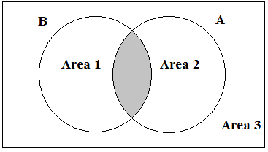

The rectangular box represents a universal set.

**Area 1:**People who passed only Physics.

**Area 2:**People who passed only Chemistry.

**Area 3:**People who passed neither Physics nor Chemistry.

**Formula:**AB = A + B - AB.

**Problem 1:**

In a school of 350 students, 100 are in the Band, 200 are in the Sports team and 50 are in both Band and Sports team.

1. How many students are involved neither in Band nor in Sports?
2. How many people involved at least one of the two?
3. What is the ratio of people who participate only in the band to only in sports?

**Solution:**

50 students are in both Band and Sports. So, 100 - 50 = 50 students are in Band only and 200 - 50 = 150 students are in Sports only.

Total students 350 and 350 - 250 = 100 students are neither in Band nor in Sports.

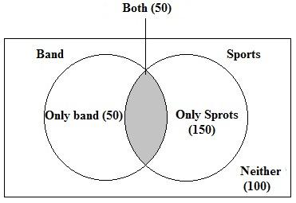

1. Students are involved neither in Band nor in Sports = 100.
2. Students involved at least one of the two = 50+50+150 = 250.
3. Students only in Band  = 50 and students only in Sports = 150

Hence, the Ratio of students only in the band to only in sports = 50:150 = 1:3.

**Problem 2:**

There are 60 students in a class, 60% fail in English and 30% pass in Maths and 20% pass in both English and Maths. How many students fail in either of 2 subjects or at least in one subject?

**Solution:**

20% of students pass in both English and Maths. So, 30% - 20% = 10% of students pass in maths only and 60% fail in english means 40% pass in english and 40% - 20% = 20% of students pass in English only.

Total students 100% and 100 - 50 = 50% of students neither pass in english nor pass in maths.

Number of students  fail in either of two subjects = 20% + 10% = 30% i.e 30% of 60 = 18 students.

Number of students fail in at least one subject = 20 + 10 + 50 = 80% i.e 80% of 60 = 48 students.

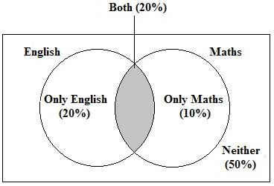

**Three attributes situation:**

Let's have a situation where there are three attributes being measured. Suppose we are talking about people who passed Physics, Chemistry and Mathematics.

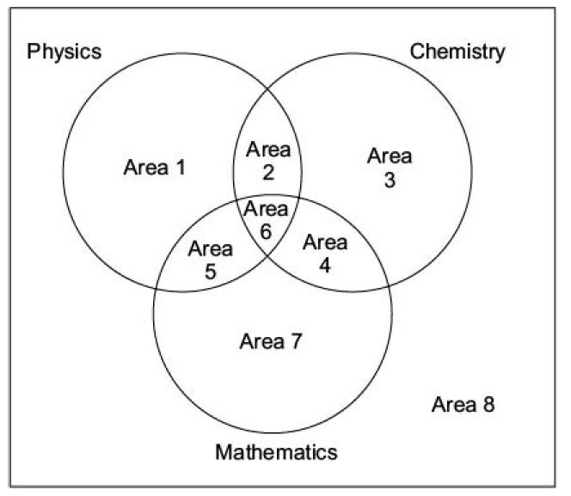

**Area 1:** People who passed in Physics only

**Area 2:** People who passed Physics and Chemistry but not Maths.

**Area 3:** People who passed Chemistry only

**Area 4:** People who passed Chemistry and Maths but not physics.

**Area 5:** People who passed Physics and Maths but not in Chemistry.

**Area 6:** People who passed Physics, Chemistry and Maths

**Area 7:** People who passed Maths only

**Area 8:**People who passed in no subjects.

People passing Physics and Chemistry: Represented by the sum of areas 2 and 6

People passing Physics and Maths: Represented by the sum of areas 5 and 6

People passing Chemistry and Maths: Represented by the sum of areas 4 and 6

People passing Physics: Represented by the sum of the areas 1, 2, 5 and 6

People passing at least 2 subjects = area 6 + area 2/4/5

People passing exactly 2 subjects: represented by area 2,4 and 5.

|  |
| --- |
| **Problem 1:**  A veterinary doctor surveyed 52 people. He discovered that 28 have dogs, 20 have cats and 10 have parrots, 8 have dogs and cats, 6 have dogs and parrots and 2 have cats and parrots. No one has all three pets.   1. How many people have only a dog? 2. How many people have at least 2 pets among dogs, cats and parrots? 3. How many people have none of the 3 pets?     **Solution:**  8 people have dogs and cats, 6 people have dogs and parrots. 28 - (8+6) = 14 people have only dogs.  8 people have dogs and cats, 2 people have cats and parrots. 20 - (8+2) = 10 people have only cats.  6 people have dogs and parrots, 2 people have cats and parrots. 10 - (6+2) = 2 people have only parrots. |

1. People have only a dog = 14.
2. People have at least 2 pets = 6+8+2=  16.
3. People have none of the 3 pets = 10.

**Problem statement**

Send feedback

If ∪ = {1, 3, 5, 7, 9, 11, 13}, then which of the following are subsets of U.

**Options:**One or more answers may be correct

**{2, 4}**

**{0}**

**{1, 9, 5, 13}**

**{5, 11, 1}**

**{13, 7, 9, 11, 5, 3, 1}**

**{2, 3, 4, 5}**

**Solution description**

Here, we can see that C, D, and E have the terms which are there in ∪. Therefore, C, D, and E are the subsets of ∪.

**Problem statement**

Send feedback

Let A and B be two finite sets such that n(A) = 20, n(B) = 28 and n(A ∪ B) = 36, find n(A ∩ B).

**Options:**Pick one correct answer from below

**12**

**15**

**17**

**11**

**Solution description**

Using the formula n(A ∪ B) = n(A) + n(B) - n(A ∩ B).  
then n(A ∩B) = n(A) + n(B) - n(A ∪B)  
= 20 + 28 - 36  
= 48 - 36  
= 12

**Problem statement**

Send feedback

In a group of 60 people, 27 like cold drinks and 42 like hot drinks and each person likes at least one of the two drinks. How many like both coffee and tea?

**Options:**Pick one correct answer from below

**7**

**11**

**9**

**4**

**Solution description**

Let A = Set of people who like cold drinks B = Set of people who like hot drinks Given,  
(A ∪B) = 60 n(A) = 27 n(B) = 42 then;  
n(A ∩ B) = n(A) + n(B) - n(A ∪ B)  
= 27 + 42 - 60  
= 69 - 60 = 9  
= 9  
Therefore, 9 people like both tea and coffee.

**Problem statement**

Send feedback

In a competition, a school awarded medals in different categories. 36 medals in dance, 12 medals in dramatics and 18 medals in music. If these medals went to a total of 45 persons and only 4 persons got medals in all the three categories, how many received medals in exactly two of these categories?(GMAT 2016)

13

The total number of medals: 36+12+18= 66.  
So, 66 medals are awarded to 45 persons.

12 of them have been awarded to 4 persons.

The other 54 medals have been awarded to 41 persons.

So, there are 54–4= 13 persons with two medals each.

## Problem statement

Send feedback

### **In a group of 100 people, 72 people can speak English and 43 can speak French. How many can speak English only?**

57

Logarithms

Questions based on this chapter are not so frequent in aptitude exams. You will find some questions based on logs, to solve those questions you have to learn some basic formulae.

**Definition of “log”:**

Let ‘a’ be a positive real number and = c. then ‘b’ is called the logarithm of ‘c’ to the base ‘a’ and written as and vice versa, if = b, then = c.

NOTE: Log of a negative base is not defined.

= b is possible if and only if a>0 and c>0.

**Formulae for log:**

1. += )
2. -=
3. = 0 for all a > 0
4. = 1 for all a > 0
5. = b

**Base change rule:**

Till now all the formulae are in logarithm with the same base. However, there are a lot of situations in Logarithm problems where you have to operate on logs having different bases. Those situations are:

1. = /
2. = /= 1/
3. = (1/z)

Problem 1:

= = a, where x,y are real positive numbers. If G is the geometric mean of x and y. What is the value of ?

Solution:

From the statement, = = a, we have

= a and = a

By definition of the log;

= a, x = and = a, y =

G is the geometric mean of x and y. So, G =

G = = =

Now; = = a= a

Hence, = a.

**Problem statement**

Send feedback

X is a real number such that log3(5)=log5(2+x), which of the following is true.( Goldman Sachs)

**Options:**Pick one correct answer from below

**0<x<3**

**23<x<30**

**x>30**

**3<x<23**

**Solution description**

Given, log35=log5(2+x) ……….(1)  
We know;  
log3(3)= 1, log3(9)= 2  
So, we can conclude that the value of log35lies between 1 and 2.  
Hence, log3(5)= 1.46<  
br> So, from eq(1)  
log5(2+x)= 1.46 …………(2)  
Now, log5(2+x)  
If x = 2. Then, log5(2+5)= log55= 1  
If x = 23. Then, log5(2+23)= log525= 2.  
But from eq(2) it is clear that log5(2+5), can not be 2. Hence, x should be greater than and less than 23.  
Hence, option (d) is the answer.

**Problem statement**

Send feedback

logx/b-c= logy/c-a= logz/a-b, which of the following is correct; (AWS hiring)

**Options:**Pick one correct answer from below

**xyz = 1**

**xyz=2**

**(x^a)(y^b)=1**

**a.b.c=1**

**All of the above**

**Solution description**

Let logx/b-c= logy/c-a= logz/a-b= k logx/b-c= k, logy/c-a= k and logz/a-b= k logx= k(b-c) and logy= k(c-a) and logz= k(a-b) and x = 10^(k(b-c)) y = 10^(k(c-a) ) z = 10^(k(a-b)) Now, xyz = 10^(k(b-c))x10^(k(c-a))x10^(k(a-b)) xyz = 10^(k(b-c+c-a+a-b))= 10^0= 1 Hence, xyz = 1.

**Problem statement**

Send feedback

Find the minimum value of 2log10(x)- logx(0.01), if x>1.

4

Sentence Completion/Fillupsfooter line

**Introduction:**

Fill in the blanks also in the same case is called sentence completion. It is basically a combination of both reading skills and grammar knowledge.

**Sentence completion is of three types:**

1. Single blank
2. Double blank
3. Cloze test

**1. Single blank:**It is basically one sentence with one blank that you have to fill.

**2. Double blank:**It is a longer sentence with two blanks that you have to fill.

**3. Cloze test:**It is like a paragraph having some blanks. Actually it a combination of both fill in the blanks and reading comprehension.

**What all factor kept in mind:**

1. First of all, you should always have a mental answer when you are trying to solve a problem.
2. With the mental answer, match it with the option skill.
3. Vocabulary should be very very strong.

1. **The idea of the sentences**:

 Every sentence has an idea and each sentence also communicates ideas.

For example:

Sentences are either positive or negative. If the positive sentence the blank word will be positive and if the sentence is negative the blank word will be negative.

Whether sentences are formal or informal. Let us say friend is a formal word and pal/buddy is an informal word.

1. **Proactive solving:**

Usually, sentences go through the option first and try to somewhat how to fit into the blanks, this way of approach is called **reactive solving**and this is likely to cause errors.

A better way would be proactive solving means acting in anticipation. In other words, try to guess the answer without solving.

1. Identify the clues present in the sentence. A positive sentence, negative sentence, formal sentence, informal sentence these all are clues in the sentence.

1. Pay special attention to introductory and transitional words. **Introductory**means this thing or that thing is talking about one thing or many things. **Transitional**words are like, but, although, however, yet, even, in spite off, despite off, etc.

For example:

Ravi is a good boy but his brother is a bad boy.

If the 1st part is positive and the 2nd part will be negative and vice versa.

1. Be sure your choice is both logically and grammatically correct. Make sure your grammar matches with the sentence, otherwise, grammar is not matching even if the meaning of the word is correct, grammatically the sentence will be wrong.

1. If you do not know words use elimination and educated guessing. This means you are able to make one or more choices that are definitely wrong or guessing from context when you know a related word.

**There are several types of sentence completion:**

1. Restatement
2. Comparison
3. Contrast
4. Cause and effect

**1. Restatement:**Restatement means repeating the same things again and again. So, if it's a positive one, it will be positive and if it’s a negative one, it will be negative.

For example:

The city council formed a committee to simplify several dozen ______ city ordinances that were unnecessarily complicated and out-of-date.

feckless b. empirical c. byzantine d. Slovenly e. Pedantic

Answer :

Here we are talking about something which was very complex and has been simplified. So, here the answer is ‘c’ i.e. byzantine that means very complicated.

**2. Comparison:**Two things are being compared. eg. Ram is a good boy similarly his brother is also a good boy.

In this case if it is positive it will remain positive and vice versa.

Similarly, likewise, and just as etc. are used for comparison.

**3. Contrast:**If contrast is there then but, although, despite, however, though, or etc. words you will be seen.

eg. Ram is a good boy but Shyam is a bad boy.

**4. Cause and effect:**Cause and effect mean one thing is the reason for others. Words like cause, lead to because, etc. when you have these words then you know there is a **cause & effect.**Even without these words, we can have cause & effect.

For example:

After a brief and violent _______ that ousted the president, General Mosanto declared himself the dictator of the country.

nurance b. Coup c. solicitation d. upbraiding e. lament

Answer:

In this sentence outage is a clue. Outage means to remove. Here the answer is ‘b’ coup that means to take over any government.

**Questions On Sentence Completion:**

1. **Single blanks question:**

1. His neighbours find his _______ manner bossy and irritating and they stop inviting him to backyard barbeques.

insentinent b. magisterial c. reparatary

d. restorative e. modest

Answer: b.

Explanation:

Find something which talks about his manner is bossy and irritating. So, magisterial is the answer that means dominating.

Insentient - can not sense anything, Reparatory - repayment, Restorative - having the ability to restore health and modest - very humble.

2. Shubham is always _______ about showing off work because he feels that tardiness is a sign of irresponsibility.

legible b. Tolerable c. punctual

d. literal e. Belligerent

Answer: c.

Explanation:

Tardiness means unpunctual or lazy. So, the answer is punctual.

Legible - handwriting, Tolerable - something you can tolerate, Literal - taking words in their usual sense and belligerent - a war like happening.

3. Anjali would _______ her little sister into an argument by teasing her and calling her names.

advocate b. provoke c. perforate

d. lament e. Expunge

Answer: b.

Explanation:

Her sister made her angry. So, the answer is, provoke that means anger.

Advocate - incorrect, perforate - make holes, lament - very sad and expunge - remove.

**Cloze test:**

In the cloze test, the whole paragraph has to be taken into concentration. Sometimes clues are given later on also, so it is a good idea to read the whole paragraph and then keep filling it as and when you can.

Text 1.

Giant pandas are black-and-white Chinese beers that are on the verge of (1)_____. These large, cuddly-looking mammals have a big head, a heavy body, rounded ears, and a short tail. Most bears’ eyes have round pupils. The (2)______ is the giant panda, whose pupils are vertical slits, like cats’ eyes, these unusual eyes (3) _______ the Chinese call the panda “giant cat bear.”

1. A) indication B) accommodation C) extinction.

2. A) dimension B) exception C) speculation

3. A) inspired B) predicated C) reversed

Answer:

1. Extinction.

The clue is on the verge.

2. Exception.

The clue is pupils are vertical slits.

3. Inspired.

Chinese inspired by the looking of giant pandas.]

Text 2.

Although the population of England in the nineteenth century was rising at a (1) ______ rate, that of the city was increasing by leaps. This was due to the effect of the industrial revolution; people were (2)______ into the towns and cities in search of employment; for the same, it was also the call of the unknown, (3)______ and a better way of life. This period is known to be the beginning of many new things.

1. A) crepuscular B) unprecedented C) reprehensible

2. A) flocking B) abrogating C) ensconcing

3. A) escapade B) pliable C) abstruse

Answer:

1. Unprecedented

Means like never before.

2. Flocking.

Means moving. The clue is town.

3. Escapade

Means adventurous

**Problem statement**

Send feedback

She had not eaten all the day, and by the time she got home she was _______ .  
(American Express 2020)

**Options:**Pick one correct answer from below

**blighted**

**confutative**

**ravenous**

**Ostentatious**

**Blissful**

**Solution description**

Here the mental answer is hungry and the word ravenous means hungry. Blissful - very happy, ostentatious - showy and confutative - the act of refuting someone's point forcefully and blighted - spoil.

**Problem statement**

Send feedback

The movie offended many of the parents of its younger viewer by including unnecessary _______ in the dialogue.  
( Oracle hiring 2018)

**Options:**Pick one correct answer from below

**vulgarity**

**verbosity**

**vocalization**

**garishness**

**Solution description**

Offended means irritating. So, vulgarity offended many parents. Verbosity - many words, garishness - very bold, tonality - music and vocalization - way of speaking.

**Problem statement**

Send feedback

The dress Ariel wore _______ with small, glassy beads, creating a shimmering effect.  
( Barclay campus hiring 2021)

**Options:**Pick one correct answer from below

**titillated**

**reiterated**

**scintillated**

**enthralled**

**Solution description**

The dress Ariel wore decorated. The answer is scintillated that means shinny or decorated.\ Titillated - excite, Reiterated - repeat again and again, Enthralled - very happy about something and Striated - having striped.

**Problem statement**

Send feedback

Insects do not have (1)_____ as sharp as that of mammals or birds. The insect compound eye is more familiar to movement and so it cannot(2) ______ position distant objects. So, insects tend to take a rather unsteady flight path to navigate to a particular object. For example, in order to locate the caterpillar, the wasp needs to balance the odour signals(3)______ by its two antennae

**Options:**Pick one correct answer from below

**A) wings B) vision C) absorption**

**A) vision B) precisely C) received**

**A) sacrificed B) accompanied C) tangibly**

**Solution description**

1. Vision.  
The clue is sharp. Sharp could be eye side or could be the vision.  
2. Precisely.  
3. Received.  
The clue is antennae, antenna received signal.

**Problem statement**

Send feedback

A last attempt is being made to move the beetles to a specially designed pile of Ribble that (1)_____ their existing habitat. But experts stress that is only a slim chance that the (2)_______ will succeed.

**Options:**Pick one correct answer from below

**A) succumb B) resonate.**

**A) replicates B) translocation.**

**Solution description**

1. Replicate.  
The clue is an existing habitat.  
2. Translocation.  
Beetles location change . migration means permanent shifting.

**Vocabulary, Antonyms & Synonyms**footer line

**Introduction to Vocabulary**

Vocabulary is an essential part of the English language section in almost every competitive exam. Vocabulary is dependent on the individual learning process. Vocabulary requires more and more practice in day-to-day life.

**Vocab-Root words:**

Root words are a very easy way to learn vocabulary. These words are a part of layer words. Root words have a significant meaning and root words can come either at the middle of the word or at the start of the word or at the end of the word. When the root word comes at the start of the word, it is called a prefix and when it comes at the end of the word, it is called a suffix.

By learning one root word we can learn many words.

**Words starting with BENE, BON & BOUN :(BENE, BON & BOUN = WELL & GOOD)**

Benefit = An advantage; as, the employees has fringe benefits

Benefiter = One who benefits; as, the employee is the benefiter

Beneficial = Wholesome; as, bathing is beneficial

Benefactor = Once who benefits others

Benefection = A gift; a donation

Benefactress = A female benefactor

Benedict = A male name which means “Blessed”

Benediction = A blessing

Benefice = The gift of an income to a priest of a church

Benevolent = Being good hearted; a well-wisher

Bonny = Sweet and attractive; as, a bonny child. And it is also used for pretty ladies.

Bonus = Extra benefits, usually extra pay

Bonanza = As unusually rich vein of gold or silver in a mine

Bonbon = A small candy

Bonbonniere = A fancy dish or box for bonbons

Bon mot = Witty remark or repartee

Bonnily = In a bonny manner

Bounty = A reward; a gift; generosity

Bountiful = Generous; munificent; large hearted

Bountifully = Generously

Benign =  Harmless; also known as cancer

**Words with root word** **MAL :(MAL = BAD & EVIL)**

Maladroit = Clumsy; awkward; inept ( not efficient ) & (Adroit = skill)

Malady = Sickness; diseases

Malapert = Ill-bred; impudent,  ( Ill-bred = not well mannered)

Malapropos = Inappropriate; Not fitting

Malapropism = Humorous misuse of words

Malaria = A diseases carried by a mosquito

Malcontent = Rebellious; discontented; bad tempered; a person who is not happy

Malediction = Slander; curse

Malefaction = An evil deed

Malefactor = One who commits an evil deed; evildoer

Malevolent = Wishing evil to others

Malevolence = Wishing evil to others

Malevolence = the state of wishing evil to others; ill will; viciousness

Malfeasance = Evil conduct; especially by a public official

Malice = Ill-will as, “with malice toward none’; something bad; something negative

Malicious = Full of ill-will; full of malice

Malpractice = Professional misconduct; something wrong

Malignant = Injurious; extremely evil; tending to produce death

Malign = to utter slander of; to defame unjustly; to speak bad about someone

Maliferous = Disease bringing; productive of evil

**What is important in vocabulary:**

**Principle 1:** 90% of the tasks to remembering a word is to remember its meaning.

**Principle 2:**Meanings are better remembered through experience than just going through sequences of words.(same as our mother tongue).

**Principle 3:**You need to crash 20 years of experience into 6 months. (20 years of knowing your mother tongue whereas 6 months of preparation for your exams in english.)

**Principle 4:**The power of learning through synonyms and antonyms.

Synonyms are words that are similar in meaning, not same.

**Introduction to Synonyms and Antonyms:**

A word or phrase that has the same or [nearly](https://dictionary.cambridge.org/dictionary/english/nearly) the same [meaning](https://dictionary.cambridge.org/dictionary/english/meaning) as another word or phrase in the same [language](https://dictionary.cambridge.org/dictionary/english/language) is called a synonym.

A word opposite in meaning to another (e.g. *bad* and *good* ) is called an antonym.

**Synonyms of slow:**

* CAREFUL                      CAUTIOUS                       CRAWLING                 DAWDLING
* DELIBERATE                DELAYED                         DILATORY                  GRADUAL
* LAGGING                      LATE                                  LAZY                           LEISURELY
* LINGERING                  LOITERING                       MEASURED           PAINSTAKING
* PLODDING                   PROTRACTED                  SLOW MOVING          SLUGGISH
* STEADY                        TARDY                               TORPID                     UNHURRIED
* UNPUNCTUAL

**DAWDLING:**

To spend time idly, to move lackadaisically (lackadaisically- lazy)

#Dowdle up the hill.  
**Careful and cautious**are related to the word slow.

**DELIBERATE:**

1. Characterized by or resulting from careful and thorough consideration *a deliberate decision*
2. Characterized by awareness of the consequences *deliberate falsehood* ( deliberate falsehood - deliberately trying to slow)
3. Slow, unhurried, and steady as though allowing time for a decision on each individual action involved *a deliberate pace*.

**DILATORY:**

1. Tending or intending to cause delay ‘dilatory tactics’
2. Characterized by procrastination: TARDY  (procrastination - just being lazy, try to delay something)

**LEISURELY:**

1. Without haste: DELIBERATELY
2. Comes from the word leisure which means free time.

**LOITERING:**

1. To delay an activity with aimless idle stops and pauses: DAWDLE
2. To remain in an area for no obvious reason: HANG AROUND
3. To lag behind

**LINGERING:**

1. To be slow in parting or in quitting something: TARRY
2. To remain alive, although gradually dying
3. To remain existent although often waning in strength, importance, or influence ‘lingering doubts’
4. To be slow to act: PROCRASTINATION
5. To move slowly: SAUNTER

**PAINSTAKING:**

1. The action of taking pains: diligent care and efforts (diligent - hard work)

**PLODDING:**

1. To work laboriously and monotonously: DRUDGE
2. To walk heavily or slowly: TRUDGE
3. To processed slowly or tediously ‘the moving just plods along’
4. To tread slowly or heavily along or over

**PROTRACTED:**

1. Archaic: DELAY, DEFER
2. To prolong in time or space: CONTINUE
3. To extend forward or outward

**SLUGGARDLY:**

1. Lazily inactive

**SLUGGISH**:

1. Averse to actively or exertion: INDOLENT (lazy); also:  TORPID
2. Slow to respond (as to simulate or treatment)
3. Markedly slow in movement, flow, or growth
4. Economically inactive or slow

**TARDY:**

1. Moving slowly: SLUGGISH
2. Delayed beyond the expected or proper time: LATE

**TORPID:**

1. Having lost motion or the power of exertion or feeling: DORMANT, NUMB ( not feel any sensation)
2. Sluggish in functioning or acting ‘a torpid frog’ ‘a torpid mind’
3. Lacking in energy or vigor: APATHETIC, DULL

**Antonyms of slow and synonyms of fast:**

ADVERBS:

* FAST
* AT FULL TILT: at a very high speed
* BRISKLY: very fast
* IN ON TIME: without wasting time
* POST HASTE: do very very fast, now. It is used at the end of the sentence.
* QUICKLY: fast
* RAPIDLY
* SWIFTLY: comes from a swift bird. Swift is the fastest flying bird

ADJECTIVES:

* BREAKNECK: very fast
* BRISK: walking fast
* EXPEDITE: process doing fast / increasing the speed
* EXPRESS: very fast
* HASTY: fast (using in a negative manner)
* HEADLONG: used in two senses

1. Going at the headlong (very very fast) speed
2. When someone deep in his/her work

* HIGH SPEED
* LIVELY: very excited, very energetic
* NIPPY: speed

1. Nip in the bud: means finishing them off right at the start
2. Nip in the air: means moisture in the air
3. Nip: bite, scratch, cut

* PRECIPITATE: move to action

1. Undessolve part of solute
2. Rainfall

* QUICK
* RAPID
* SMART
* SPANKING : (at a-pace) : very fast speed
* SPEEDY
* SUPERSONIC: faster than the speed of sound
* SWIFT
* UNHESITATING

**Problem statement**

Send feedback

Choose the word which best expresses the meaning of the word CORPULENT. ( American Express)

**Options:**Pick one correct answer from below

**Lean**

**Gaunt**

**Emaciated**

**Obese --**

**Problem statement**

Send feedback

Choose the word which best expresses the meaning of the word EMBEZZLE:

**Options:**Pick one correct answer from below

**Misappropriate**

**Balance**

**Remunerate**

**Clear**

**Solution description**

Main Entry: embezzle Part of Speech: verb Definition: steal money, often from employer Synonyms: abstract, defalcate, filch, forge, loot, misapply, misappropriate, misuse, peculate, pilfer, purloin, put hand in cookie jar, put hand in till, skim, thieve Antonyms: compensate, give, pay, reimburse, return

**Problem statement**

Send feedback

Choose the word which is the exact OPPOSITE of the word ENORMOUS:

**Options:**Pick one correct answer from below

**Soft**

**Average**

**Tiny --**

**Weak**

**Problem statement**

Send feedback

Choose the word which is the exact OPPOSITE of the word EXODUS:

**Options:**Pick one correct answer from below

**Influx --**

**Home-Coming**

**Return**

**Restoration**

Data Interpretationfooter line

Data interpretation, as the name suggests, is all about the analysis of data. Data interpretation is the process of making sense out of the collection of data. Data may be collected in the form of bar graphs, line charts and tabular forms and hence some kind of interpretation that we need.

**Introduction to data**

Data is the number that comes from the occurrence of any event - physical, social, economic, graphical and other kinds of events.

A number value by itself represents nothing. Thus if we imagine a number, say 40, it means nothing by itself. The number starts to gain some significance when any unit attaches to it, say 40 crores. However,  just by saying that the number represents crores does not complete the description of the number. It has to be further qualified by specific descriptions, that is the sales revenue of Coding ninjas for the year 2019-20.

Thus, three facts attached to the number:

1. The number which represents the sales revenue.
2. It refers to a company Coding ninjas.
3. In the year 2019-20.

**Introduction to data interpretation**

The interpretation of data is the process through which some information is drawn about the data available for analysis.

Let say Coding ninjas in 2019-20 has sales revenue of Rs 40 crores and in 2020-21 has sales revenue of Rs 50 crore.

From these two sales revenue, you get certain information:

1. Company sales have grown by 10 crores.
2. Company % growth has been 25%.
3. The ratio of sales revenue for 2019-20 to 2020-21 is 5:4.

You make out these types of deduction by interpreting the data.

Data does not make any sense when it is in random form or it is difficult to draw out information from random data. So, you have to represent the data in some standard forms like a line graph, pie chart, bar chart, tables and caselet.

**How To Read Pie Charts**

Pie chart is a specific type of data presentation where data is presented in the form of a circle and pie charts essentially divide 100% of value within a circle. The circle is divided into various subparts. Each subpart represents a certain percentage of total. In the pie chart, the value of the individual pie chart will be an additive construct.

**For example**: A pie chart showing the distribution of car sales between six companies.

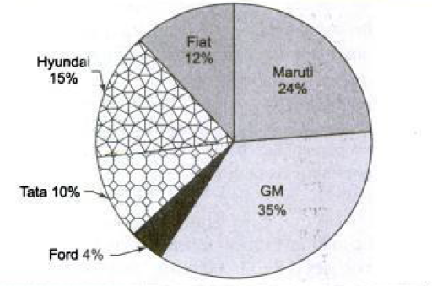

In this pie chart, Maruti has 24% of market share, while GM has 35% of market share, ford has 4% of market share, tata has 10% of market share, Hyundai has 15% of market share and fiat has 12% of market share.

The basic component here is car sales and divided into six companies. The pie chart is a circle, so it is also equal to or 100%. Thus, 1% is on a pie chart.

**For example,**The following pie chart figures (a) and (b) gives the information about the distribution of weight in the human body w.r.t. different kinds of components.

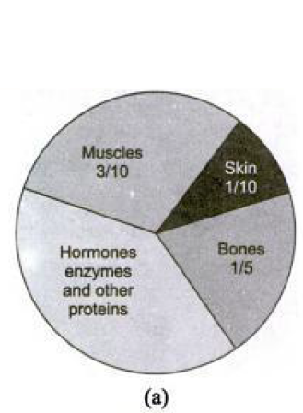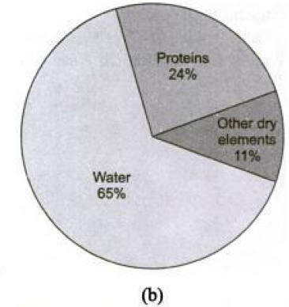

In this case, the kind of information that we can extract by interpreting what is given:

Here muscles are 3/10 means 30%, the skin is 1/10 means 10%, bones 1/5 means 20% and hormones and enzymes and other proteins is 40%.

Let's say a person whose weight is 40kg. So, we can extract information about the components. Thus, weight of the muscles = 30% of 40 = 12 kg,

Weight of skin = 10% of 40 = 4 kg

Weight of bones = 20% of 40 = 8 kg

Weight of hormones and enzymes and other proteins = 40% of 40 = 16 kg

Weight of protein = 24% of 40 = 9.6 kg

Weight of other dry elements = 11% of 40 = 4.4 kg

Weight of water = 65% of 40 = 26 kg.

The question may be asked, what is the difference between water weight of a 40 and 60 kg person?

Water weight of 40 kg = 65% of 40 = 26 kg.

Water weight of 60 kg = 65% of 60 = 39 kg.

Difference between water weight = 39 - 26 = 13 kg.

In DI once you start understanding the variable, you start understanding the extraction or deduction you make. So, understanding the variable is the most important construct in DI.

**How To Read Bar Charts**

Data is always about variables, variables are either continuous or discrete.

**For example,**Sales revenue of company coding ninjas is 40 crores in the year 2019-20. Inside this statement there are few variables, which are running. The running variables are as follow:

1. Number 40 crore is a sales revenue, which is a variable.
2. The year 2019-20 is also a variable because it could be 2020-21.
3. Company Coding Ninjas is also a variable.

Sales revenue is a continuous variable because it could be 40.01,40.12 etc. whereas the year 2019-20 and company coding ninjas are discrete variables.

**Simple Bar Chart:**

The simple bar chart is the simplest bar chart which has one continuous variable charted along with one discrete variable.

**For example:**

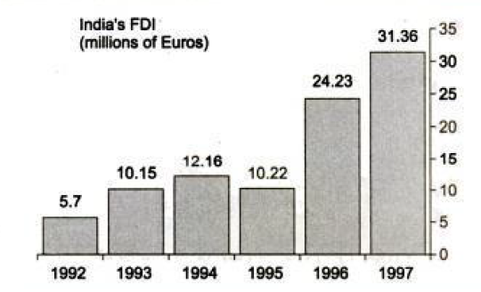

To read this Bar chart, we have to focus on the variables involved.

The year is a discrete variable.

Country India is also a discrete variable.

India’s FDI is a continuous variable.

In 1992, number 5.7 meant 5.7 million euros. In this bar chart, we can see the trends of what is happening to India’s FDI.

**Composite Bar Charts:**

In the composite Bar chart, we have two or more continuous variables that are represented.

**For example:**The following figure shows a Composite Bar Chart.

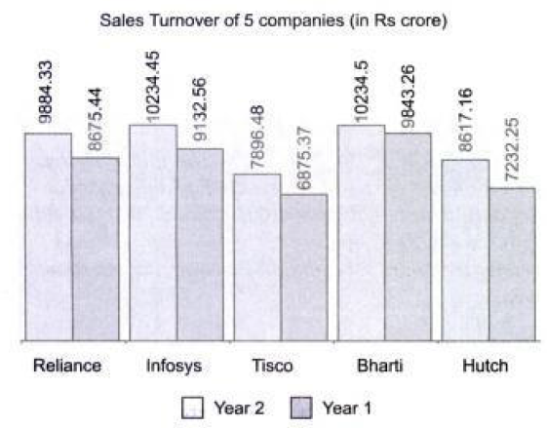

To read this Composite Bar chart, we have to focus on variables involved.

1. Year is a discrete variable.
2. Company names are also a discrete variable.
3. Sales turnover is a continuous variable.

This bar chart gives two or more information about the same discrete variable, for Reliance in Year 1 the sales turnover was 8675.44 crores and in the Year 2 was 9884.33 crores.

**Stacked Bar Charts:**

Stacked Bar charts represent multiple continuous variables. Sometimes stacked Bar chart can also be used to represent the break-up of some continuous variables.

**For example:**

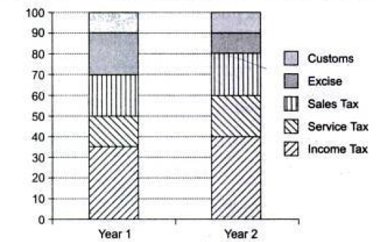

**Representing Percentage on Stacked Bar Chart**

To read this Composite Bar chart, we have to focus on variables involved.

1. Year is a discrete variable.
2. Percentage is also a discrete variable.
3. Taxes i.e. customs, excise, sales tax, service tax and income tax are five continuous variables.

In the Stacked Bar Chart defining different types of taxes into their percentage component breakdown for Year 1 and Year 2.

**How To Read Tables and X-Y charts**

**Tables:**

Tables refer to the representation of data in form horizontal and vertical columns. Tables are one of the more versatile methods of representation of data. In tables, we can have any number of continuous variables over any number of discrete variables. The data that can be represented on any type of chart can also be represented on a table.

**For example**:**:**Representation of state-wise Literacy and Population growth on a table.

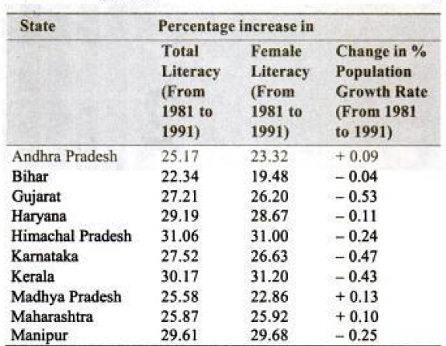

To read this Composite Bar chart, we have to focus on the variables involved.

1. Three continuous variables: (a) total literacy (b) female literacy (c) change in % population growth rate.
2. States are discrete variables.
3. Year is also a discrete variable.

Total literacy of  Andhra Pradesh 25.17% (from 1981 to 1991) means literacy rate 10 years later increased by 25.17%.

Change percentage growth rate 0.09 means percentage growth rate 10 years later increased by 0.09.

Some following type of questions may arise after reading this table:

1. Which state has the highest % growth in literacy?

Ans: % growth literacy highest for Himachal Pradesh (31.06%)

1. Which state shows the lowest % growth in female literacy?

Ans: Bihar (19.48%)

1. How many states may have negative growth in population growth rate while having more than 20% growth in both total literacy and female literacy?

Ans: Gujrat, Himachal Pradesh, Haryana, Karnataka, Kerala and Manipur i.e. 6 states.

**Example 2:**Shows courier charges (in Rs) for sending a parcel of 1 kg from one city to another city.

**Courier Charges For Sending Parcel:**

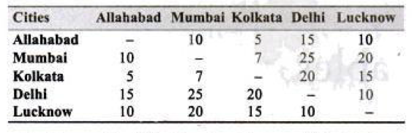

In this table, sending parcels from Allahabad to Mumbai costs 10 Rs. and sending parcels from Lucknow to Mumbai costs 25 Rs. Similarly, we can see the costs for other cities.

In this table what kind of question can be asked, Minimum cost, maximum cost, % difference in cost or cost of the parcel from Mumbai to Kolkata and then from Kolkata to Delhi.

In this table from Mumbai to Delhi and Delhi to Mumbai has the same courier cost and this is true for every pair.

**Example 3:**Employees working in various departments of Hoola Moola Boola, Inc.

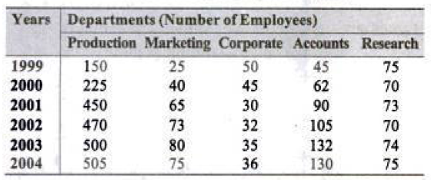

Variables are; Year, Departments and Number of employees. Let's say if we want to extract in 2004 the number of employees in Research, then it is 75 employees.

**X-Y Charts:**

As the name itself suggests the X-Y Charts will be, in which discrete variables against the continuous variables.

X-Y charts are also useful in determining the trends, rate of change and for illustrating comparison w.r.t some time series.

**Feo example:**The X-Y Chart of Consumer Price Index In 1993-94.

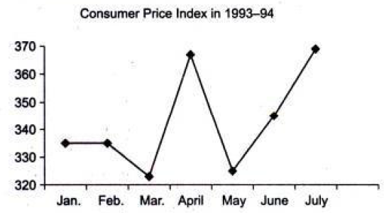

The continuous variable in this set is the consumer price index for the year 1993-94 and the discrete variable is the name of months.

Consumer price index in 1993-94, Jan was 335.

**In X-Y charts we also have multiple continuous variables:**

**For example,** The following graph shows the trends of consumption of metals and plastic in the production of cars between 2000-2005.

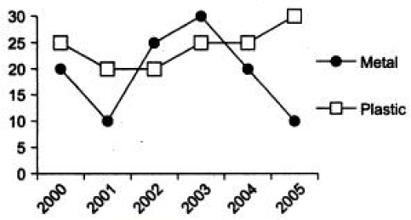

**Consumption of metals versus plastic in given years for car manufacturing (in thousand tons)**

In 2000 the metal used in cars was 10 k tons and plastic used in cars was 20k tons.

There is a small difference between Line cheats and X-Y charts, in Line charts we draw the lines and in X-Y charts the line will not be there, only points will be marked.

**Problem statement**

Send feedback

The following pie-chart shows the percentage distribution of the expenditure incurred in publishing a book. Study the pie-chart and the answer the questions based on it.  
  
Various Expenditures (in percentage) Incurred in Publishing a Book  
  
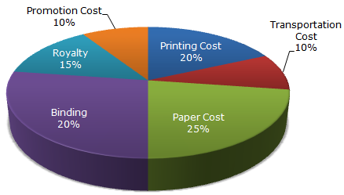  
  
If for a certain quantity of books, the publisher has to pay Rs. 30,600 as printing cost, then what will be amount of royalty to be paid for these books? ( Honeywell Inc. hiring 2020)

**Options:**Pick one correct answer from below

**Rs. 19,450**

**Rs. 21,200**

**Rs. 22,950**

**Rs. 26,150**

**Solution description**

Let the amount of Royalty to be paid for these books be Rs. r. Then, 20 : 15 = 30600 : r  
r = Rs. (30600 x 15)/20 = Rs. 22,950.

**Problem statement**

Send feedback

The bar graph given below shows the sales of books (in thousand number) from six branches of a publishing company during two consecutive years 2000 and 2001.

Sales of Books (in thousand numbers) from Six Branches - B1, B2, B3, B4, B5 and B6 of a publishing Company in 2000 and 2001.

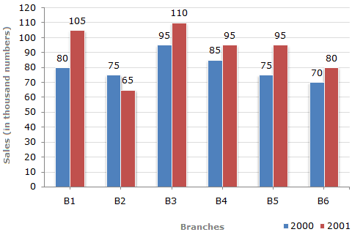

What is the ratio of the total sales of branch B2 for both years to the total sales of branch B4 for both years?

**Options:**Pick one correct answer from below

**2:3**

**3:5**

**4:5**

**7:9**

**Solution description**

Required ratio =(75 + 65)=140=7.(85 + 95)1809

**Problem statement**

Send feedback

Study the following line graph and answer the questions.  
Exports from Three Companies Over the Years (in Rs. crore)

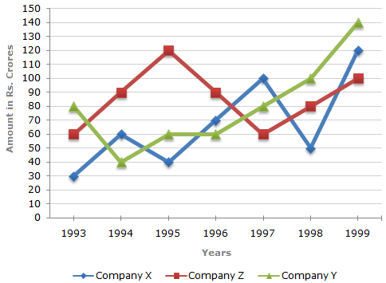

For which of the following pairs of years the total exports from the three Companies together are equal? ( Sapient assessment test 2019)

**Options:**Pick one correct answer from below

**1995 and 1998**

**1996 and 1998**

**1997 and 1998**

**1995 and 1996**

**Solution description**

Total exports of the three Companies X, Y and Z together, during various years are:  
In 1995 = Rs. (40 + 60 + 120) crores = Rs. 220 crores.  
In 1996 = Rs. (70 + 60 + 90) crores = Rs. 220 crores.  
Clearly, the total exports of the three Companies X, Y and Z together are same during the years 1995 and 1996.

**Problem statement**

Send feedback

Study the following table and answer the questions based on it.  
Expenditures of a Company (in Lakh Rupees) per Annum Over the given Years.  
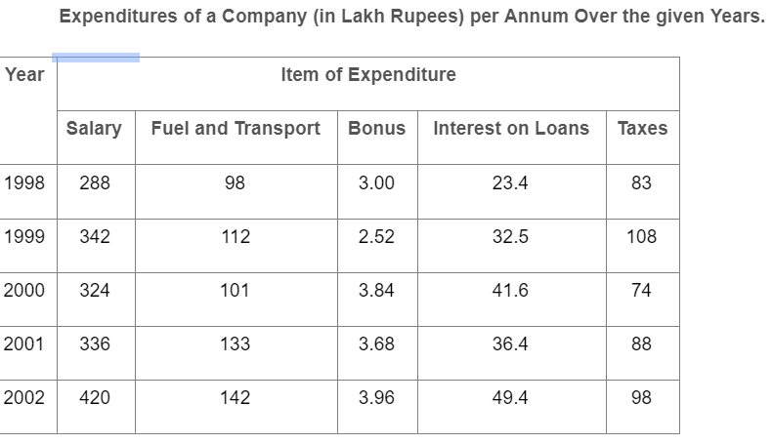

What is the average amount of interest per year which the company had to pay during this period?

**Options:**Pick one correct answer from below

**Rs. 32.43 lakhs**

**Rs. 33.72 lakhs**

**Rs. 34.18 lakhs**

**Rs. 36.66 lakhs—**

**Problem statement**

Send feedback

Find the odd one out.

**Options:**Pick one correct answer from below

**E9T**

**I9P**

**C7L**

**O7V**

**Solution description**

ASCII value of E is 69 , T is 20th letter of alphabet 69%20 = 9 . E9T , Similarly check for other options . Option D is wrong as O ‘s ASCII value is 79 and V is 22nd letter of alphabet then 79%22 = 13 . O13V should be the correct value.